

  - 7 January 2026
  - Configuration Guide
SCALE
PUSH POSSIBLE®
Table of Contents
Document Revision History 1
Initial Notes 2
Overview 3
1. Configuration Process 4
1.1 Technical Values 4
1.2 Warehouse 5
1.2.1 Country 5
1.2.2 Warehouse 5
1.2.3 Company 6
1.2.4 Users 7
1.3 Inventory Control 9
1.3.1 Zone Type 9
1.3.2 Zone 9
1.3.3 Units of Measure 11
1.3.4 Location Type 12
1.3.5 Location Status 13
1.3.6 Location Class 13
1.3.7 Location Template 14
1.3.8 Location 14
1.3.9 Storage Template 17
1.3.10 Item Class 18
1.3.11 Item 19
1.3.12 Item Unit of Measure 20
1.3.13 Item Categories 22
1.3.14 Item Cross Reference 25
1.3.15 Item Location Capacity 26
1.3.16 Item Location Assignment 27
1.3.17 Inventory Control Values 27
1.3.18 Inventory status 28
1.3.19 Adjustment type 29
1.3.20 Inventory transfer work criteria and Inventory adjustment work criteria 29
1.4 Receiving 30
1.4.1 Putaway location group 30
1.4.2 Location selection 31
1.4.3 Locating rule 32
1.4.4 Locating rule assignment criteria 33
1.4.5 Location rule assignment 34
1.4.6 Disposition Code 35
1.4.7 Receipt ID type 36
1.4.8 RF receiving check in initiation 36
1.4.9 Receiving preferences 37
1.4.10 Work group 38
1.4.11 Work type 39
1.4.12 Work profile 40
1.4.13 Receipt work criteria 41
1.4.14 Work Creation master 42
1.5 Work 42
1.5.1 Work system values 43
1.5.2 Work type 44
1.5.3 Work criteria 44
1.5.4 Work creation master 47
1.5.5 Work profile 48
1.5.6 Work special handling 50
1.6 Outbound 51
1.6.1 Outbound Status Action 52
1.6.2 Functional area 53
1.6.3 Custom status flow 54
1.6.4 Carrier 57
1.6.5 Dock area management carrier assignment 59
1.6.6 Dock management flow 59
1.6.7 Dock area anchor criteria 61
1.6.8 Packing preferences 63
1.6.9 Shipping preferences 64
1.6.10 Planned Shipment Filters – Not used 65
1.6.11 Comment Type - Not used 65
1.7 Allocation 66
1.7.1 Allocation rule assignment criteria 66
1.7.2 Allocation location selection 67
1.7.3 Allocation rule 68
1.7.4 Allocation rule assignment 69
1.8 Wave 70
1.8.1 Container type 71
1.8.2 Override data 71
1.8.3 Wave steps 72
1.8.4 Wave flow 73
1.8.5 Wave maximums 74
1.8.6 Wave criteria 75
1.8.7 Wave master 75
1.9 Value Added Services 76
1.10.1 VAS activity criteria 76
1.10.2 VAS Activity 76
1.10 Cycle counting 77
1.10.1 Cycle count system values 77
1.10.2 Cycle count Preferences 78
1.10.3 Cycle count item criteria 78
1.10.4 Cycle count location criteria 79
1.10.5 Cycle count master 81
1.10.6 Cycle count threshold 82
1.10.7 Cycle count work criteria 83
1.11 Work orders 84
1.11.1 Bill of materials 84
1.11.2 Work order preferences 84
1.11.3 Work order system values 85
1.11.4 Work order finished item work criteria 85
1.11.5 Work order component work criteria 85
1.12 Replenishment 85
1.12.1 Replenishment location criteria 86
1.12.2 Replenishment item criteria 87
1.12.3 Replenishment empty location criteria 88
1.12.4 Replenishment master 89
1.12.5 Replenishment work criteria 90
1.13 Container creation 91
1.13.1 Container creation system values 92
1.13.2 Container creation criteria 92
1.13.3 Container Class 93
1.13.4 Container type 94
1.13.5 Container Group 94
1.13.6 Packing class 94
1.14 Quality control (QC) 95
1.14.1 QC assignment criteria 96
1.14.2 QC evaluation method 96
1.14.3 QC assignment 97
1.15 Interfaces 97
1.15.1 Interface system values 98
1.15.2 Interface data maps (not required if XML) 98
1.15.3 Interface process 99
1.15.4 Interface upload criteria 102
1.15.5 Carrier Interface 102
1.16 Document Printing 104
1.16.1 Shipment data selection 104
1.16.2 Document master 104
1.16.3 Document Type 104
1.16.4 Document 105
1.16.5 Label master 106
1.16.6 Document routing 107
Conclusion 108
Links and Documentation 108

Document Revision History
Date | Changed By | Version | Notes
29 JULY 2022 | Raphael COLOMBEL | 1.0 | Initial Document Creation
29 JULY 2023 | brandon reitz / TABOUBI KHALLOULI WIeM | 1.1 | Initial Document Creation

Initial Notes
The version of SCALE used in this project is SCALE 2020, meaning some parts of this report might differ according to the version of SCALE used.
The document “Manhattan SCALE - Configuration Flow Diagrams”, which can be found here (URL still valid on 29 July 2022) was used as a reference to build this report. All the figures, except if mentioned otherwise, are taken from the report, and follow the color code defined in the following table.
KEY
Requires Configuration
Optional Configuration
Related Configuration

Overview
The process of building the SCALE configuration can be divided into different functional areas. The following are the main functional areas: Items, Locations, Inventory Management, Receiving, Work, Outbound Flow, Allocation, Wave, Cycle Counting, Work Orders, Replenishment, Container Creation (sometimes called Cubing) and Quality Check (also known as QC). Not all functional areas are required, for example, some warehouses do not have replenishment flows and would not require configuration in this functional area.
These functional areas are sometimes interconnected. Therefore, it is advised to follow a certain order when creating the configuration, as some steps require the definition of certain parameters beforehand. It is not compulsory to follow the order defined in this document although it is recommended. This document serves as a reference for how to use the configuration tool and how the functional areas communicate with one another.
If, at any time, additional information is required (regarding a folder or a field in the configuration), you can go to the Help Window or AIM, as shown in the following figures.
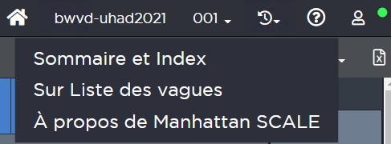
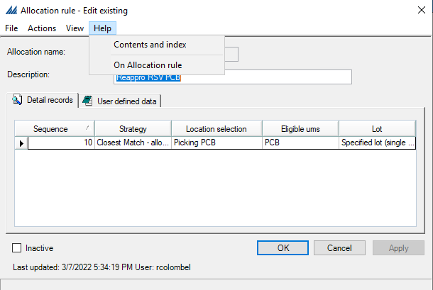

- Configuration Process
  - Technical Values
Prior to starting with the basic process of warehouse configuration, technical values need to be verified. These do not apply to functional processing, instead, they manage path names, audit log activity, filter record maximums, and other technical details. These values should only be changed by a technical expert. There is support documentation available on AIM for each of these fields. The highlighted values below are typically updated for each new environment.
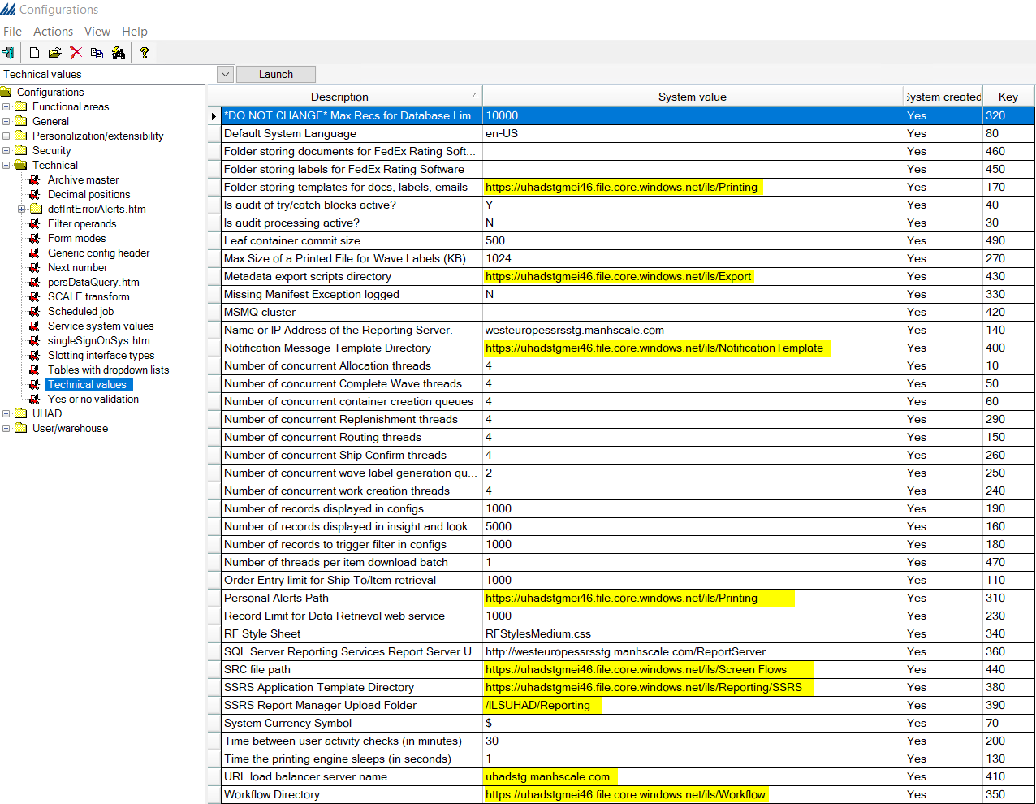

  - Warehouse
A common starting point for SCALE configuration is with the warehouse, then the company and the users. In this section we detail the steps to configure these functional areas.

Country
First, we start by reviewing the list of countries. Select the country in which the warehouse is located and ensure that it is active.
Refer to the following image and note the configuration file path [Functional areas -> Rating/routing -> General rating/routing -> Country].
²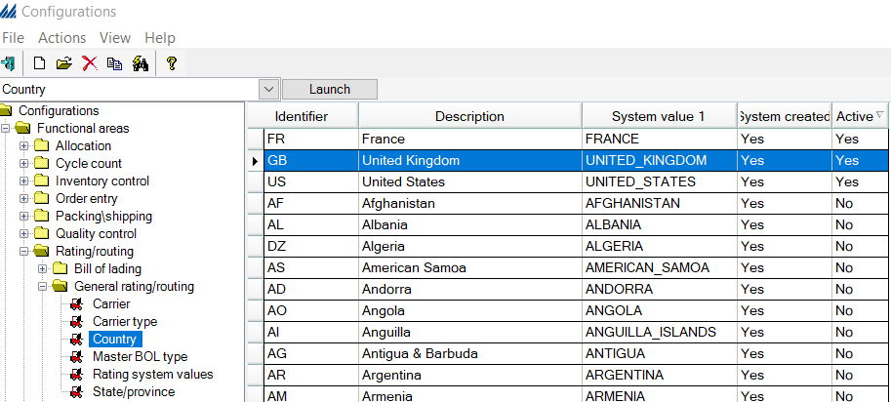
Select France (by right clicking and choosing Open) and verify that the Inactive checkbox is unchecked.
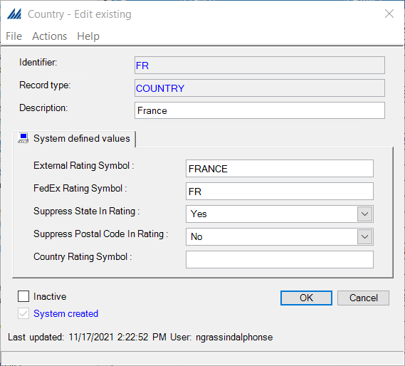

Warehouse
Warehouses [User/warehouse -> Warehouse] represent the physical building where items are stored prior to their distribution for sale. To create a warehouse, navigate to the correct menu option, right click the Warehouse menu option, or right click anywhere in the right-hand pane, select New, and enter the relevant information. Switch to the Interface tab, check the first two checkboxes.
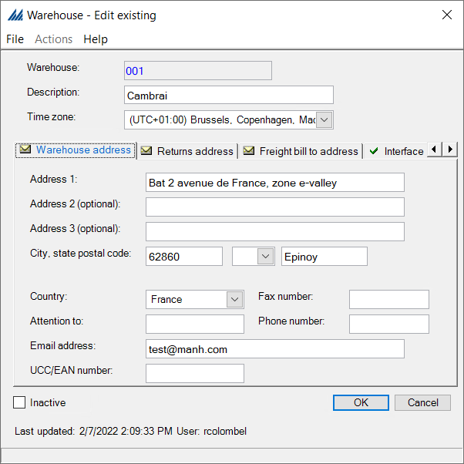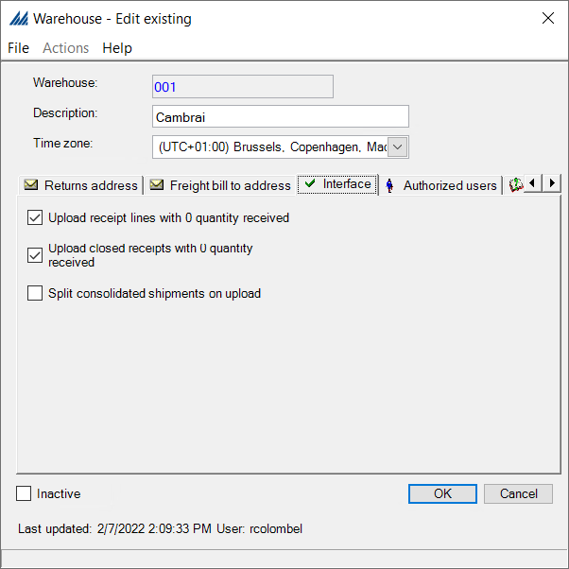
In the Authorized Users tab, it is important to make sure that the only users with access are the users that will be working in this warehouse. This is especially critical when a single environment will have multiple warehouses configured. Lastly, in the Miscellaneous tab, update the path of the Rendered pdf file directory, where SQL Server Reporting Services will save rendered (created) pdf files. Make sure the Inactive checkbox is unchecked. Click OK.
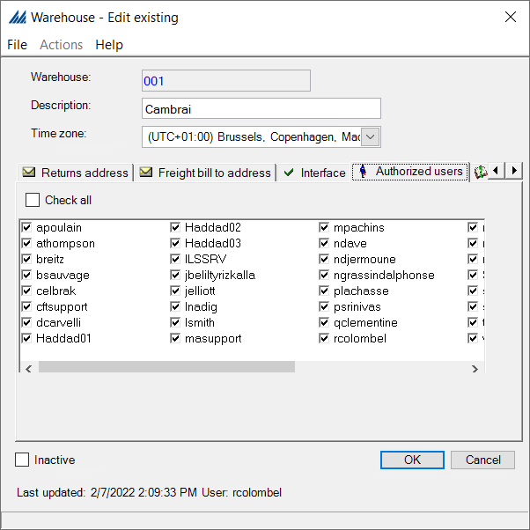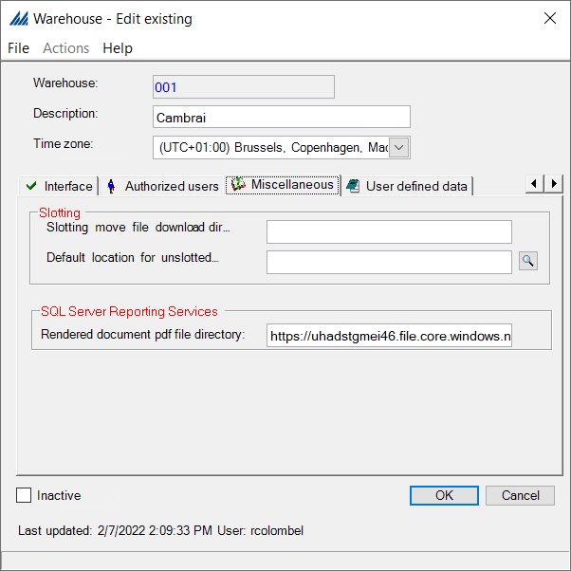

Company
Companies [User/warehouse -> Company] are unique entities that ship product from the warehouse, usually under their own brand name. The system can support multiple companies in one warehouse. Each company can have its own customer base and item(s) in the system. This is particularly useful for 3PL application, as it enables the definition of unique item/company and customer/company relationships in the same warehouse. For example, the same item in the warehouse can be associated with two different companies and SCALE would be able to track this item independently for each company.
Navigate to the Company menu option, Right click and select New. Fill in the relevant information in all the tabs (some of this might be repetitive and contain the same input as for the warehouse section above).
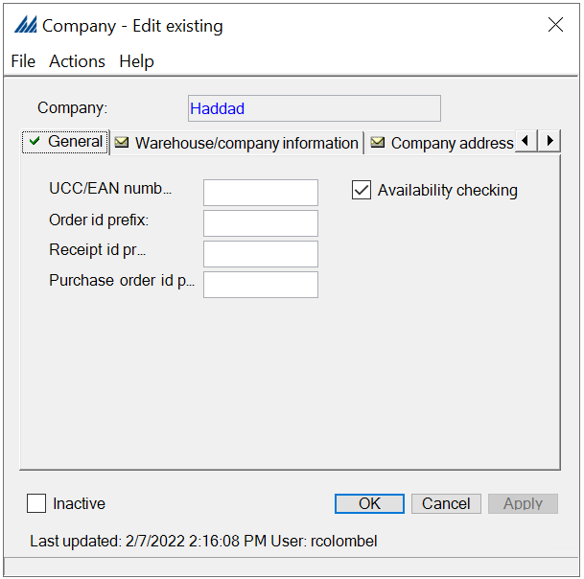
Switch to the Interface tab, check the first two checkboxes. In the Assigned Users tab, it is important to make sure that the only users with access are the users that will be working in the warehouse where this company is created. This is especially critical when a single environment will have multiple warehouses configured. Make sure the Inactive checkbox is unchecked. Click OK.
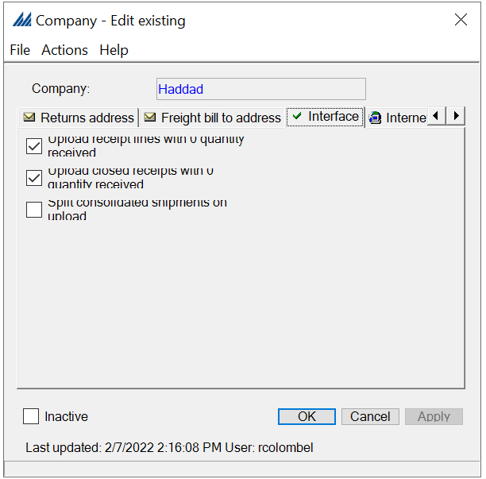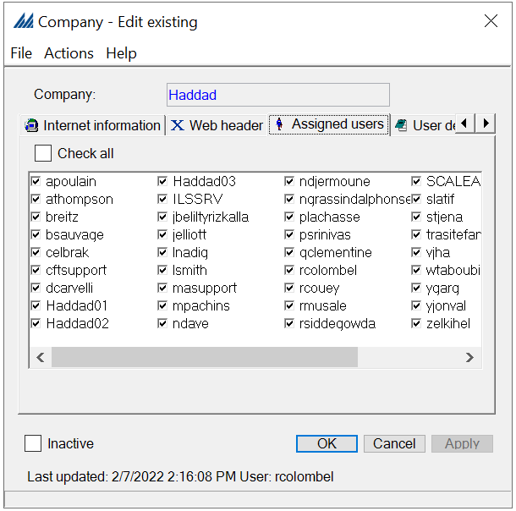

Users
All employees using the application must have a User defined in the system. To define a new user, navigate to the User profile [User/warehouse -> User profile] menu option, right click and select New. Once a user profile is defined, SCALE will recognize the employee in the system. SCALE references the username to identify an employee for such things as assigning work and tracking productivity, among other things.
Choose a short and easily recognizable Username, for example, a common naming convention is first initial and last name. Fill in the corresponding Email address belonging to this user. Choosing a default warehouse will configure the system to associate the selected warehouse with the user each time they access SCALE. Preferences can be defined to speed up warehouse processes. For example, set the receiving preference for a user that will always be following the same receiving flow, so that they can skip one step in the RF menu.
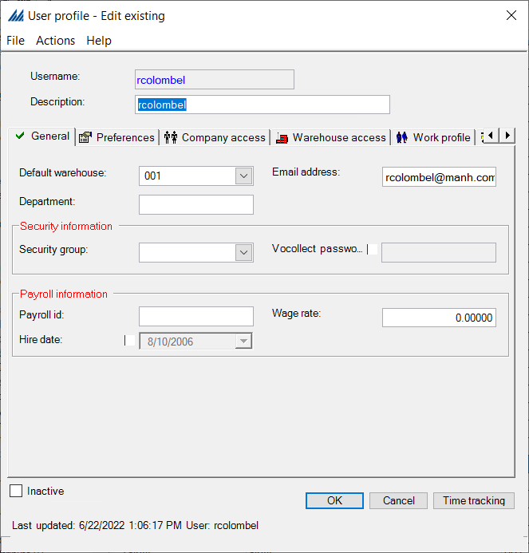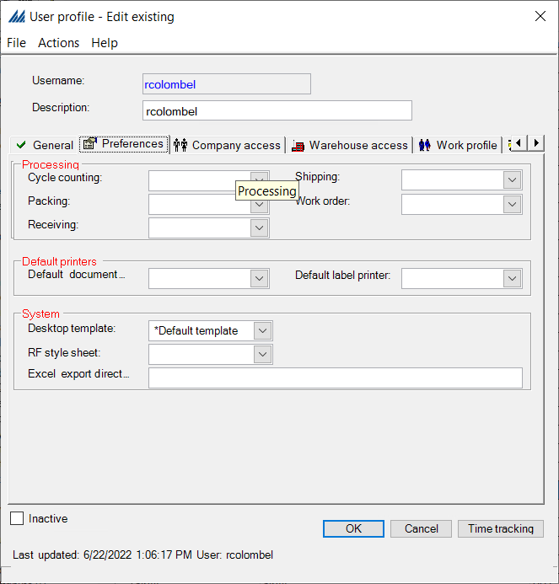
Most importantly, grant the user access to the correct companies and warehouses through the Company access and Warehouse access tabs.
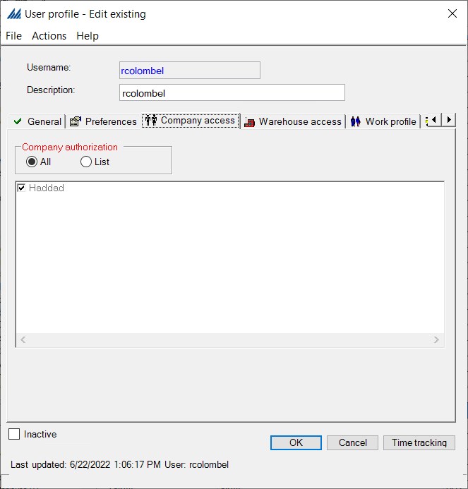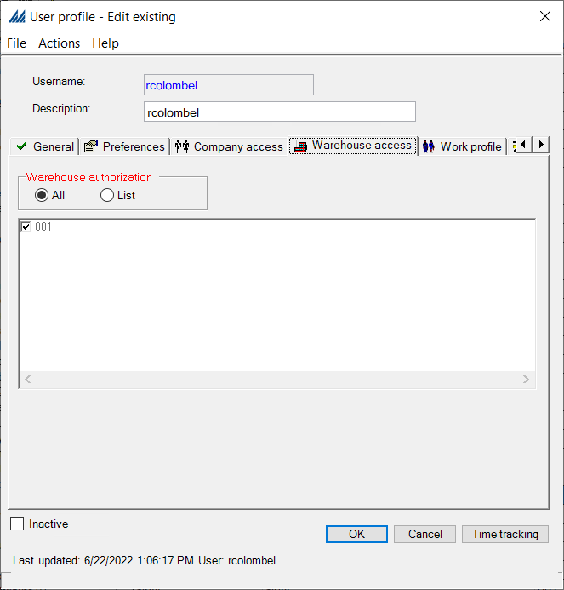
Then, in the Work profile and Authorized adjustment types tabs, check all the required checkboxes (it is possible to check all the boxes if applicable). Make sure the Inactive checkbox is unchecked and then click OK.
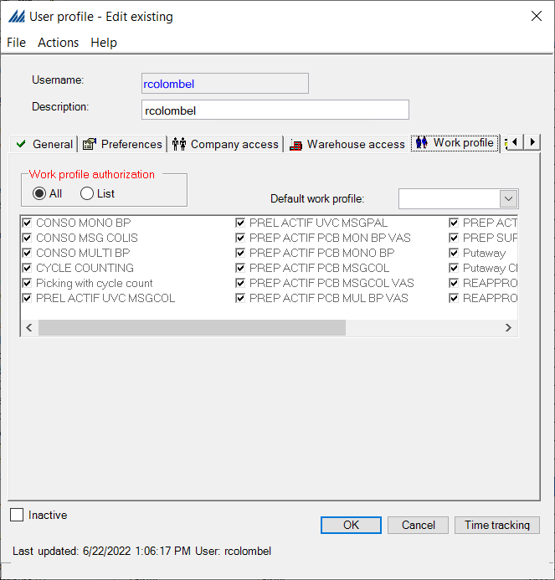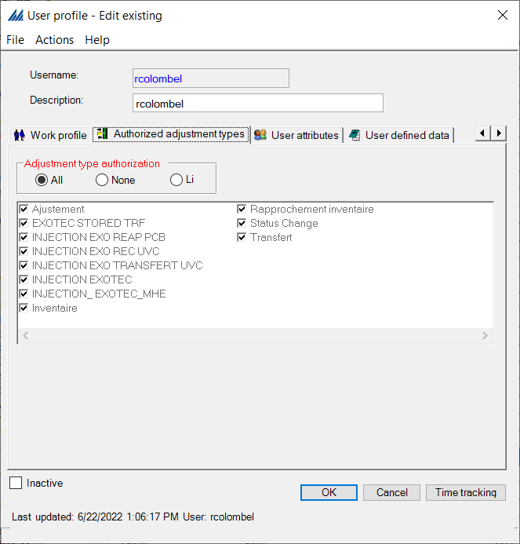

  - Inventory Control
In this section, we set up the warehouse by defining the different zones, locations within these zones, and how they are all characterized. Additionally, we will create Items (including any associated configurations) and define general inventory parameters. The following figure illustrates the required configurations to thoroughly define all locations.

Zone Type
The functionality of the warehouse largely depends on the zone configurations and the setup of locations within these zones. First, we review the zone types within the warehouse. A Zone type [Functional areas -> Inventory control -> Zone type] identifies the purpose of a zone and these are predefined in the system, but you can create additional zone types if necessary. A zone type can be associated with multiple zones. Usually, a warehouse has all three zone types: Allocation, Locating and Work. Make sure the Inactive checkbox is unchecked for each of these zone types.
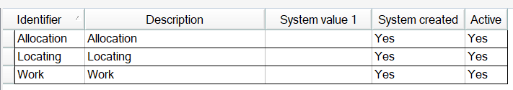

Zone
Zones are not physical positions; they manage what activity can occur in a group of locations. A Zone [Functional areas -> Inventory control -> Zone] can also be used to group locations together for processing. This minimizes processing time and increases control over which locations are considered during system processes such as locating and allocation. When defining zones, it is important to use a certain naming convention for consistency and to make it easier to define the subsequent configurations.
An example naming convention for Zones can be seen below:
- Allocation zones are preceded by A-
- Locating zones are preceded by L –
- Work zones are preceded by W-
This can be seen in the following figure. This naming convention is not official, however it is useful to make the configuration clearer and easily understandable, since each physical location in the warehouse can have a unique value for Allocation, Locating and Work zones.
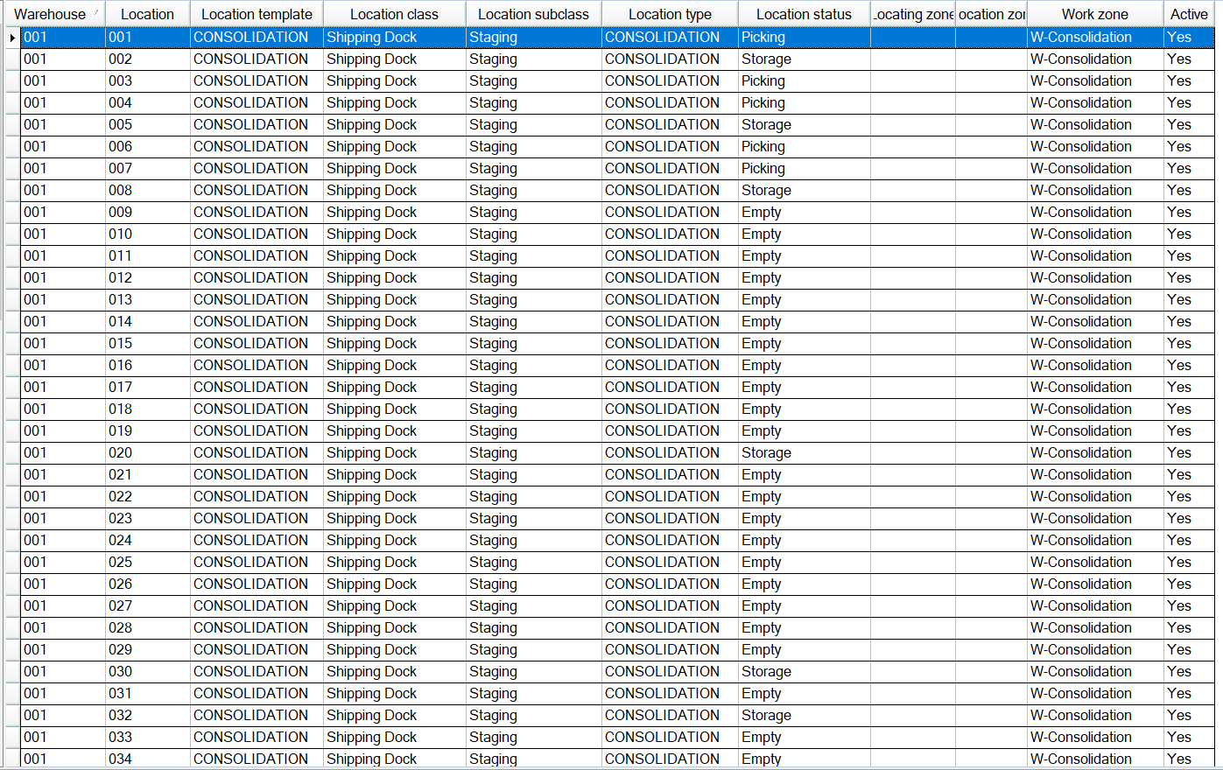
To create a new Zone, right click, select New. Name your zone (remember the recommended naming convention) and select the Zone type.
For the 001 warehouse, Locating zones are created per grade ( A, B, C) and “classe” ( Classe A/B/C) and Allocation zones are created per type ( Picking , Reserve, Masse) and unit of measure (UVC, PCB, SPCB).
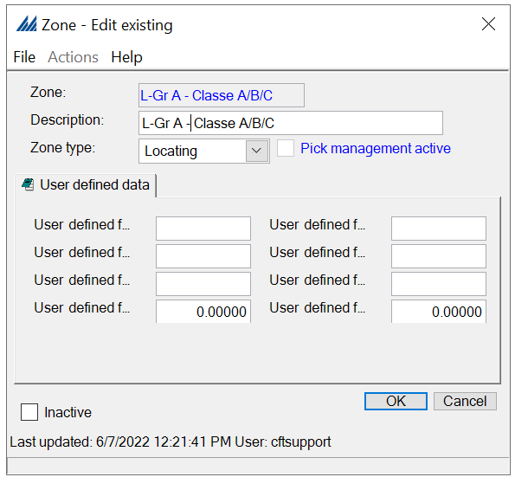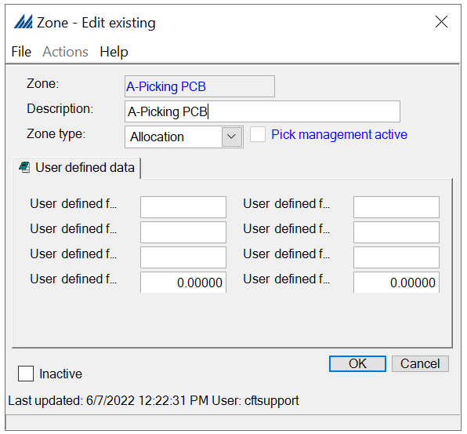

For “Work” Zone types, the corresponding Work profiles should be included. Refer to section 1.5 Work for details on this configuration. Make sure the Inactive checkbox is unchecked.
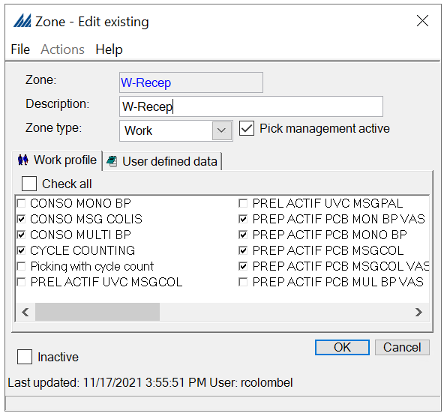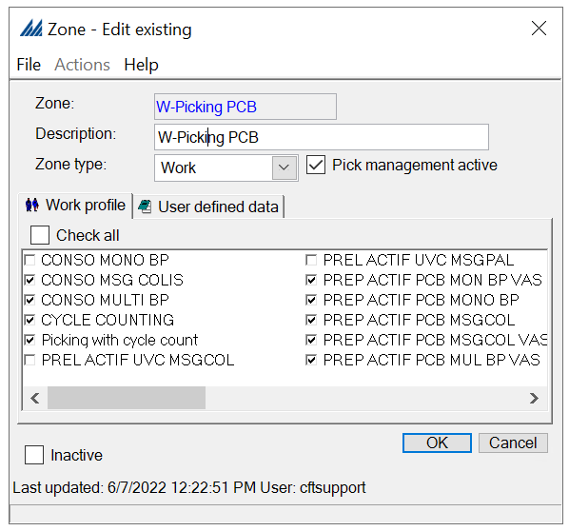

Units of Measure
Units of Measure (UOM) [General -> Units of measure] in SCALE belong to the following categories:
- Dimensions
- Quantity
- Volume
- Weight
SCALE supports all units of measure used by businesses, but the most common default values are usually system created and already available. For the Haddad warehouse, dimensions will be measured in Centimeters (cm); quantity in Pallet, PCB, SPCS and UVC; volume in Cubic Centimeters (cm³) and weight in (kg).
Right click, select New, and define the dimension unit of measure to be used for length, width and height measurements. Make sure Inactive is unchecked. Repeat the process for all quantity units of measure that will be used in the warehouse. Note that this step does not define the unit count that corresponds to each quantity UOM. That is configured in a different section. Also, in the example below the Quantity UM pallets will be set to PAL.
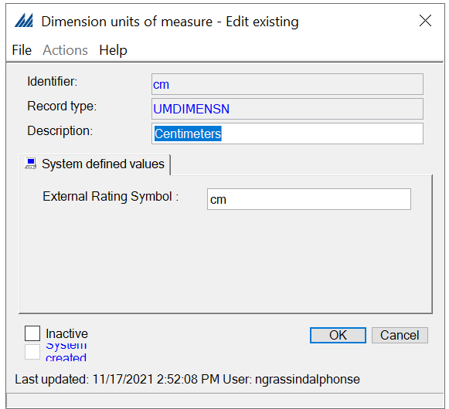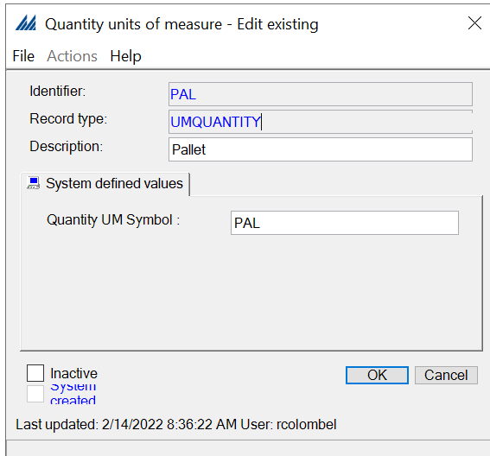
The same process described above can be followed for the volume and weight units of measure. See the figures below for reference.
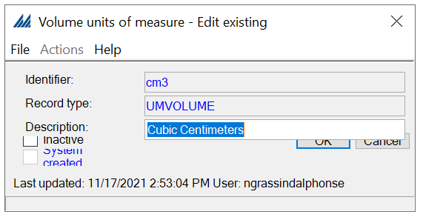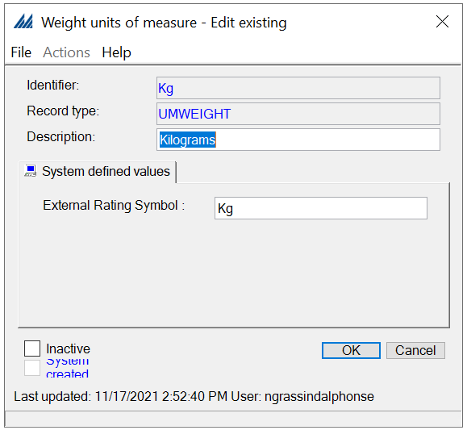

Location Type
A Location type [Functional areas -> Inventory control -> Location type] is used to define the maximum weight and dimensions (length, width, and height) for each type of location in the warehouse. This allows SCALE to determine if an item or container can fit at a location. The dimensions are used whenever item location capacity is not configured for an Item. The units of measure used here were defined in the previous section.
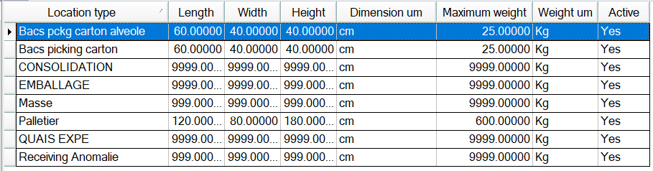

Right click, select New, and fill in the maximum values. Define these as needed, but SCALE does not require the configuration of dimensions or weight. For example, if the location is a receiving dock without a weight limit, then there is no need to set a maximum weight value. Make sure the Inactive checkbox is unchecked.
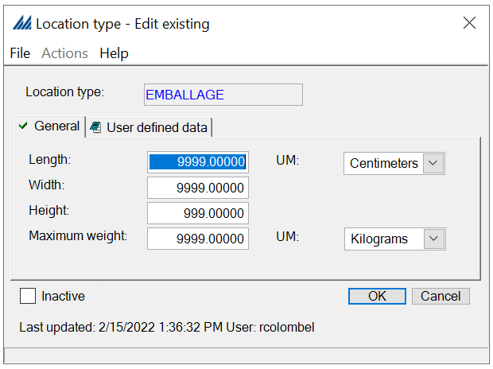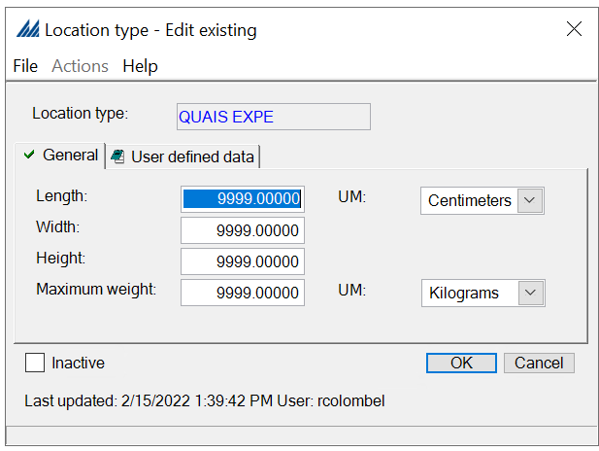

Location Status
A Location status [Functional areas -> Inventory control -> Location status] indicates the status of a location, which can be updated by SCALE during processing. These statuses are system created and usually there is no need for additional statuses. Refer to the AIM documentation as described in the Overview section for detailed descriptions of each system status seen below. Make sure the Inactive checkbox is unchecked.
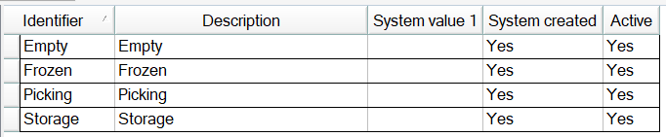

Location Class
A Location class [Functional areas -> Inventory control -> Location class] identifies the purpose of a location. Each location will be associated with a location class (“category”). Location classes are usually system created, but additional classes can be configured. Refer to the AIM documentation as described in the Overview section for detailed descriptions of each system created class seen below.
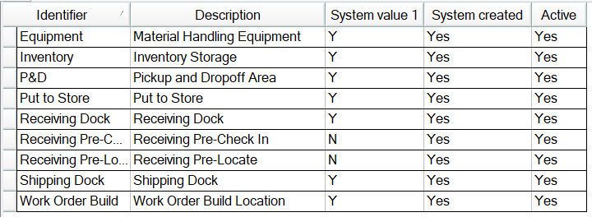
For the basic receiving and shipping flow, SCALE requires at least one location of each of the following location classes: “Receiving Dock”, “Inventory Storage” and “Shipping Dock”.
System value 1 corresponds to the Include in Item Balance Upload checkbox, which defines the location classes that should be included as part of the Item Balance Upload sent to the ERP system. When this field is inactive, the inventory in all locations belonging to this location class will not be included in the uploaded data.

Location Template
A Location template [Functional areas -> Inventory control -> Location template] defines the naming structure for a group of locations in the warehouse. This information is usually provided by clients according to their preference or to match the existing setup of the warehouse.
Right click, select New, and fill in the details to achieve the desired naming convention. Note that the length determines the number of characters allowed for each field and the field type can be set to Alpha or Numeric. Make sure the Inactive checkbox is unchecked.
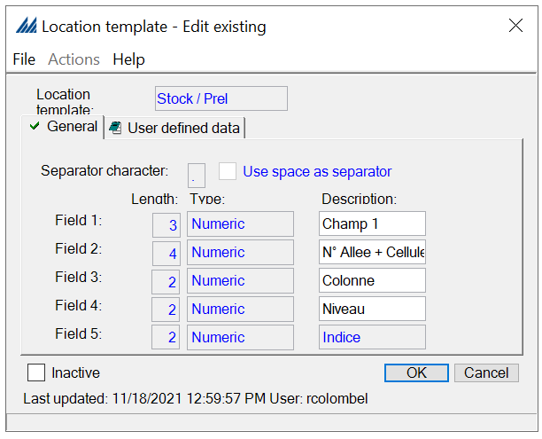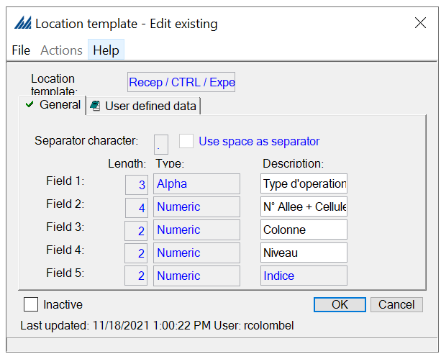

Location
A Location [Functional areas -> Inventory control -> Location] is the unique place in the warehouse where an item or license plate can be picked, putaway, or replenished. To properly configure locations, the configurations in the previous sections (1.3.1 – 1.3.7) must be completed correctly.
Right click, select New, and choose the Location template and Warehouse configured in the previous sections. This window is used to define the naming convention to be used for this set of locations.
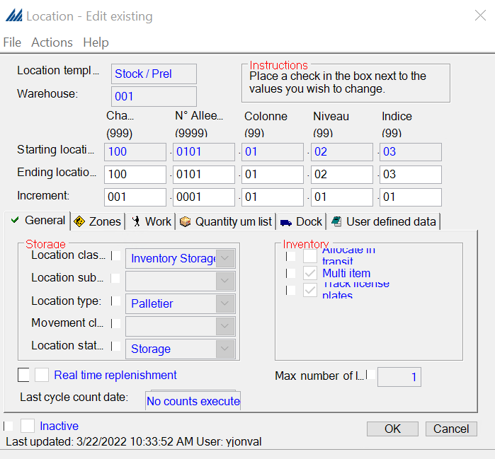
SCALE provides the option to define the Starting and Ending locations using Increments. For example, assume the starting location is 0000 and the ending location is 1000:
- An increment of 0001 will create 1001 locations (increasing the location Id by 1 every time)
- An increment of 0010 will create 101 locations (increasing the location Id by 10 every time)
- An increment of 1000 will create 2 locations (0000 and 1000)
Increments work the same way for the Alpha fields: A to B is an increment of 1 whereas A to C is an increment of 2.
The General tab is also where the Location class, Location type and Location status are defined. Although, when creating new locations, the status is usually prepopulated as “Empty”. Shipping locations require a subclass that further specifies the purpose of these locations. For example, packing stations in the warehouse are configured with a shipping location class and a packing location subclass.
Note the Inventory subsection on the right-hand side contains checkboxes that control inventory tracking and allocation. Allocate in transit indicates whether the system should include "In Transit" quantity when computing "Available" quantity at this location. Multi item determines if a location can contain different items or must be mono SKU. Track license plates is used to track item quantity at the license plate level.
In the Zones tab, select the Locating, Allocation and Work zones. This is where having the recommended naming convention is beneficial as it will be easier to know which zones should be assigned to each location.

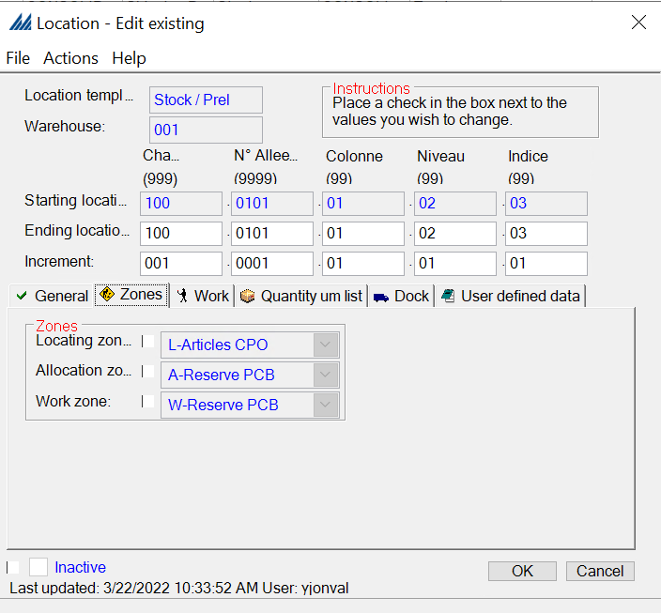
In the Work tab, fill in the Pick-up and drop-off information.
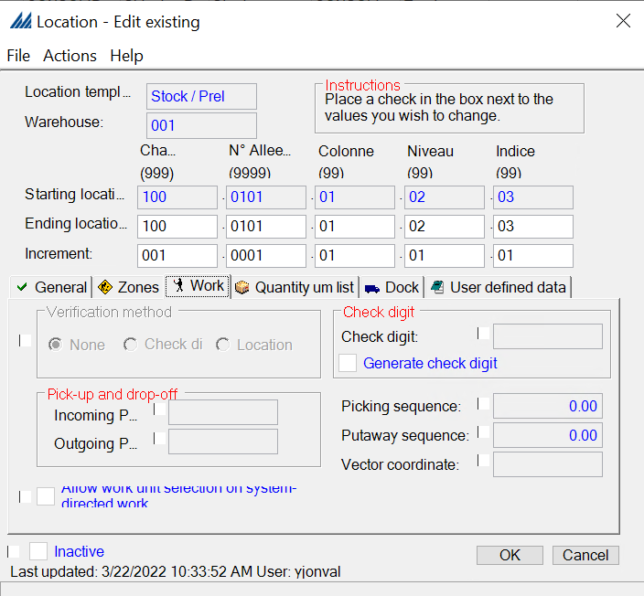
In the Quantity um list tab, select the different units of measurement that will be handled at this location.
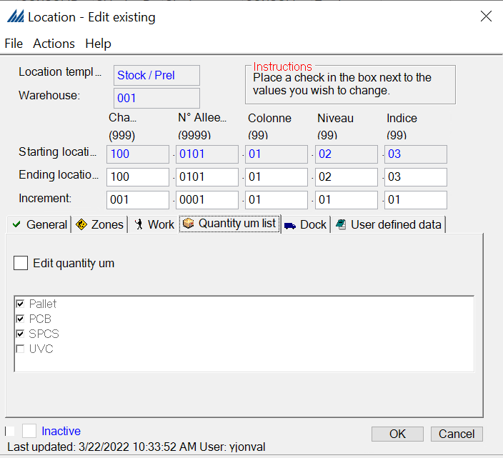
In the Dock tab, the configuration will be grayed out if there is only one shipping dock door/area configured for the warehouse. However, if there are multiple shipping dock door/areas, then this tab is used to assign the correct one to the respective location. This will be the dock door that is automatically populated during the dock management flow process.
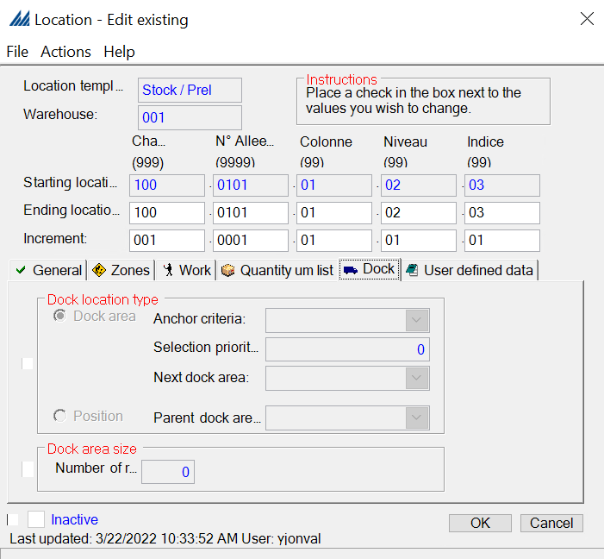
Lastly, fill in the User defined data if necessary.

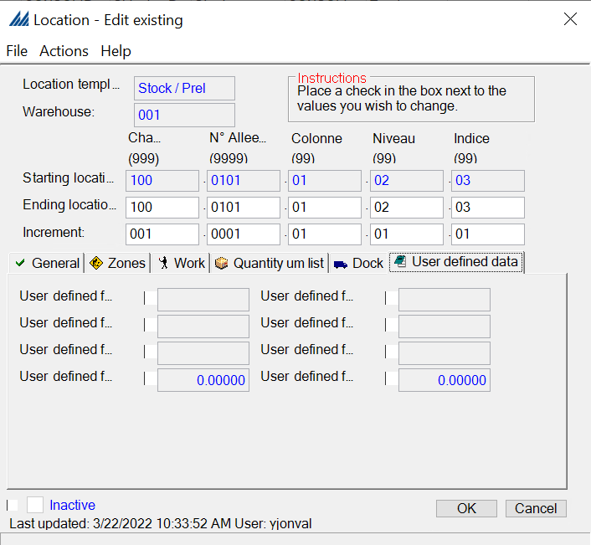

Storage Template
The following sections (1.3.9 – 1.3.16) are related to item configurations. Like the location master, the item master is provided by the customer and downloaded into SCALE at once. Minor updates might follow, but the full download is usually only completed one time. The figure below highlights all the configuration that ties into item configuration.

A storage template identifies all the units of measure linked with an item category; a unit of measure can be shared across multiple storage templates. Default storage template is applied to all items if no other storage template is created or associated to the correct items and UM values.
In our example, we will have UVC, SPCB, PCB and Pallets (PAL) in a unique default template applied to all items of the warehouse.
To define the storage templates, go to the Inventory Control folder. Then head to Storage Template, right click, New and create your storage template as shown in the following figure. Make sure Inactive is unchecked.
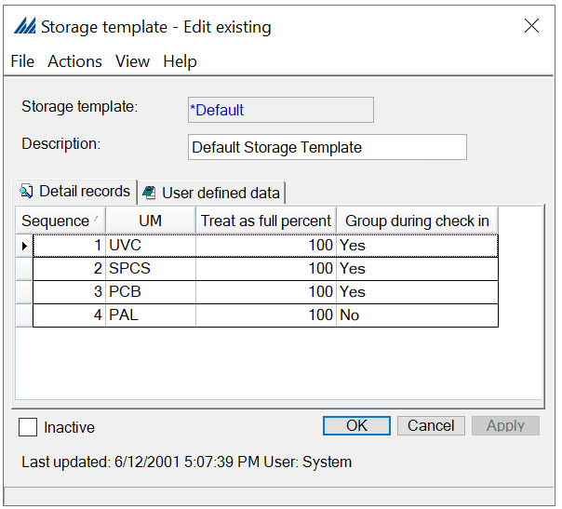

Item Class
This part is optional, but very useful to minimize configuration time for replenishment and item location capacity because item class can be used to group items that have the same unit of measure (linked through the storage template associated), space requirement and container dimensions. To create an item class, go to the Inventory Control folder. Then head to Item Class, right click, New and create your class as shown in the following figure, by assigning the correct storage template. Make sure Inactive is unchecked

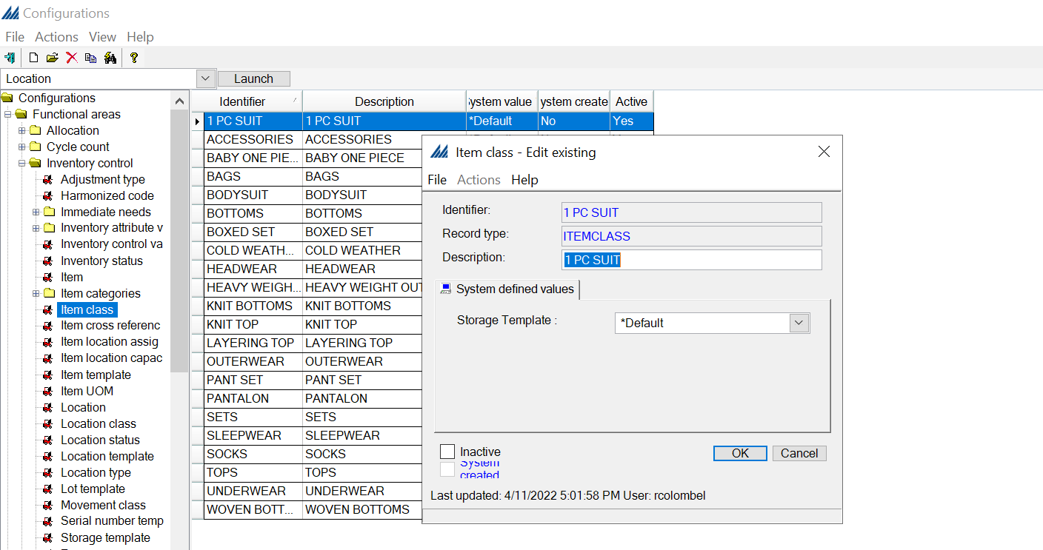

Item
First, we look at the parts related to the item. In this part is defined not only the information directly linked to the item (such as the Item name, size or price).
Now that we have defined the information linked to the users and warehouse, we can start looking at the items and their storage templates.
Here, we will give the example of the creation of an item. Theoretically, all items which go through the warehouse must be created, which implies they must have a reference number. Therefore, for a real warehouse, we need the client’s item information.
First, go to the Item tab, right click, New.

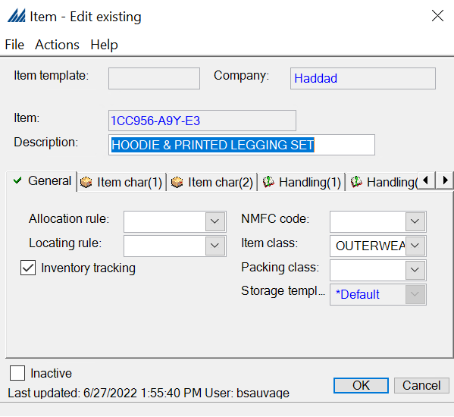
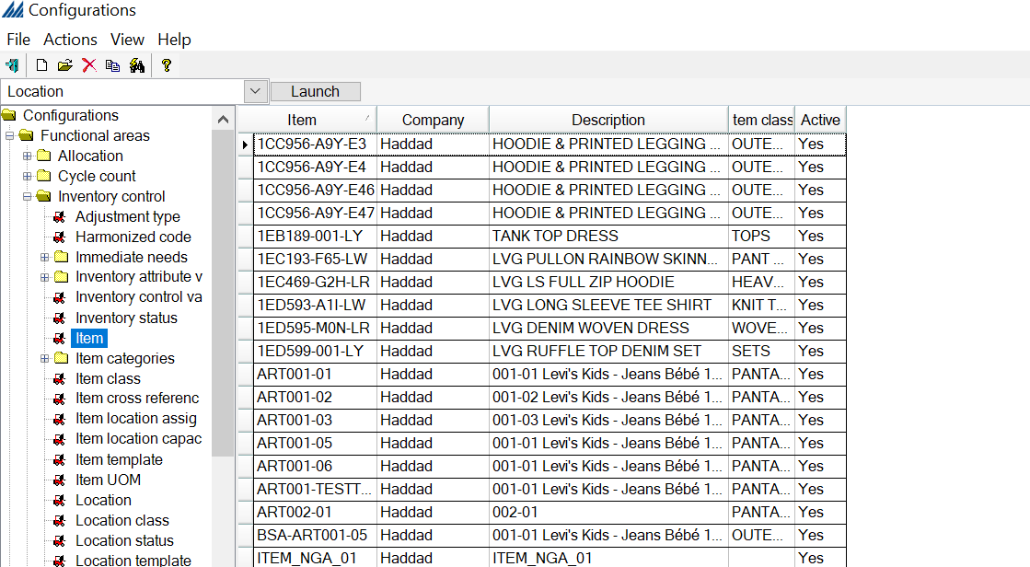
Each item will be configured as a Haddad company.
In the General tab, write the item reference number in Item, give a Description to this item (typically, its name). For example, for a book, the description could be its title. Then, in the Categories tab, you can fill the information according to what has been defined with the client.
Make sure the Inactive box is unchecked.

Item Unit of Measure
Item unit of measure allows you to define, for each item, its main dimensions, weight and quantity by which it is handled (UVC, SPCB, PCB or PAL). All these values are applied to item which can be either identified by its individual reference number (defined in the paragraph Item), or by using an Item Class.
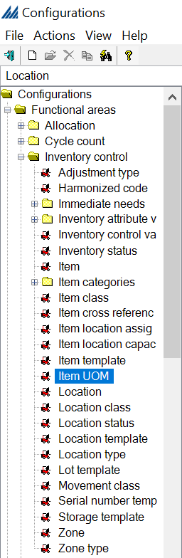
In our case, we defined each Item unit of measure individually. To do so, right click in the blank window, New. In the new window, select either Item class or Item. In our case, we select Item, as we decided to define each item individually. Click on the Research button (the little magnifying glass), write the information related to the item you are looking for (remember to use the % wild card if necessary), and click on the item and then OK. Right click in the blank part of the window, New and write the information you have for that item. An example is provided in the following figure.

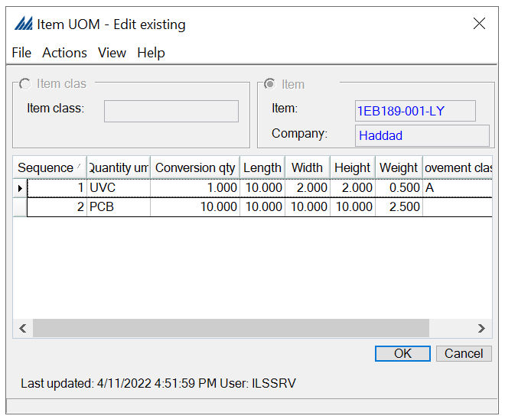
Then click OK. Repeat as many times as needed.
Note: each item can be given several Sequences in a single unit of measure, but you cannot create several units of measure for a single item.

Item Categories
It is possible to identify specific characteristics of the items in the Item categories such as value-added inserts (catalogs, promotional gifts, etc.), special handling instructions, pay terms, or any other user-defined message/label. These information at Item level can be used then in configuration of item filter for warehouse processes (replenishment, allocation, location etc.)
Ten different Item categories are available and can be configured in SCALE to store specific item values.

To configure an item category, go to the Inventory Control folder, then in the Item Categories folder select the preferred Item Category, right click, New and create your category fields as shown in the following figure. Make sure Inactive is unchecked.
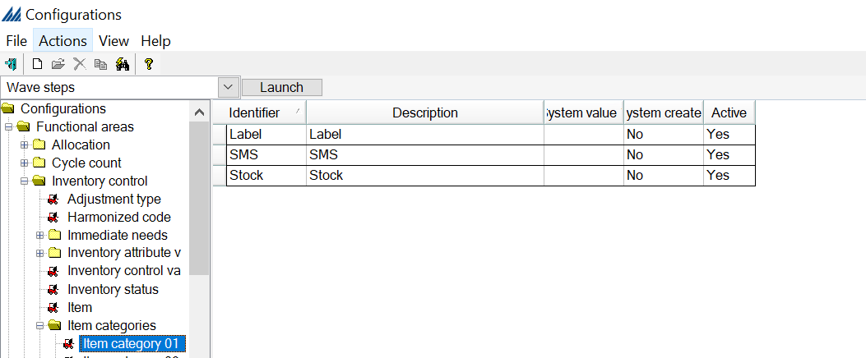
We also need a new category (item category 02) for the Product status:
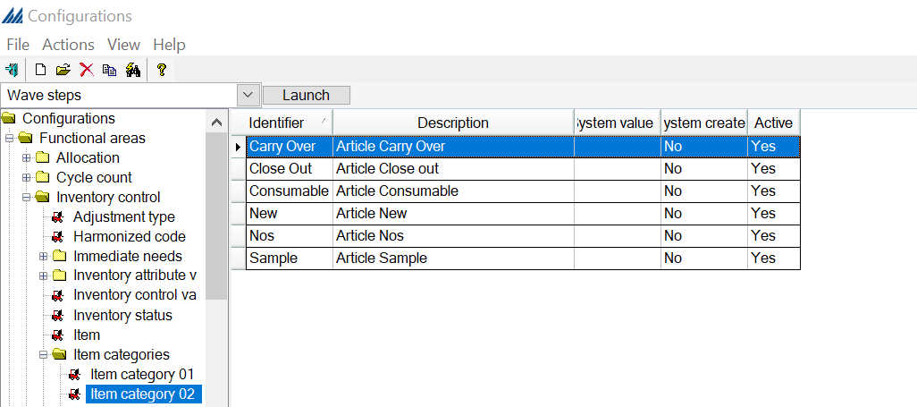
We use item category 03 for the “Famille de produit”

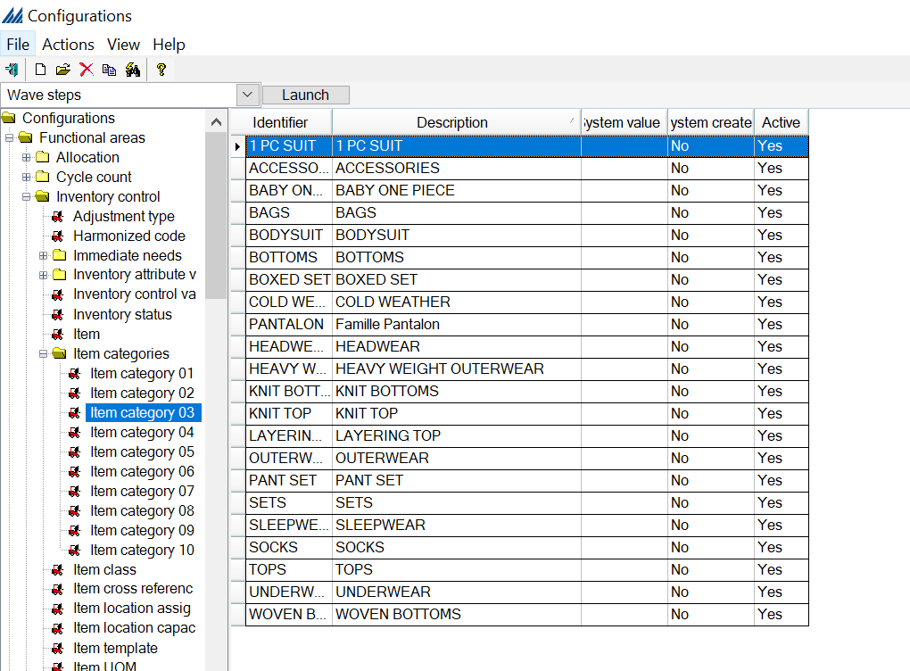
We use item category 04 for the “Sous-Famille de Produit”:
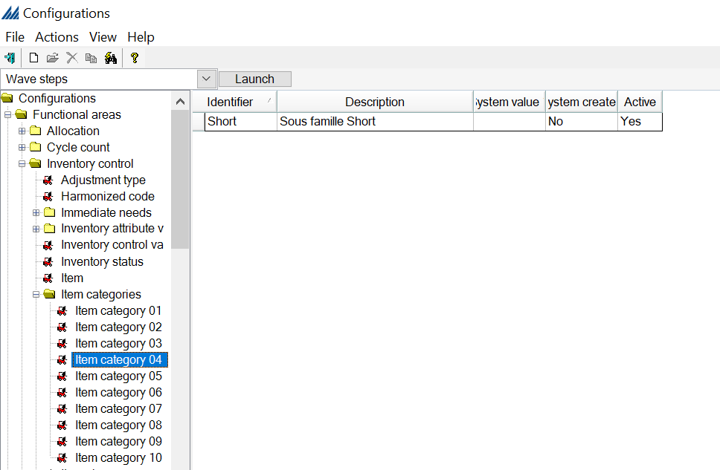

We use item category 05 for the Rotation class:
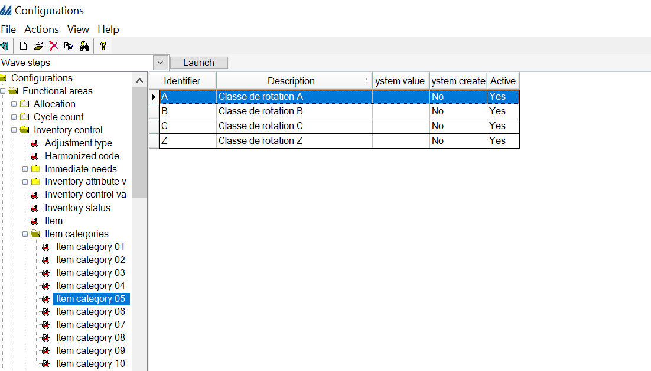
We use item category 06 for the “classe de vente”:
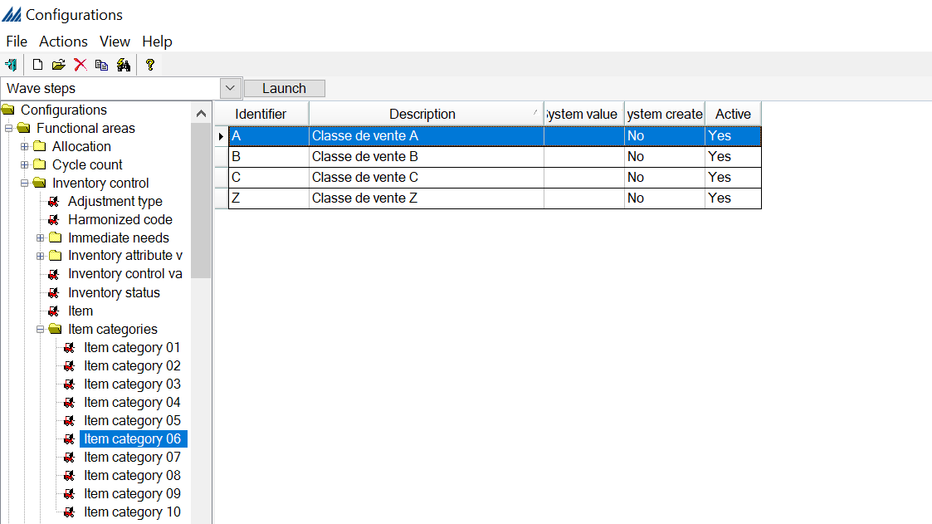

Item Cross Reference
“You can create a cross-reference record for any item defined in the system. Generally, a cross-reference number is established to identify an item's UPC or GS1 number. A user processing an item can use either the item number or the cross-reference number to identify it on an RF device.” (Source: Item cross reference Help window
https://emlb-scale2018.manh.com/Scale/Help/WebHelp/Content/Itemcross.htm)
Go to Item cross reference, right click, New and fill in the fields. The first field should contain the reference number you defined in the paragraph Item, the Company field is relevant only if you have several companies. If it is not the case, it can stay blank. Write the cross-reference item number and quantity unit of measure. Click OK.
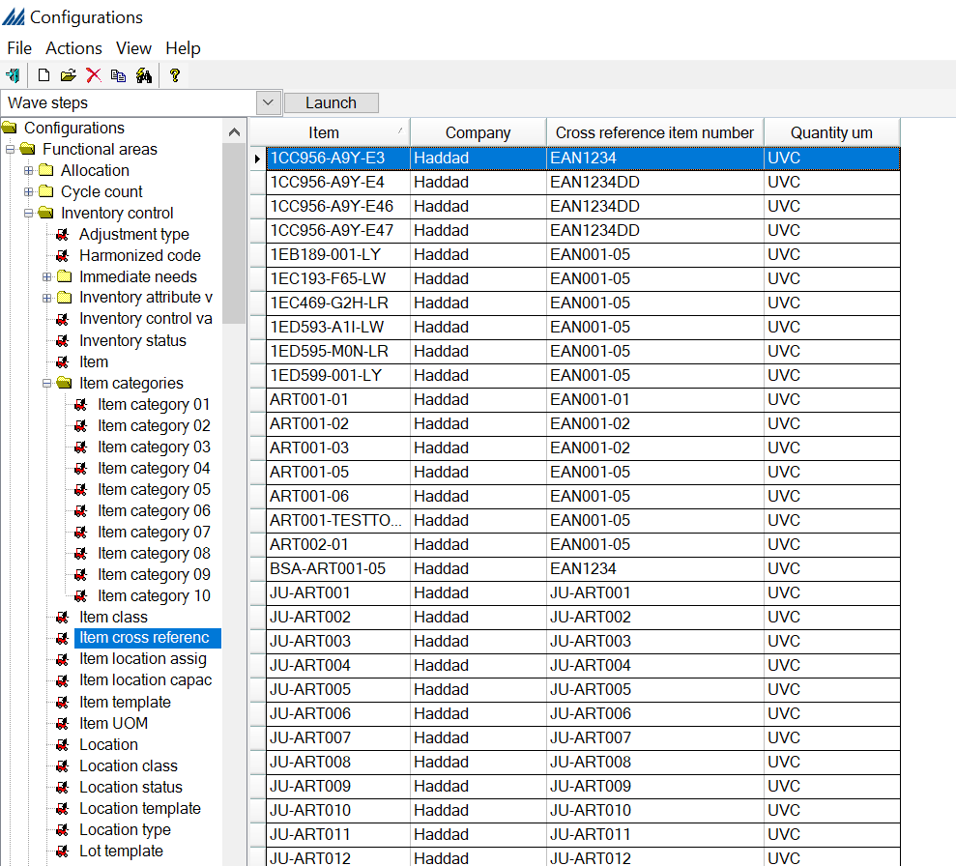

Item Location Capacity
This feature allows us to define, for either a specific Item or for an Item class, the maximum amount of a quantity we can store in a certain location or location type. Maximum capacity is taken into consideration during putaway and replenishment process, in case of manual location override or RF transfer this criterion is disregarded.
In our case we use item location capacity for the item class “Pantalon”.
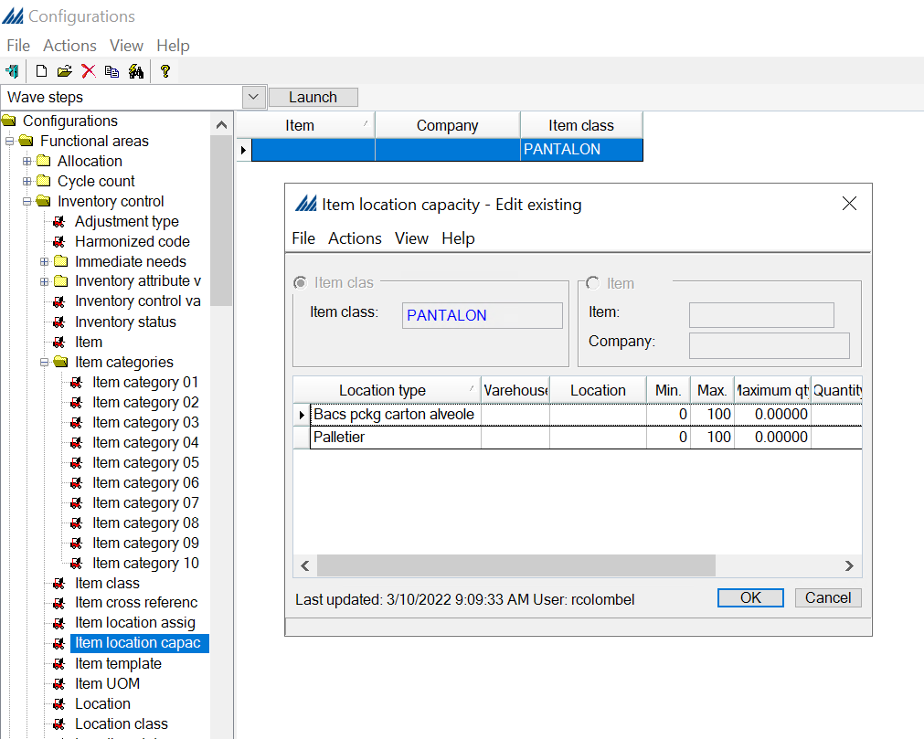

Item Location Assignment
This feature enables you to assign a permanent location to an item. A permanent location identifies the one location where a specific item/unit of measure is stored.
We are not going to use the item location assignment for this warehouse

Inventory Control Values
In this part, we will see how to define inventory adjustments (positive, negative or transfers) with or without work, for every movement across the warehouse that requires work to be completed by a user the following configuration are required:
- Work Group
- Work Type
- Work Profile
- Work Criteria
- Work Creation Master.
Work Special Handling configuration is also usually configured, despite is optional to change default validation fields to confirm work in RF.
These technical values regulates the management of inventory in SCALE, are usually set up by default and should only be reviewed from technical experts.
The description and use for each inventory control value, reported in the figure below, is detailed in AIM.
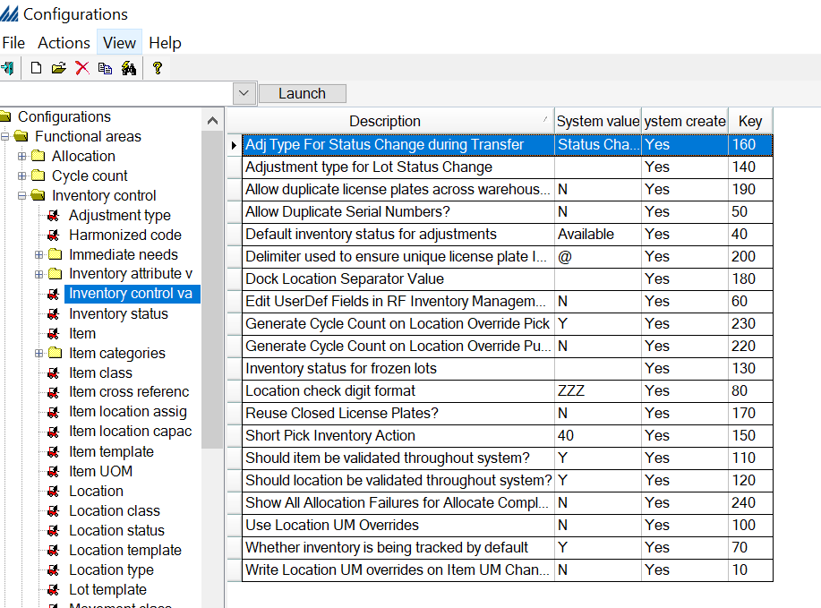

Inventory status
This indicates the status of items in a location. Theoretically, you will only need two statuses: Available and Held (both normally system created), but you might need to modify or add statuses.
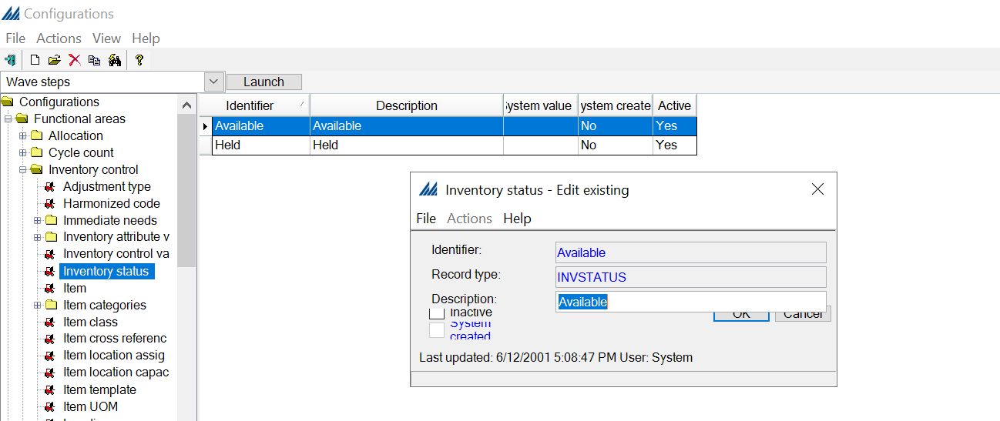

Adjustment type
An adjustment type record defines the parameters for a specific inventory management transaction. When defining an Adjustment type, you will have to choose if you want to check Include In Interface Uploads. Check this checkbox if you want to interface records for this adjustment type back to the ERP.
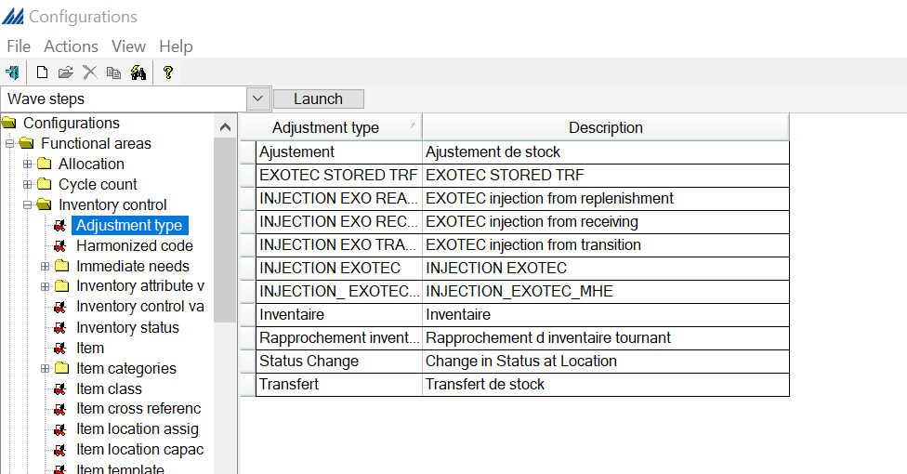

Inventory transfer work criteria and Inventory adjustment work criteria
A work criteria determines the required characteristics of a work request to be eligible for work creation within a defined work master (filter data tab) and what is the required order of work instructions generation and release to the warehouse (order by tab).
Then create work unit checkbox in the Order by tab when the system will break a work instruction group and create a new one.
In our case, we are not going to use this part
  - Receiving
This section will present an overview on how to define the receiving process. This can be divided into three different subsections, which can be seen on the following figure. The first subsection deals with the location and locating rules. Secondly, the right side of the process flow focuses on the work that will be created for the users to perform the receiving operations. Note that disposition codes are not specifically tied to either side of the process.

Putaway location group
A putaway location group allows a series of received items to be putaway as one group. Once you create one putaway group (using either a location range or a locating zone), then all groups will have to be created using either ranges or zones, whichever one you chose for the first group.
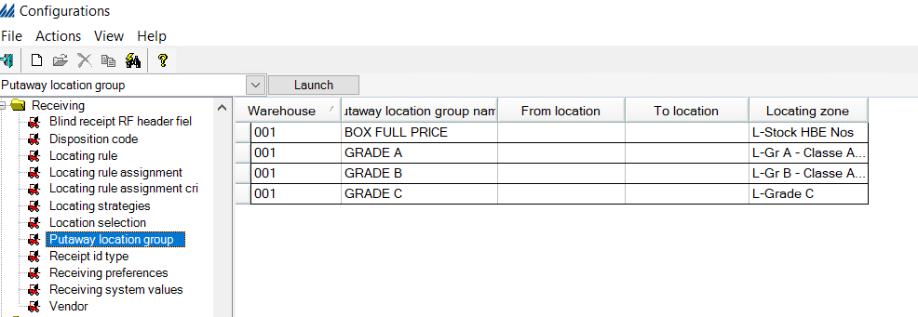
Putaway groups can be used as alternatives to nesting for creating pallets during the check in process. The putaway groups will be stored in the parent LPN field in the inventory records even after putaway completion.

Location selection
There are numerous locations in the warehouse, but not all are positioned in the right zone or have the right characteristics.
Therefore, we use location selection records, along with locating strategy records, to identify the characteristics that a location must have to be considered during locating. It also determines the order that the system will organize the eligible location.
Only the locations in that table which respect criteria are eligible to be considered as locations during locating. This gives us a list of potential locations, but we now have to choose among that list to find the ideal location for our putaway group, this can be achieved by configuring the locating rules as shown in the next section.
The location selection for the 001 warehouse is divided per cellule which will putaway goods according to their ‘GRADE’ and ‘Converted qty um’.
Template_field 2 is composed of the cellule + the alley.
Template_field 4 indicates the level of the shelve.
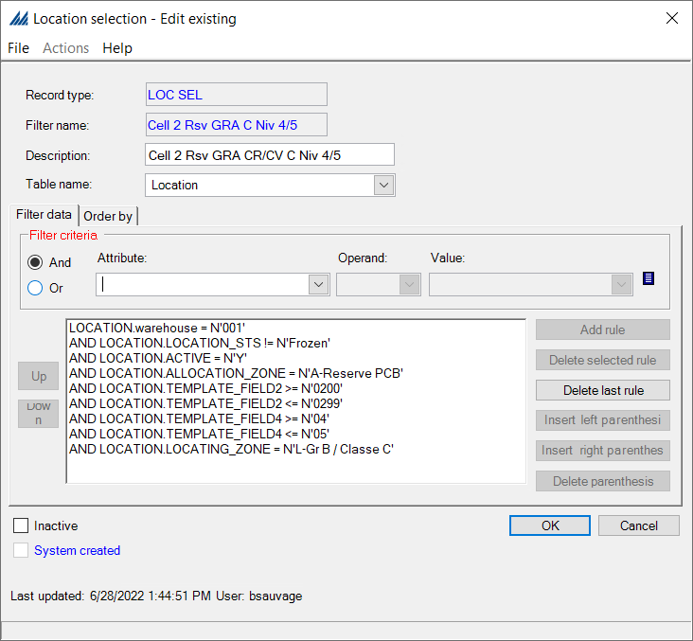
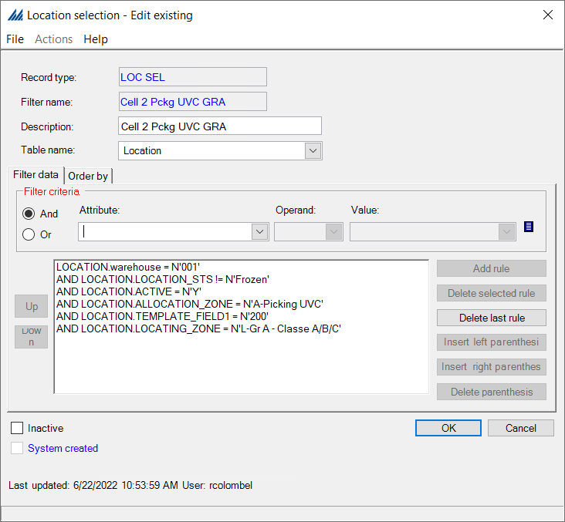

Locating rule
A locating rule identifies the sequence and rule details the system will use to locate a product. A rule detail determines which location the system will assign that product to. Generally, a locating rule includes multiple details, which the system processes in numerical order (10, 20, 30, etc.).

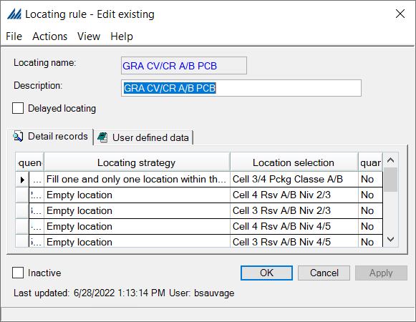

Locating rule assignment criteria
This function indicates how the system will determine when to use a certain Location rule assignment. For example, you could define a criterion to indicate a value such as "less than 20 eaches of Item A." Then, when the system attempts to allocate/locate this quantity, it will use the Location rule assignment that is associated with this criterion to assign a rule to the item. Haddad criteria mainly depends on the converted_qty_um ( if it is UVC or PCB), the rotation class (item_category5), the sale class (item_category6) and the grade (lot).
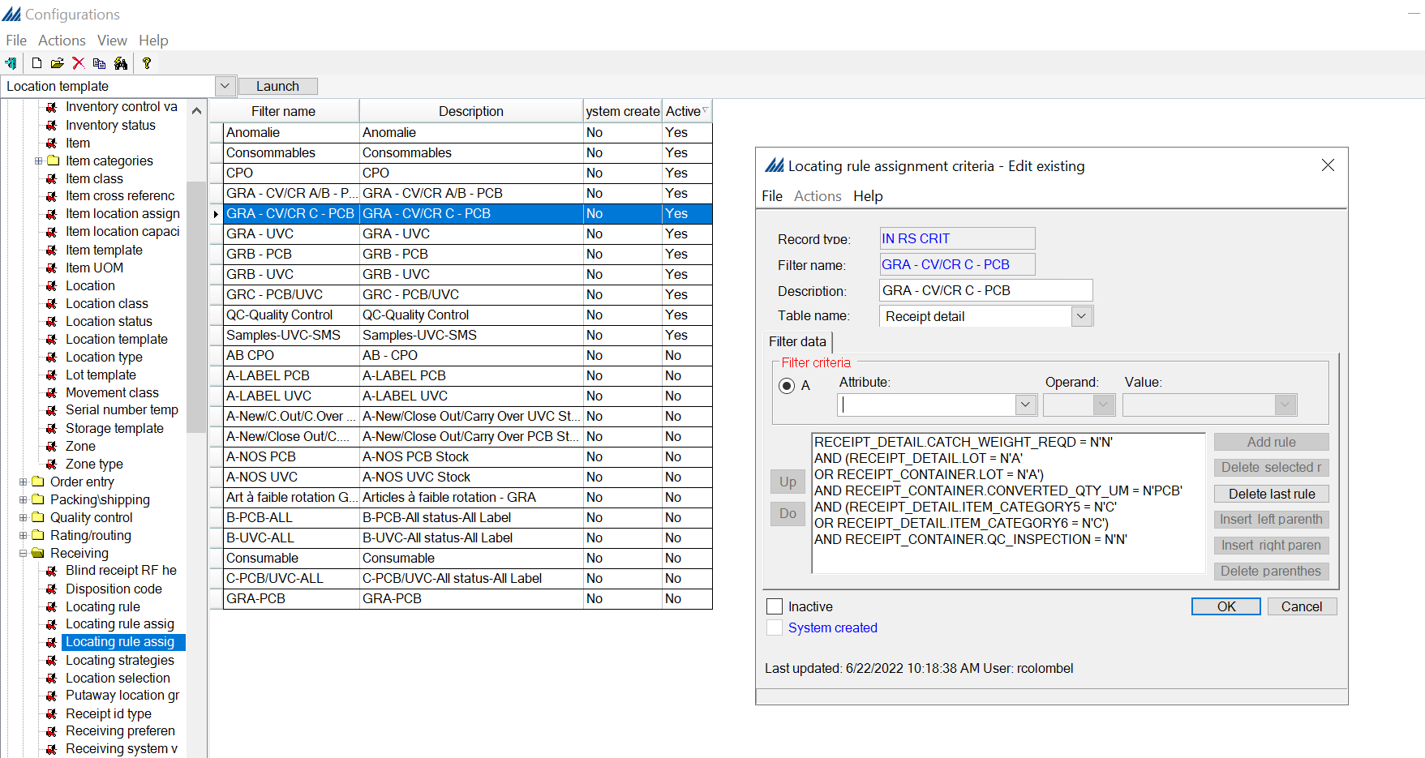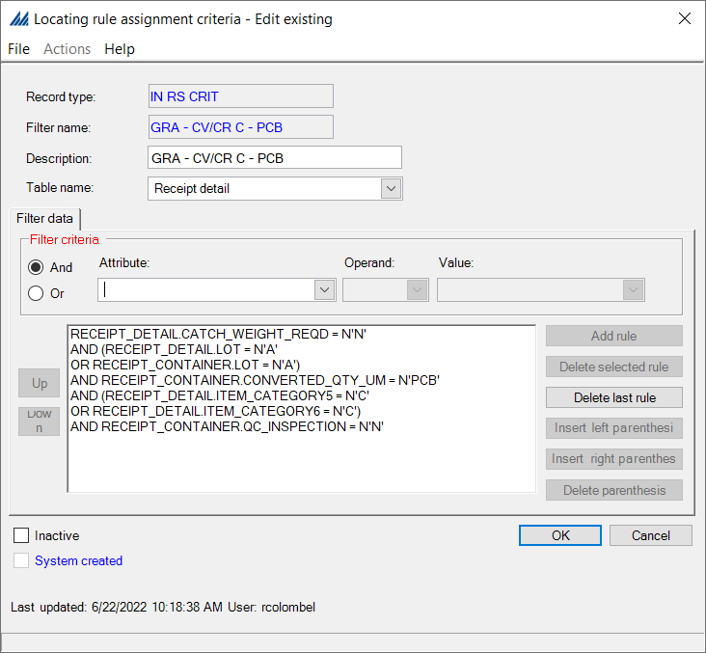

Location rule assignment
Now that you have defined the Locating rule and its related assignment criteria, you must define the order in which it will be assigned, relatively to other Locating rules. To do so, we define priorities: the rule with the smallest priority number will have the most importance.

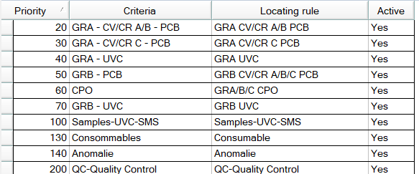
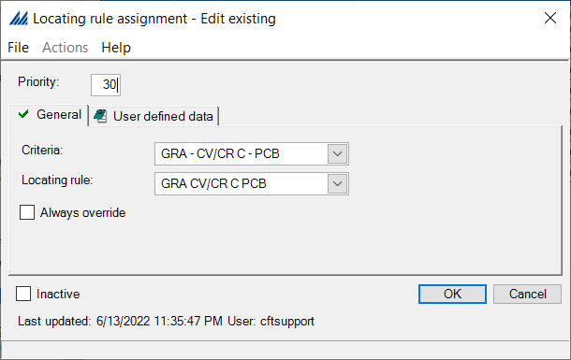
The priority of Locating Rule Assignment can determine a different rule for a receipt in case the rule assignment criteria are not mutually exclusive.

Disposition Code
After defining the information tied to the locating rules and the way they are assigned, we look at the second subsection of Receiving which is the definition of Disposition Codes.
These codes indicate the status of the inventory within a receipt container. For example, the item(s) could be in good condition, damaged, broken, etc. These codes are helpful when processing returns. Also, since these codes are linked to a specific locating rule, the system can locate product differently based on its disposition code. For Haddad we will use disposition code only for the Receiving Preferences ‘RECEP QUALIF’.
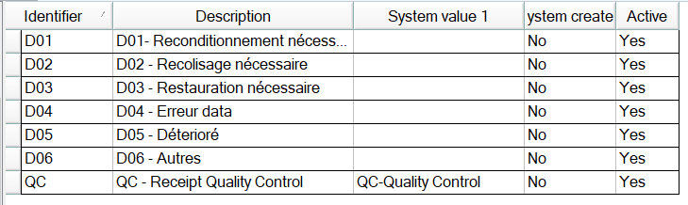

Receipt ID type
A receipt ID type indicates what type of number is used as a receipt's ID. Common receipt ID types include PO number and manufacturer number. Some are already system created.
You will want to define valid receipt ID types based on the interface design and mapping between the host system and SCALE Some are already system created, to satisfy the most common requirements

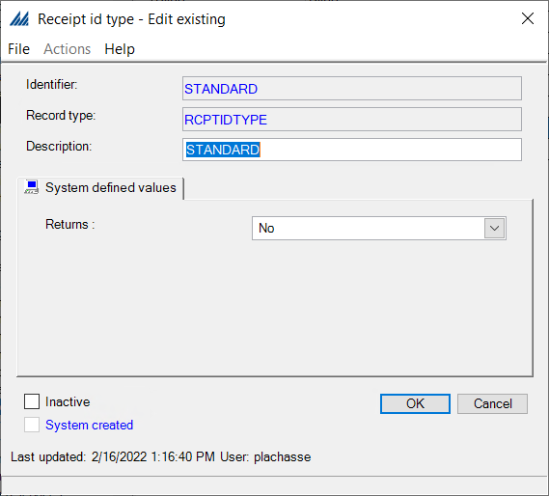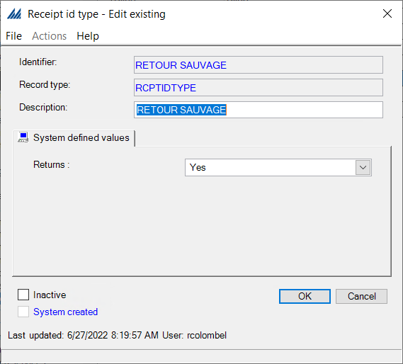

RF receiving check in initiation
This step will not always be necessary for simple configurations, as it is a personalization feature.
In order to associate a RF receiving initiation workflow to a user's receiving preference, the workflow first needs to be defined in the system. This is done by creating an initiation workflow record.
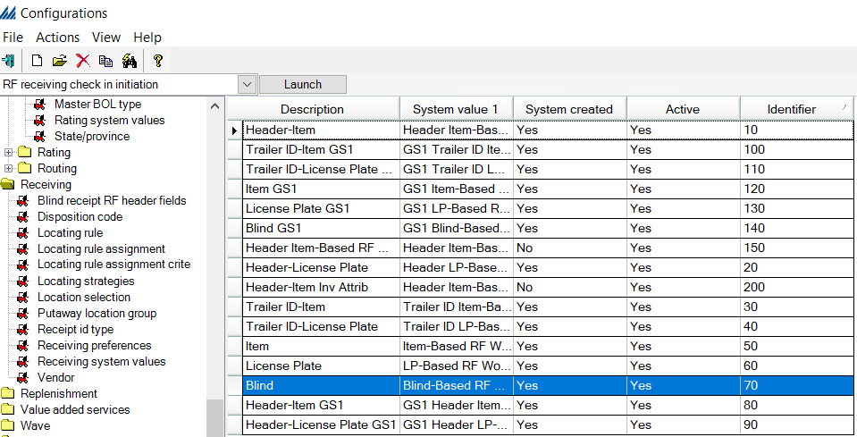
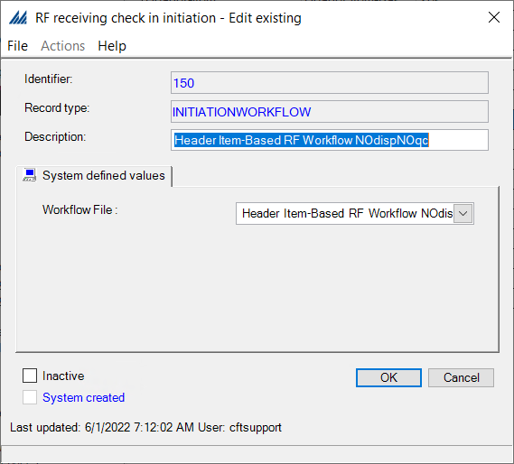

Receiving preferences
This step requires previously defining the Receiving docks, Inventory statuses, Work types (and in some cases Work teams) and eventually an “RF receiving check in initiation“ for non-standard RF workflows. The Assigned users will not need to be checked.
In the General tab you can define the default Receiving Dock, inventory status and work type.
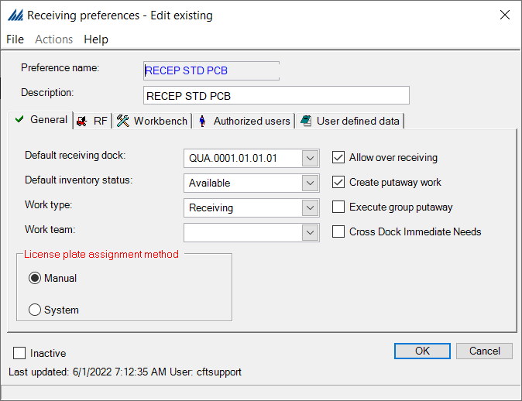
In the RF tab is where the Check-In Initiation Workflow is defined as well as the receiving operation executed during check in using the execution method configuration ( only check in, check in and locate, quick receiving).
To allow putaway group creation the execution method needs to be set as Check In and Locate (Immediate). Alternatively, in this tab you can also set the automatic pallet nesting during check in if desired.
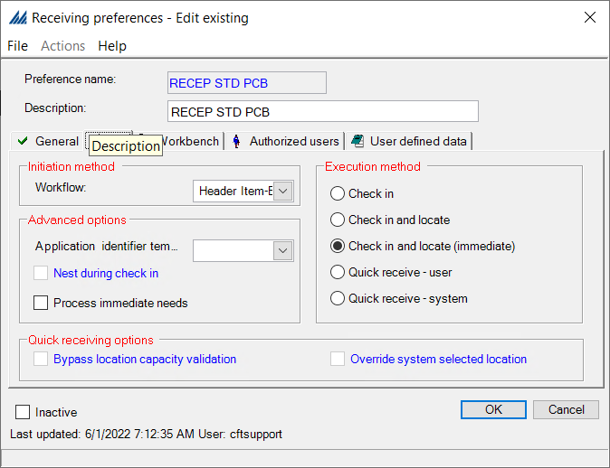
In the Workbench tab we define the container level used during the locating operation and any advanced options we’d like during check in.
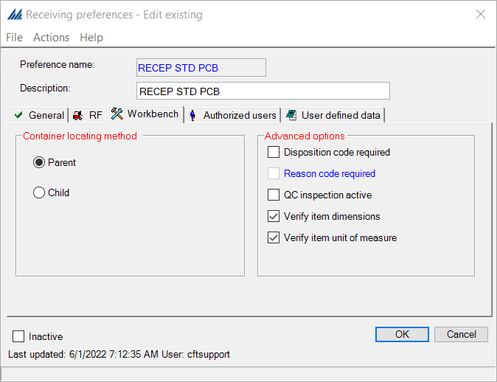
Note that the “*Default” Reception preference is made Inactive.

Work group
Finally, the last subsection of the receiving process configuration is based on work configuration. We start by looking at the Work groups.
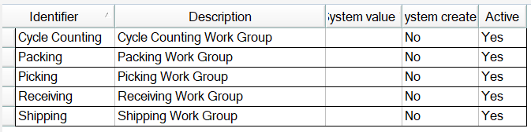
Here, we simply create a Work group associated to Receiving.

Work type
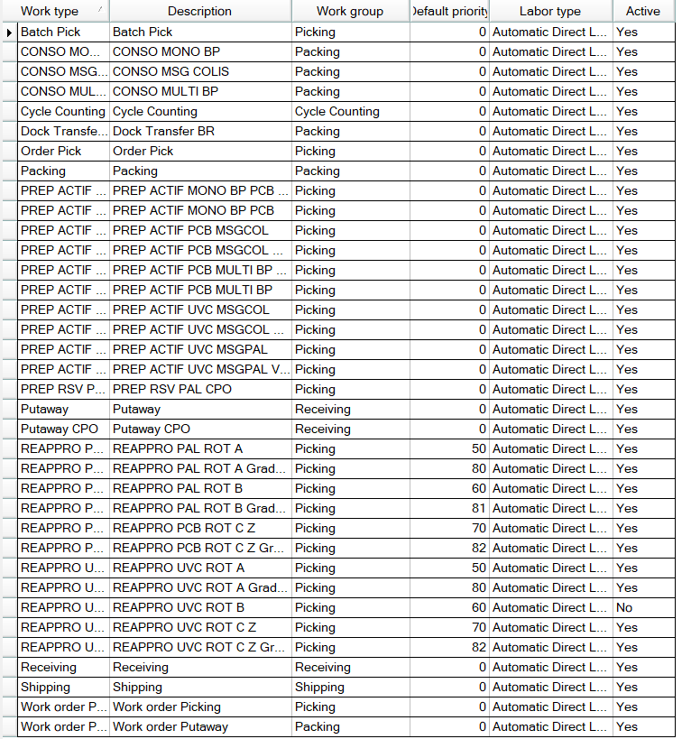
Each work type is tied to a specific work group as you can see above.

Work profile
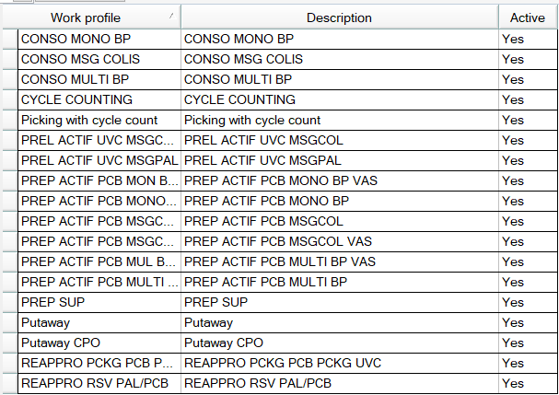
Each work profile is tied to its specific work type and work zones. In the details record, the Work Processing tab defines how the work will be assigned and completed. See below for an example.
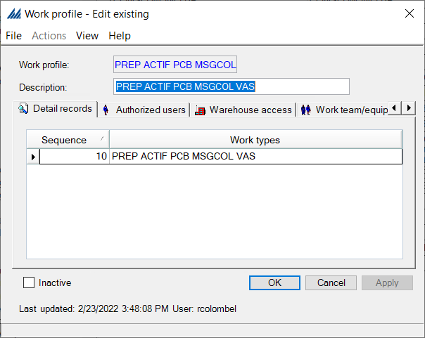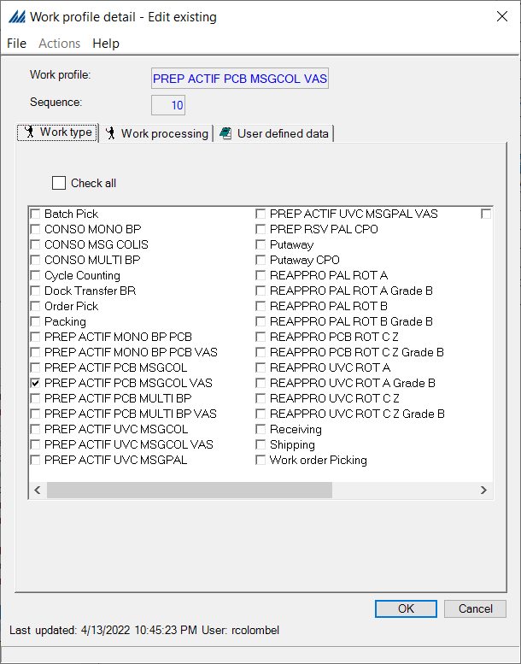

It is important to make sure the warehouse access and authorized users are configured correctly.
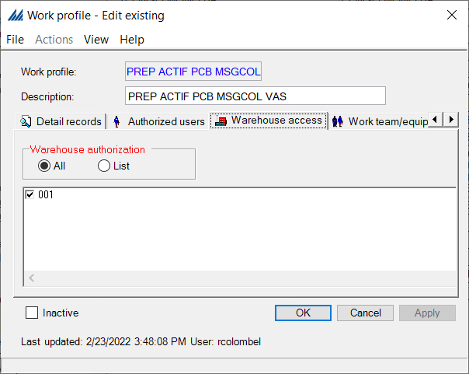
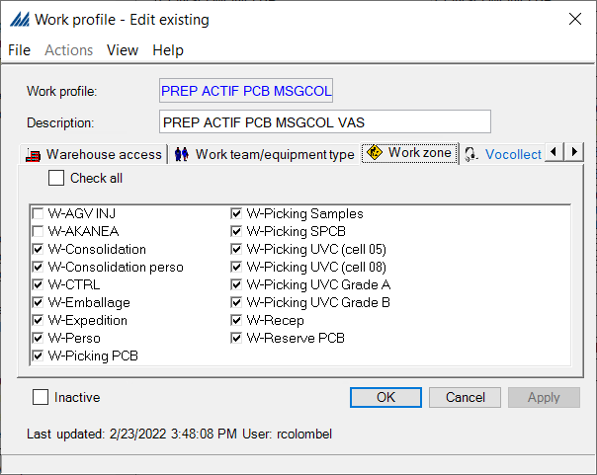

Receipt work criteria
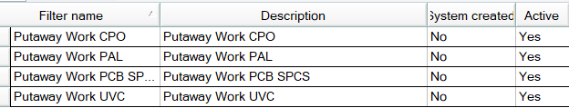
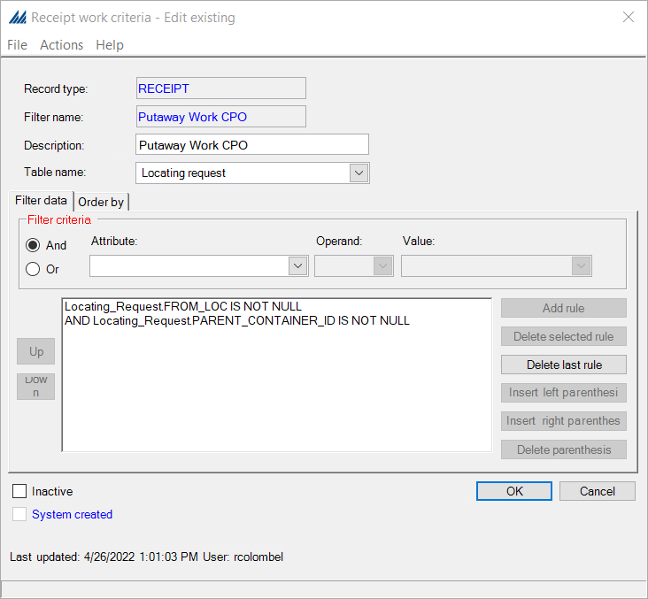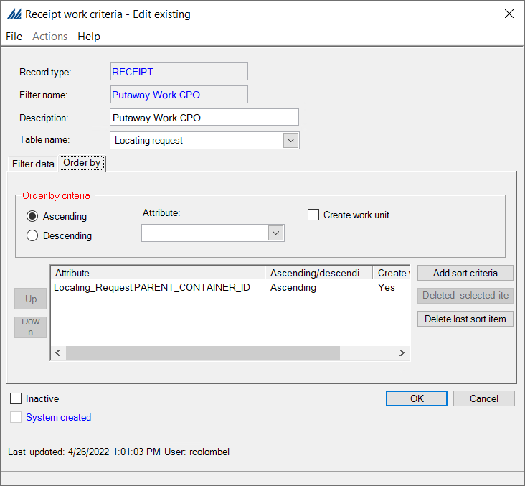

Work Creation master
Work creation masters define how the system generates work, based on the other work creation configurations. This step ties all the previously created information together.
One Work Creation Master needs to be created for each Receipt Work Criteria of the receiving work type.
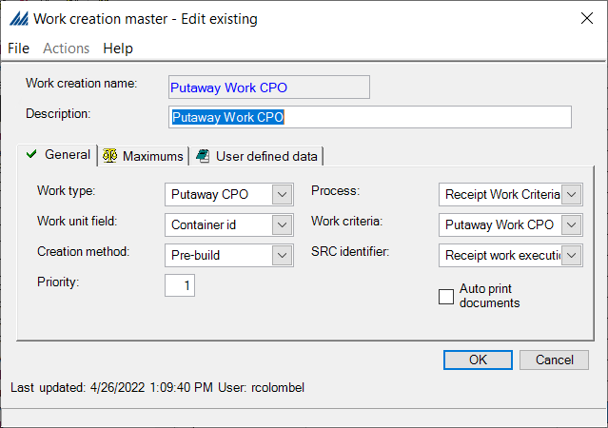

  - Work
This section will deal with the creation and assignment of work according to the operator, the area in the warehouse and the type of item, for example. We will follow the next steps for configuration.
- Work System Values
- Then the same steps will be repeated for the Receipt, Shipment Allocation, Shipment Container, Inventory Transfer and Cycle Count:
  - Work Type
  - Work Criteria
  - Work Creation Master
  - Work Profile
  - Work Special Handling

Work system values
These values are usually all system created. They accommodate specific events that may occur during the work process. When the system encounters an unexpected experience during work creation or work execution, it will display the appropriate system defined values. You should not need to create unique values on this window.
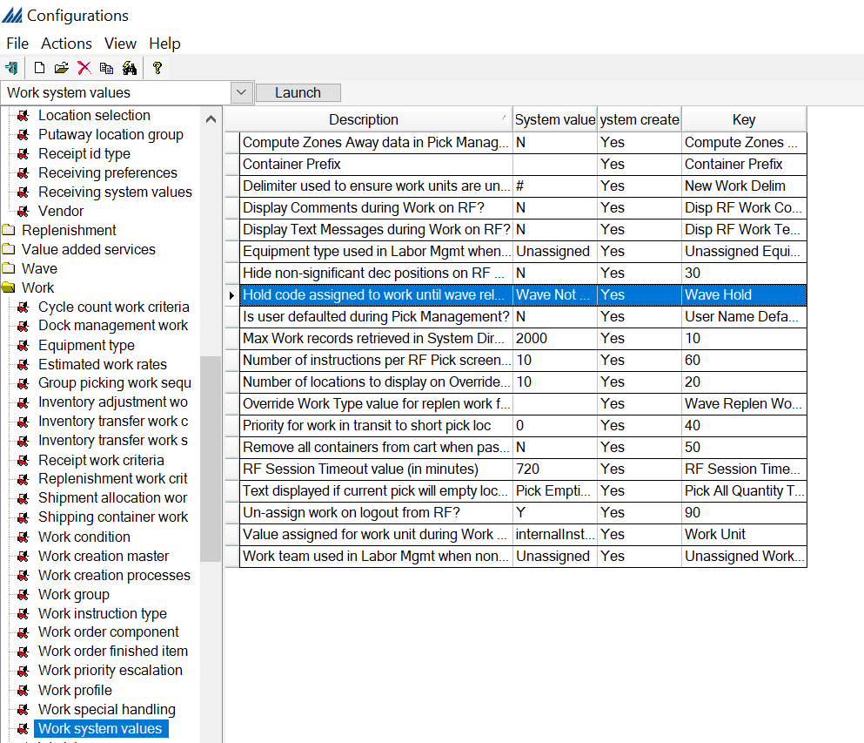

Work type
Please refer to section 1.4.11 for details on defining the work type.

Work criteria
Work criteria are independently created. The following work criteria must be configured and are ordered by priority:
  - Receipt Work Criteria – Please refer to section 1.4.13 for details on this configuration.
  - Dock Management Work Criteria:
  - 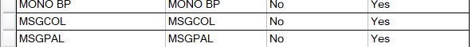
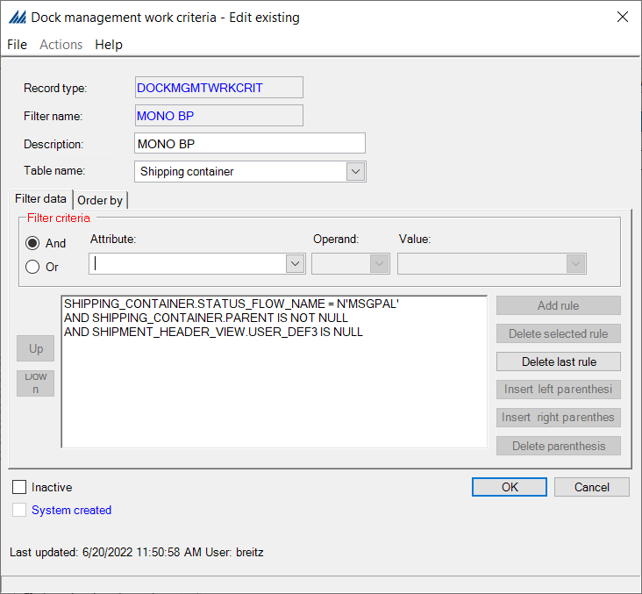

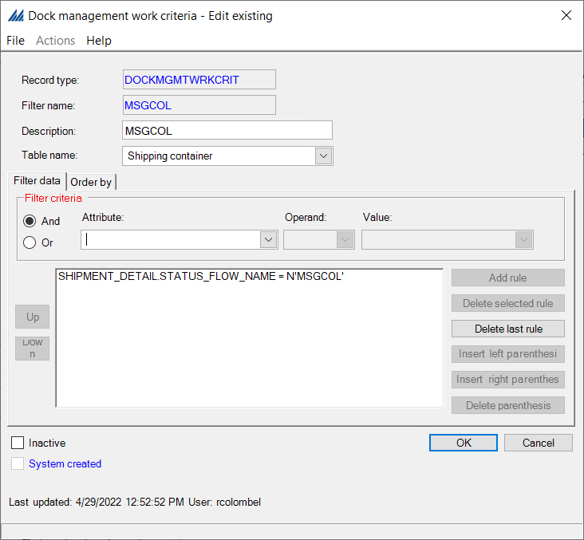
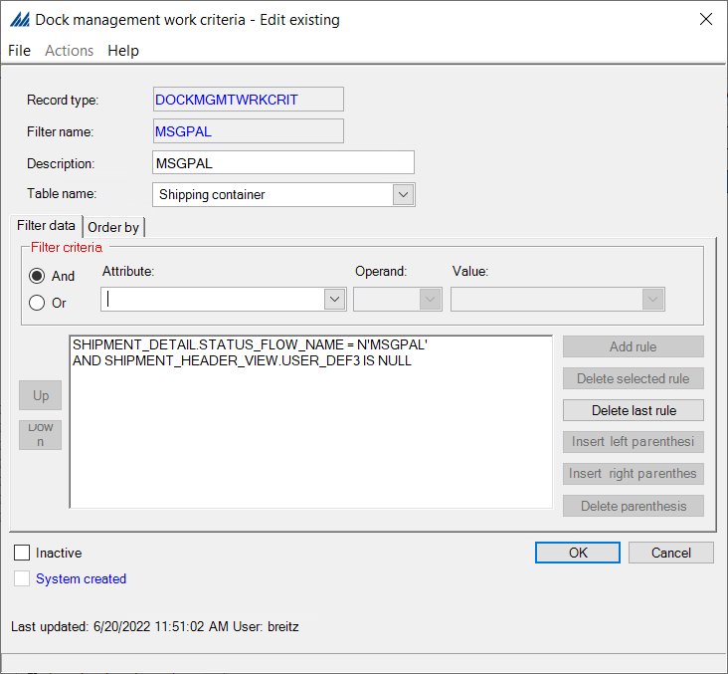

  - Shipment Allocation Work Criteria:
  - Shipment Container Work Criteria
  - Replenishment Work Criteria
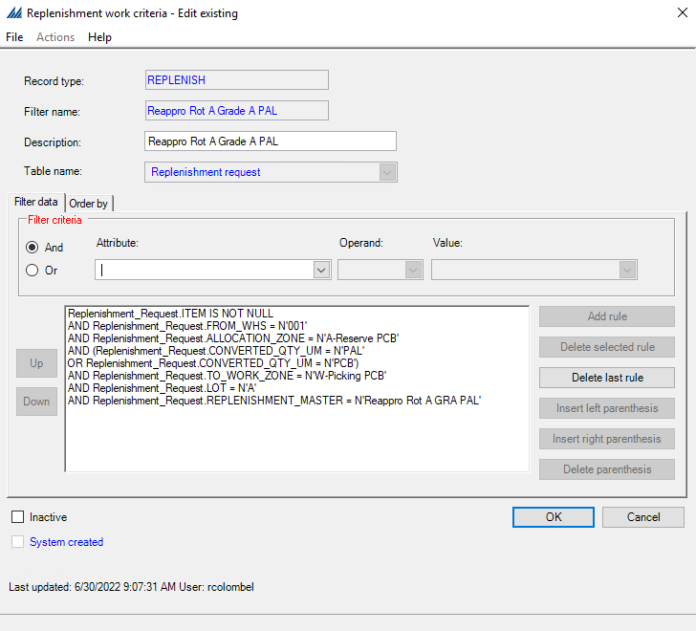
  - Inventory Transfer Work Criteria
  - Cycle Count Work Criteria
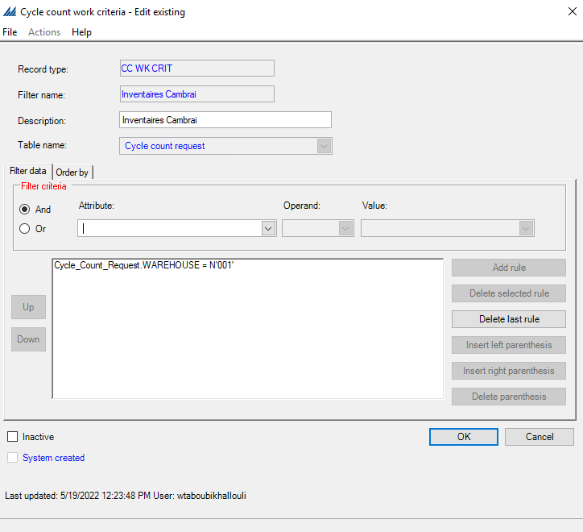
  - Work criteria windows manage the following activities:
    - they determine which work requests are selected for work processing
    - they create a work unit
    - and they determine the order in which work instructions are generated and released to the warehouse floor

Work creation master
  - Please refer to section 1.4.14 for details on the work creation master for receiving.
  - For the Picking:
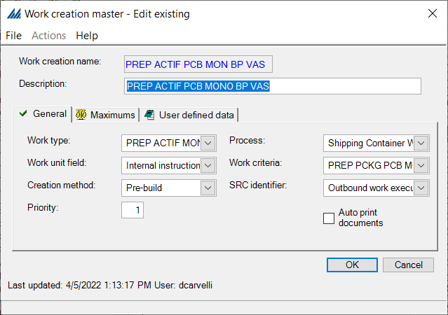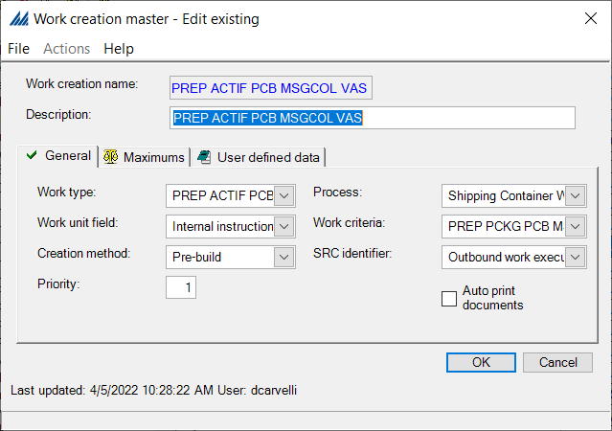

  - For Dock Transfer:

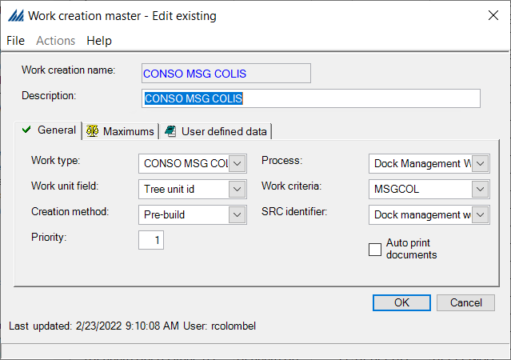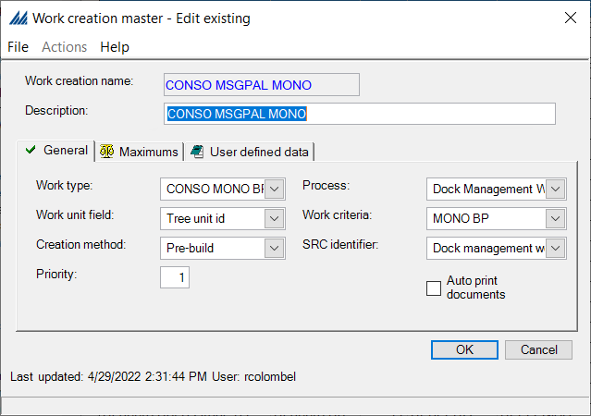

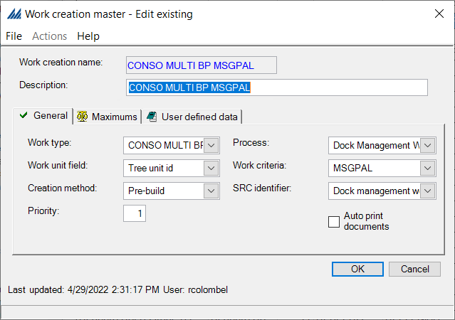

Work profile
Please review section 1.4.12 for details on creation of work profiles.
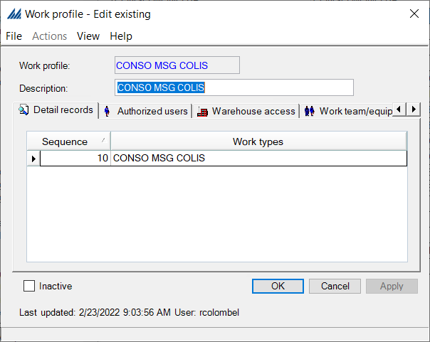
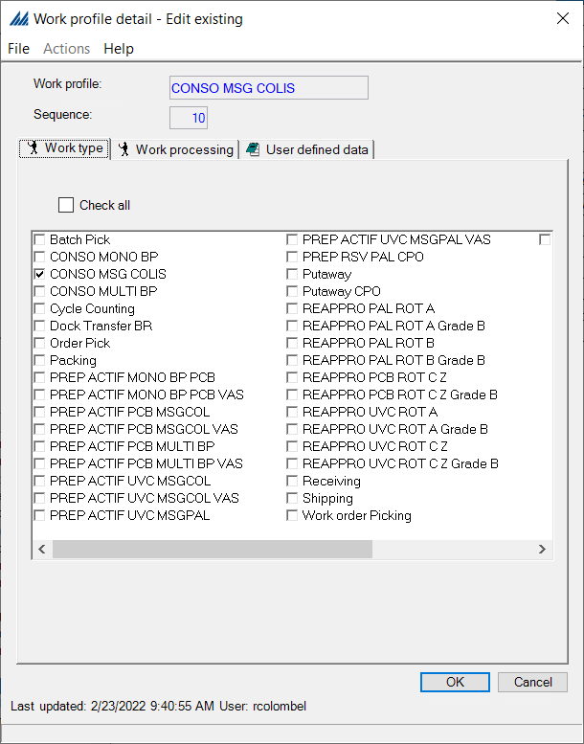
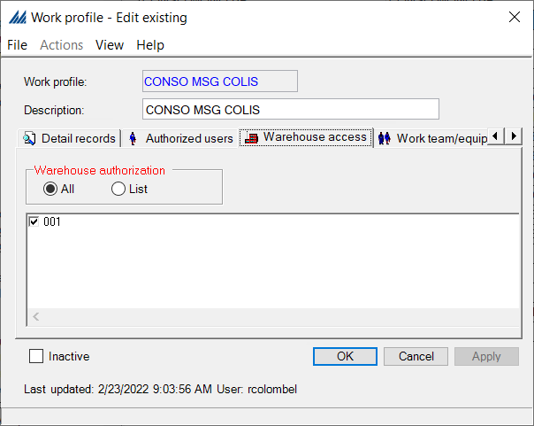
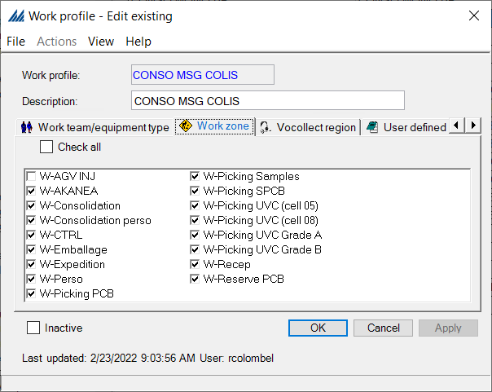

Work special handling
A special handling constraint record defines processing validations or restrictions required for a specific group of work instructions. You can use them to increase security for expensive product, support a customer account's requests, provide guidelines for new employees, and minimize errors occurring in specific warehouse zones.
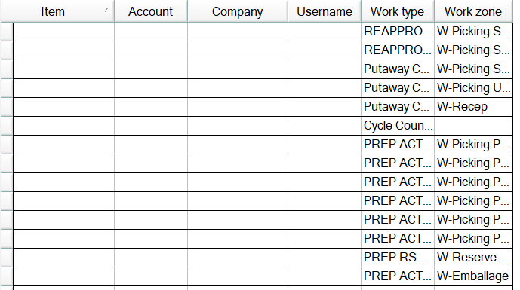

- If we continue with our previously started example, we want to associate our Work special handling to a specific type of Work.

You have now set up the Work configuration for one part of Receiving, you must now repeat this entire process for the rest of Receiving, Shipment Allocation, Shipment Container, Replenishment, Inventory Transfer and Cycle Count.
For Picking:
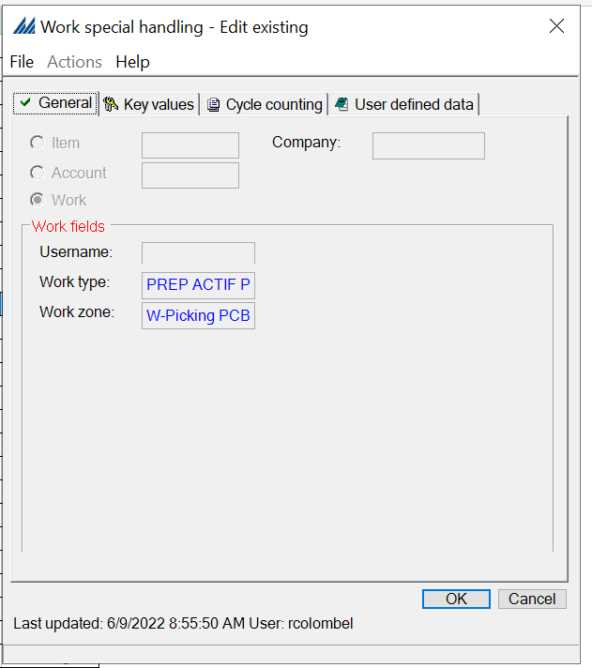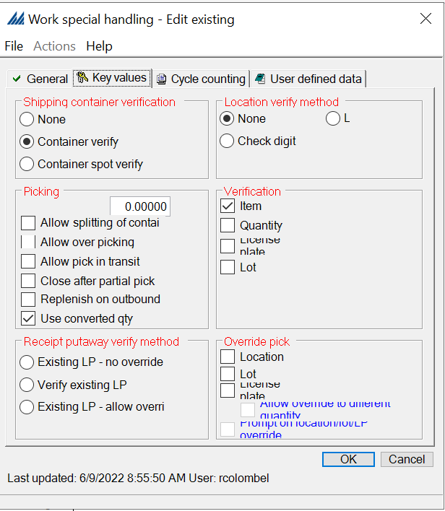

  - Outbound
We will now see how to configure the Outbound process. It can be split into different subsections:
- Dock management and carrier
- Customer and preferences
- Consolidation

Outbound Status Action

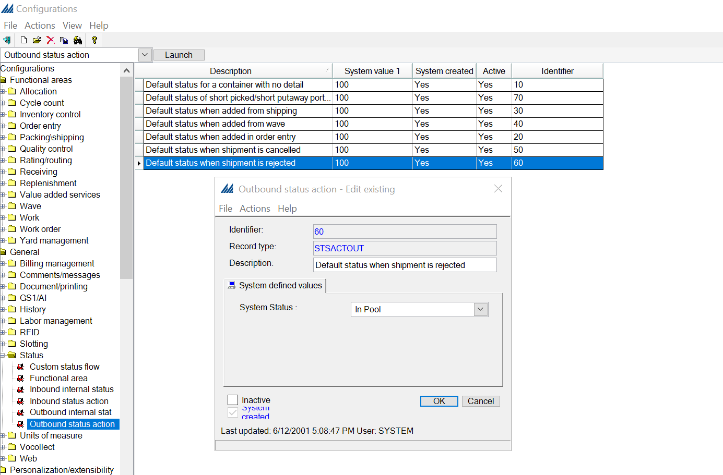

Functional area
This window usually has two system created functional areas: Inbound and Outbound. Within each of these areas is enclosed a status flow, made of numerous statuses.
The system defined statuses accommodate all processes generally completed for a functional area. They are provided to minimize setup time and to support the default status flow, so theoretically you should not need to add any new ones.
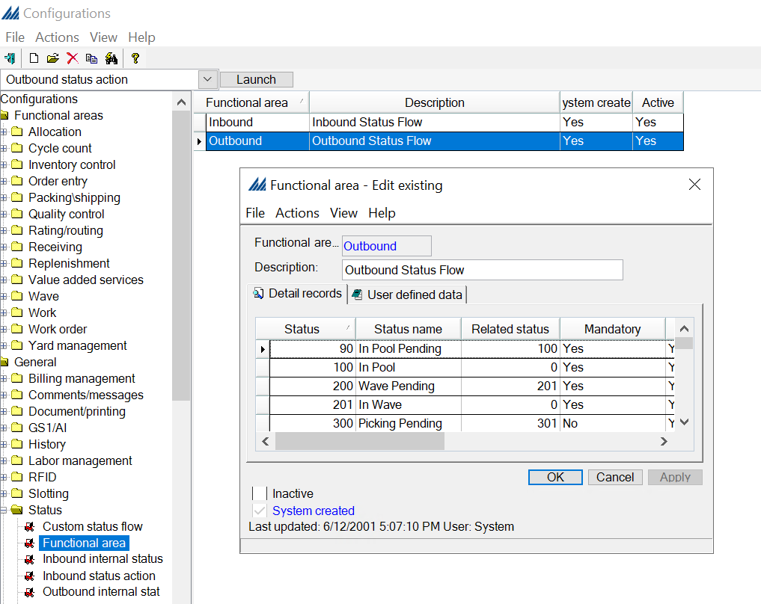
You should review this step and add a status in case of special requirements either in inbound or outbound flow common for all processes. The status to be added need to be defined in the Outbound Internal Status Name Configuration.
In case a special process needs a particular flow, a custom status flow needs to be defined as explained in the following chapter.

Custom status flow
A custom status flow accommodates the processing needs of special or unique items. Custom flows are defined per functional area. They cannot be shared across functional areas: in other words, a custom flow associated with the outbound functional area cannot also be used by the inbound functional area.
In our case, 2 custom flows have been defined to manage the outbound flow: MSGCOL (Messagerie colis) and MSGPAL (Messagerie palette) as shown in the image below:
- MSGCOL (Messagerie colis) for Shipment that have less or equal than 3 CASES:
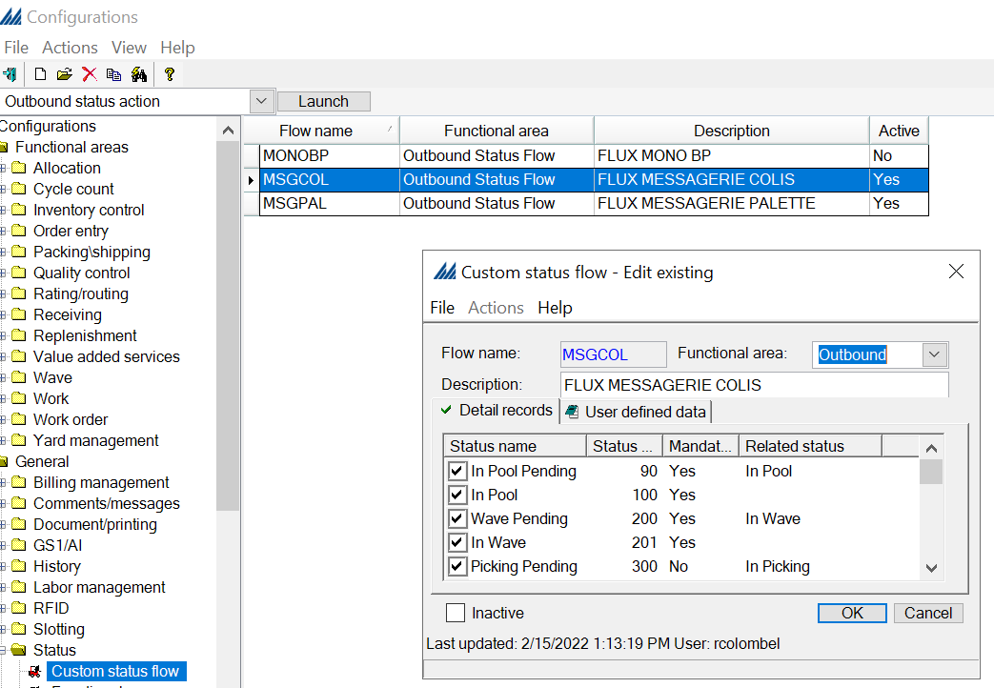

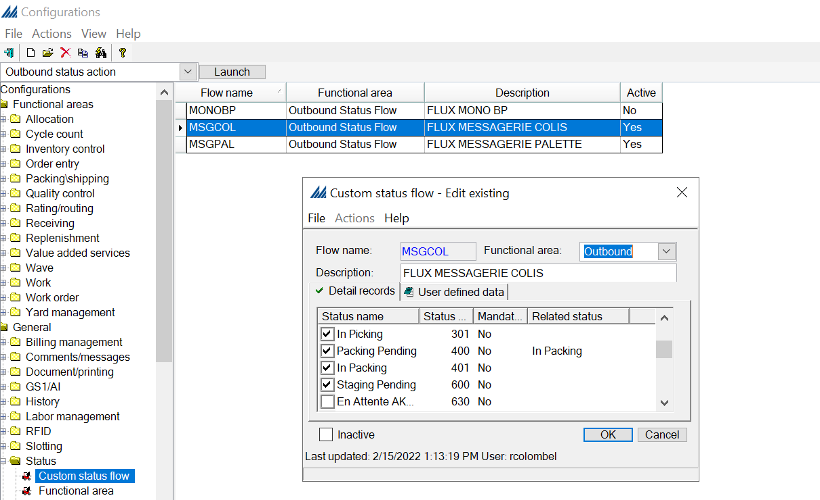

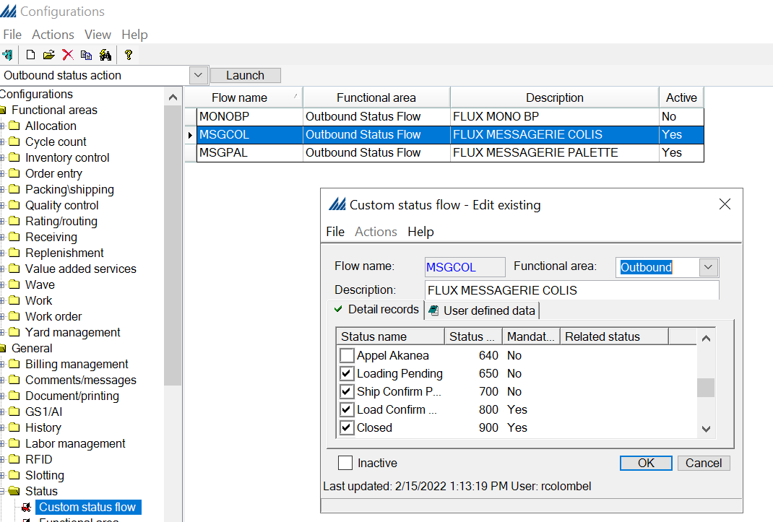

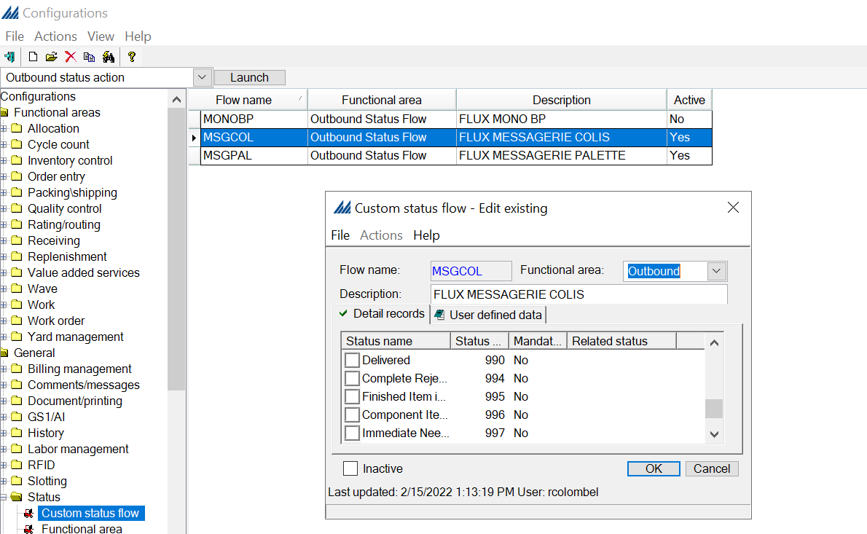

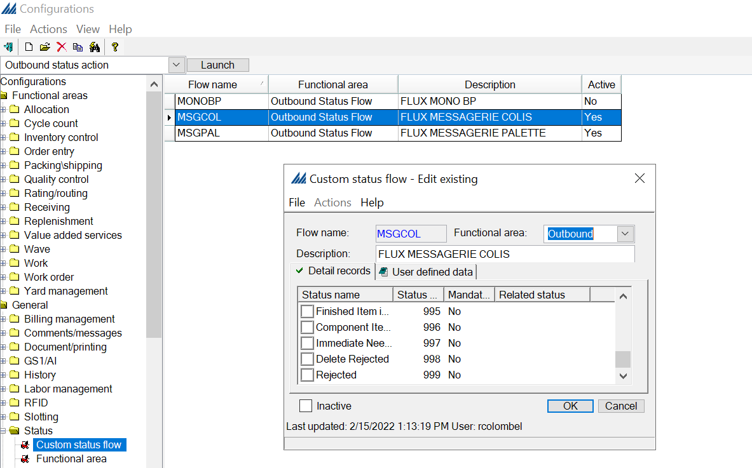
- MSGPAL (Messagerie palette) for Shipment that have more than 3 CASES:
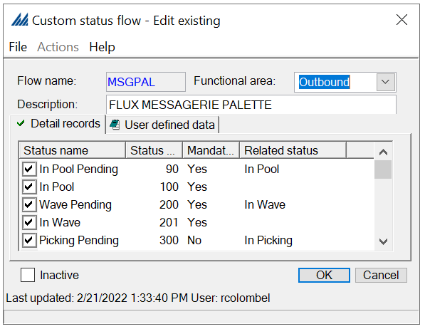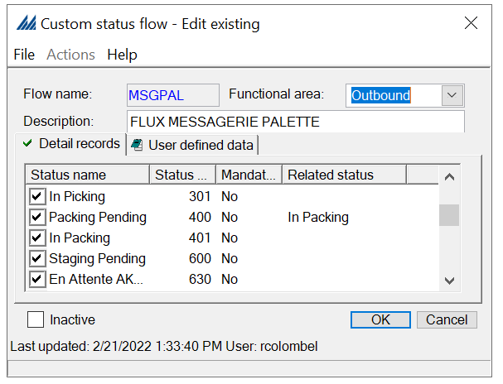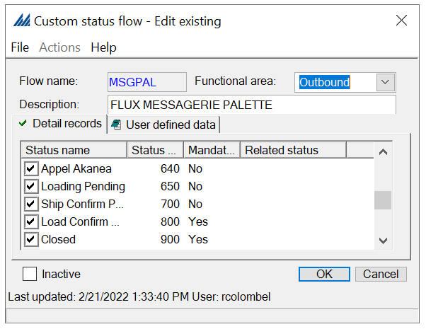
The custom status flow needs to be linked to a specific wave flow in the dedicated Override step, please refer to paragraph Override Data in the wave process description.

Carrier
This window contains all the information regarding Carriers. However, you will usually only fill in the General, Address and eventually the Dock tabs.
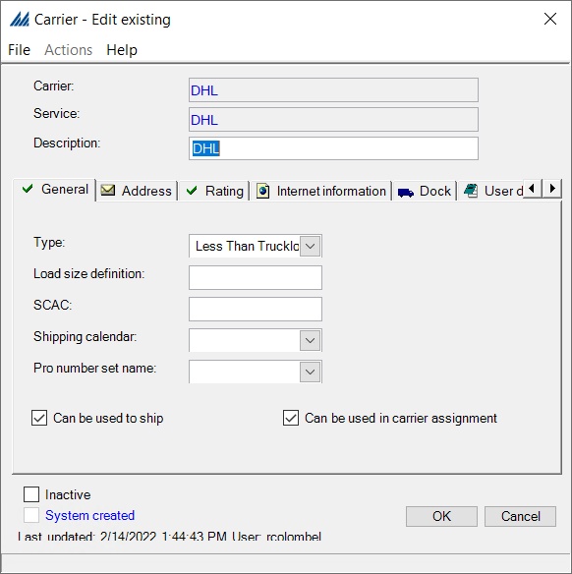
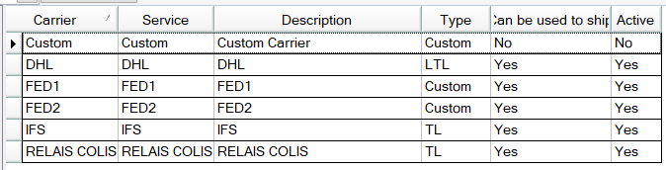
SCALE has many more features for carrier management and evaluation in the folder Rating/routing, but we will not detail their use here.
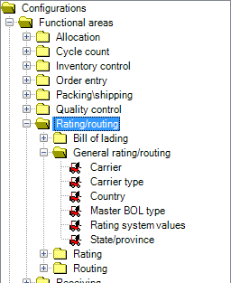

Dock area management carrier assignment
The system uses these records to help ensure that all a shipment's containers/details are assigned to the carrier's appropriate dock location area (staging or dock door). The system references this record when using the dock location selection strategy.
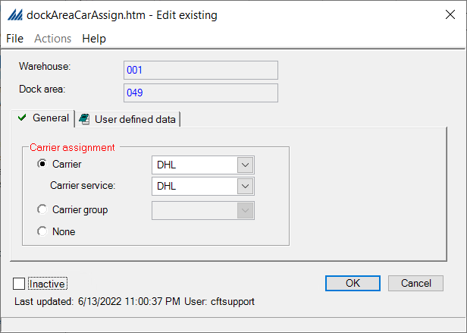
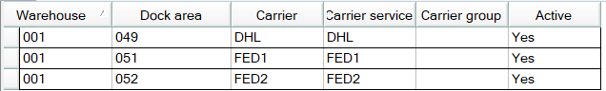
Note that these records are optional, and if they do not exist, the dock assignment process will assign the default dock locations as defined on the dock management flow header or detail.

Dock management flow
A dock management flow record includes information which determines how the system will assign a dock location destination to a shipment line/container, and if the line/container is eligible for assignment. Each flow record is made up of a series of detail records that identify what selection and assignment strategies that the system should use when a quantity hits a certain status in your status flow.
At minimum it is required to add a detail line for each of the subclass of the shipping dock location in use for the warehouse (Packing, Staging, Dock Door), in case a custom status flow is used it can be linked to the required dock management in this configuration.
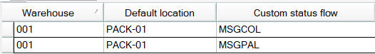
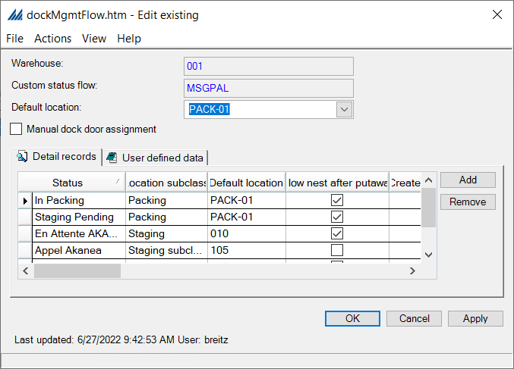
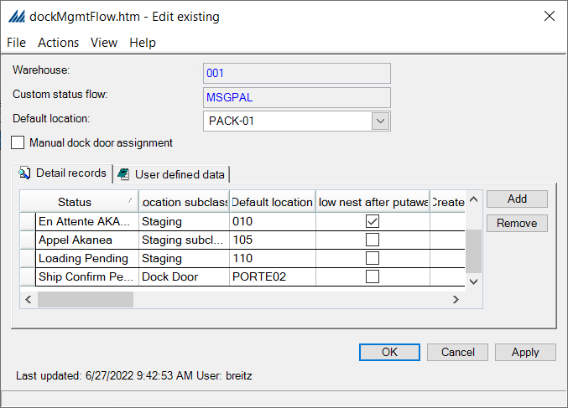
For the status “Appel Akanea” a specific location subclass has been created in “Generic config header”. We have created a second staging location subclass to let the system differentiates two staging locations with two different statuses.
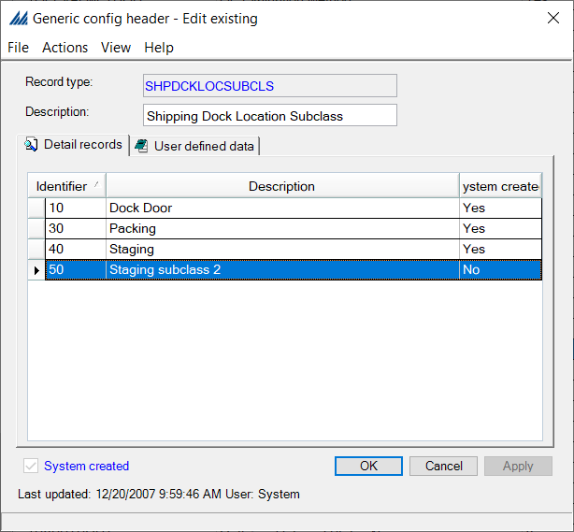

Dock area anchor criteria
This window defines which dock areas are assignable to shipping containers when they are being anchored. The system will add all dock areas to the eligible list that match the user defined filter criteria. Later, the dock location assignment strategy will choose the container's exact destination dock location.
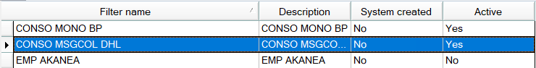
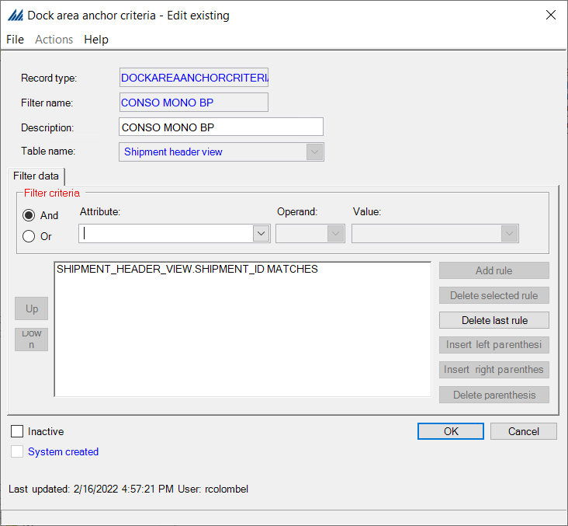
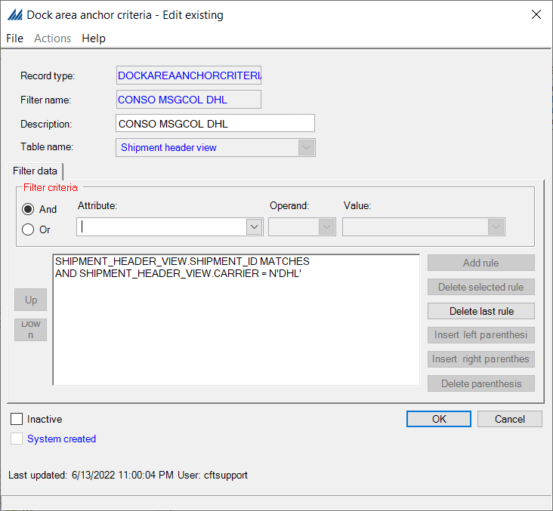

Packing preferences
A packing preference record allows you to manage how a user or group of users will pack shipments. You can create specific preference records for employees with unique packing processing needs.
Packing tab is dedicated to set up behavior of SCALE for the Packing stations, no changes required in case of Pick&Pack process.
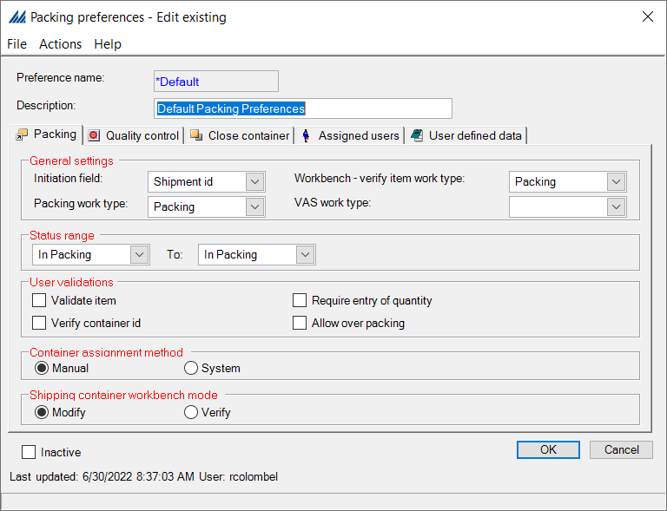
Quality control tab is dedicated to set up behavior of SCALE for the quality workbench QC is performed on outbound.

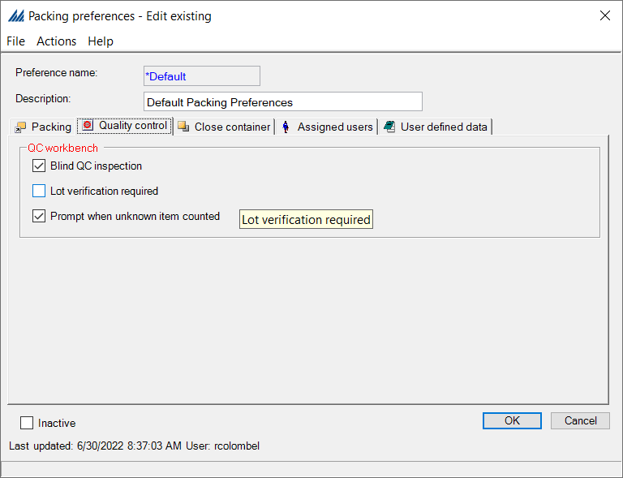
Close Container tab is dedicated to control behavior of SCALE for the close container operation both in UI and RF.
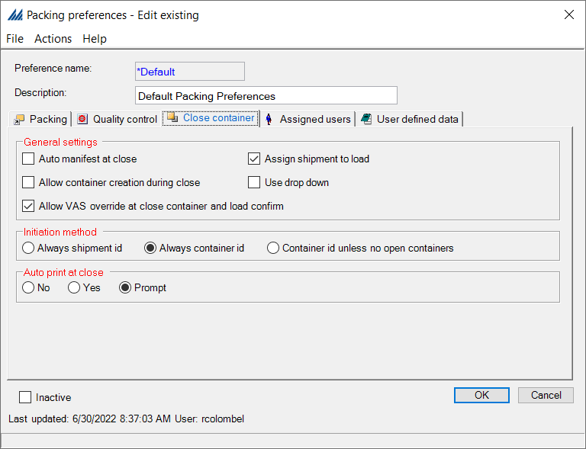

Shipping preferences
A shipping preference record allows you to manage how a user or group of users will ship confirm orders. The default shipping preference record should accommodate most employees. Create specific preference records for employees with unique processing needs.
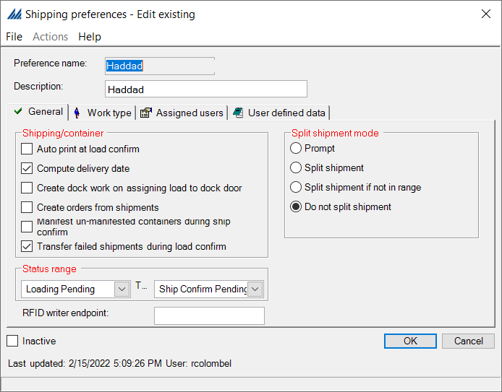
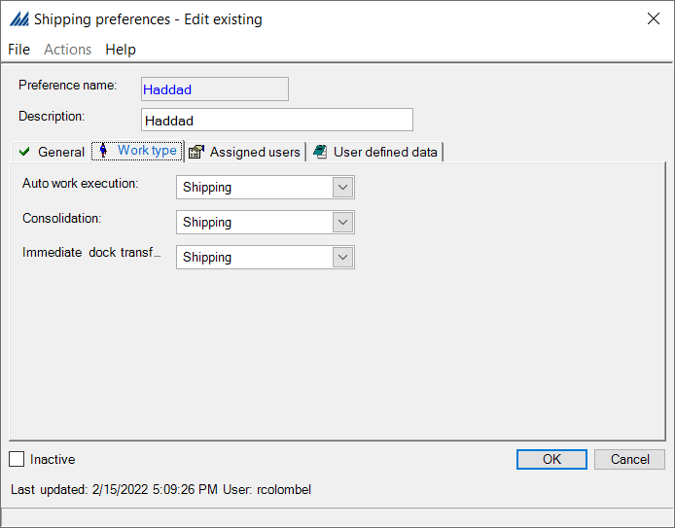

Planned Shipment Filters – Not used

Comment Type - Not used

  - Allocation
Allocation rules are use both for waving and replenishment process to determine from where the stock can be taken.
For the configuration of the Allocation process, we first look at the criteria to assign allocation rules, before selecting the allocation locations, then creating the rule and finally assigning the latter rule.
So, we first define how the rule is selected, then where it will affect the warehouse, then what it will do, and finally tie all this information together in an Allocation rule assignment.
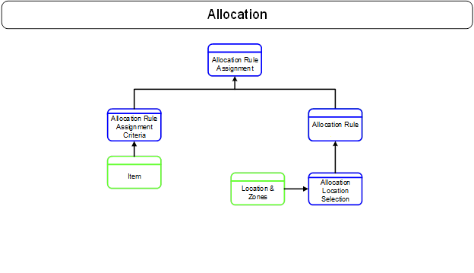

Allocation rule assignment criteria
This window enables the definition of criteria to select a specific rule. We first create the assignment criteria and will later tie it to a rule thanks to a rule assignment.
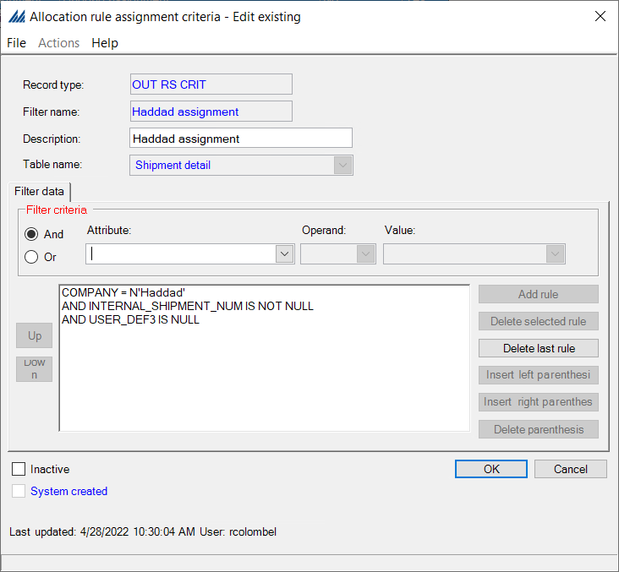
In this specific example, we have a criterion named “user_def3” that will define if we use the “Haddad assignment” or the “Haddad assignment CPO”

Allocation location selection
Those allocation location selection will be linked to the allocation rule. The allocation rule will indicate a location to allocate according to those following details.

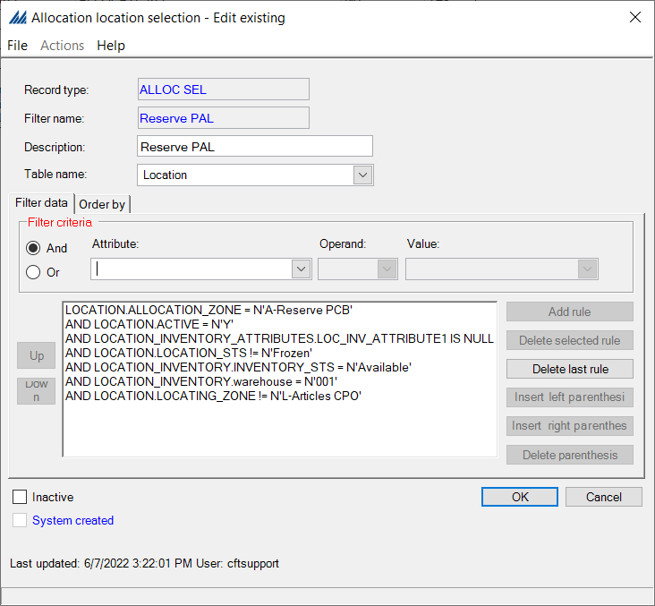

Allocation rule
Now that we defined how the rule will be assigned and where the operator will go and pick from, we define what the rule consists in.
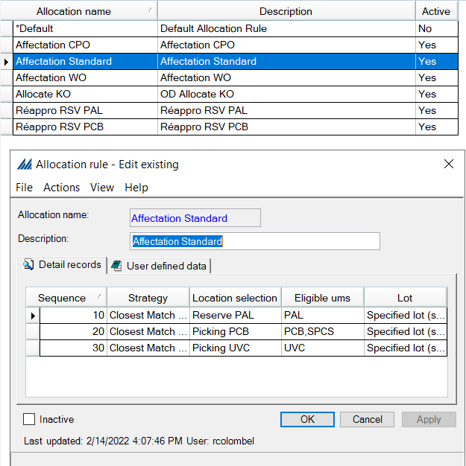
In our example, the ‘Reserve Pal’ location selection will be filter according to the “allocation location selection” criteria. It will look into this area to do the picking. If nothing is found in “Reserve Pal” location the system will redirect the research toward the “Picking PCB” location and then “Picking UVC”.

Allocation rule assignment
Finally, once we have defined how the rule is selected, where it will affect the warehouse and what it will do, we need to tie all this information together in an Allocation rule assignment.
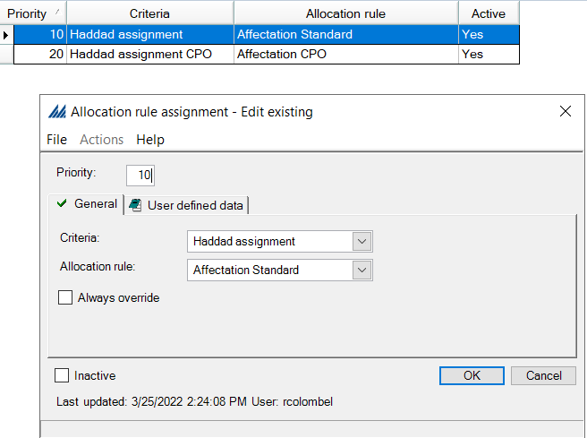
  - Wave
For this section, the focus will be on wave flows and how they are selected. The following figure illustrates the steps to complete in order to be able to use the Wave master properly.

Container type
Defining a container type consists in informing the system of the sizes of the different available containers used by the warehouse and their empty weight. This step may seem unimportant, but SCALE requires this information to know the container type that can be assigned to an item and where these containers can be stored. The following figure shows a typical example of how to define a Container type.
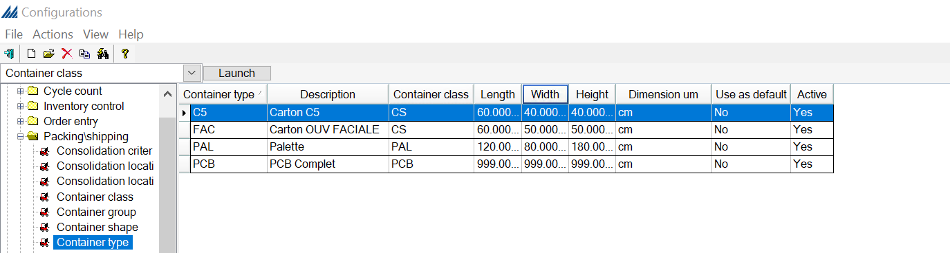

Override data
This step allows you to override or update data (that you normally would not have access to) during the wave process. You can configure this "override data" wave step to replace a specific data field with a value that you define. To configure this action, you will need to create an override data record (and a corresponding criteria record) and include this "override data" wave step in your default flow. Additionally, the system allows you to include multiple "override data" wave steps in your wave flow. This allows you to override different types of data at different times during the wave. To create additional steps, you will first need to copy the default override wave step, and then create the wave step(s) based on this base override data functionality.
Note that only override data wave steps (with the specific base Namespace/Class/Method) will appear in the Wave Step Field on the Override Data Window.
Override data are usually personalized SQL scripts as shown below:

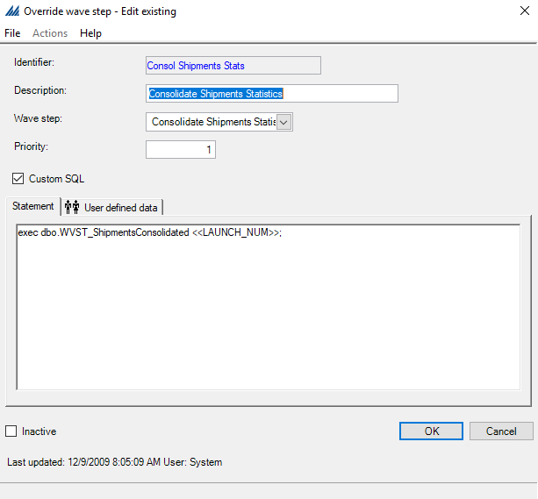

Wave steps
A wave step identifies a specific process that will occur during the wave, such as carrier routing or replenishment. Default wave steps are shipped with the system and cannot be changed.
It takes custom programming to add a new wave step different than an override one. As best practice different override steps in copy from the default one is usually created in advance to be set before and after relevant wave steps in case of need.
Basically, is this step you will create all the existing steps within all the waves. These steps will then be put into order and tied to a specific wave later.
We are going to create a new wave step:

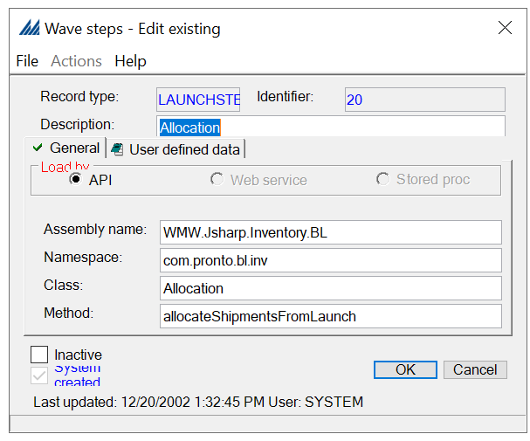

Wave flow
In this step, we put in order the wave steps we created previously, according to the wave they belong to. We will later associate each wave flow with the appropriate wave in the Wave Master Window.
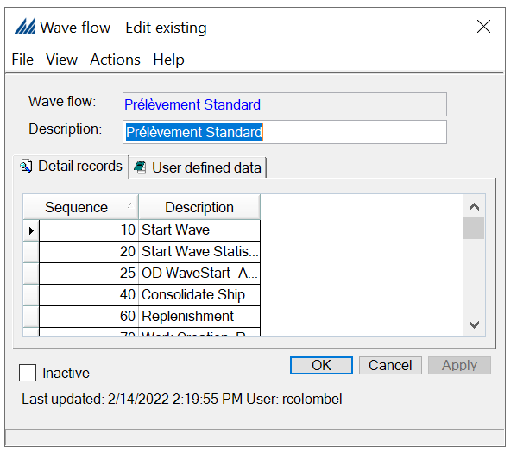
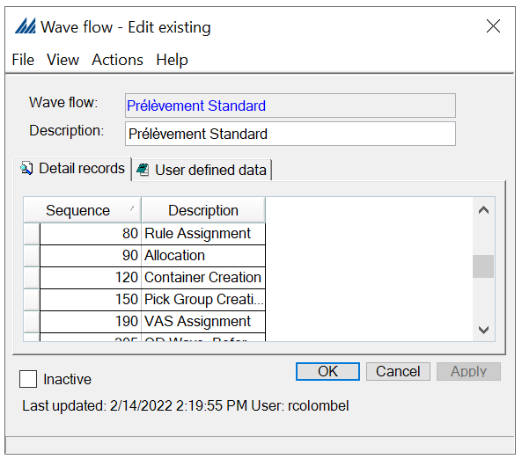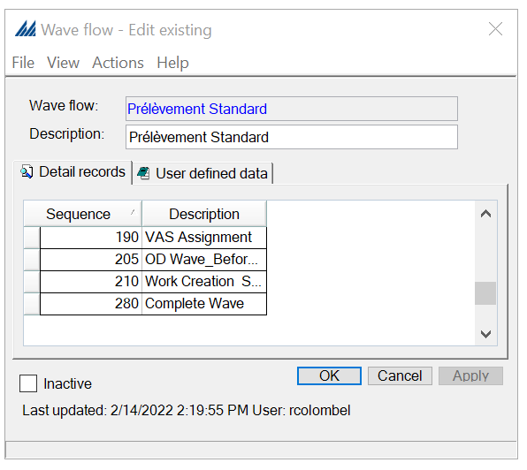
When creating a new Wave flow, remember to click Apply once you have written down the Wave flow name and Description to have access to the Detail records. You can then right click, New and select the Wave steps you wish to add. Remember to set up the wave steps in the right order, using the Sequence field. More information on the suggested order for wave steps are detailed in AIM.

Wave maximums
During the wave building process, the wave maximum record determines when a wave will stop accepting shipments. When the system stops accepting shipments, it generates a new wave and therefore continues accepting shipments. You will establish wave maximums on the Wave Maximums Window. This maximum may be number of lines, of shipments, a quantity, a weight or even a volume.
These maximums are later associated with the appropriate waves via the Wave Master Window.
In our case, no maximums needed to be defined.

Wave criteria
This step allows the definition of the criteria which will determine which shipments will be included in which type of wave. If a shipment line matches a criteria rule, then the system will select the entire shipment for the wave.
Note that all the shipment lines do not have to match for a shipment to be selected.
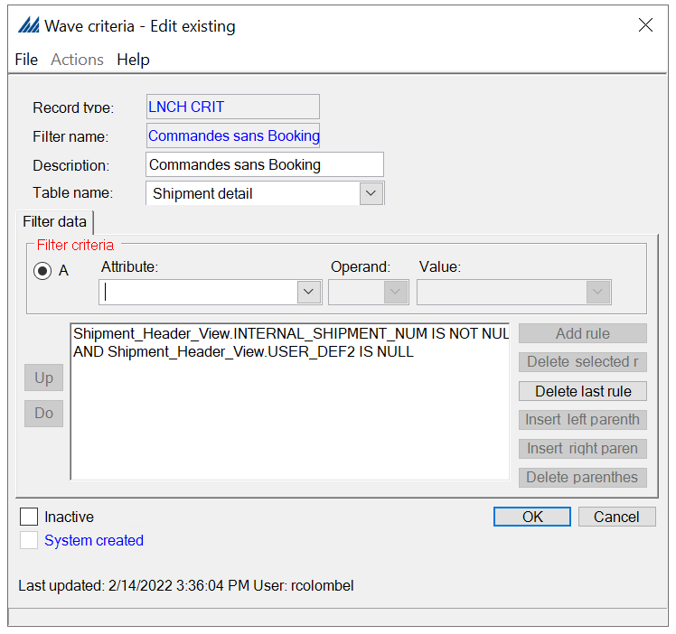

Wave master
This step ties all the previously created information together under a Wave master also including the document and label masters (detailed in the Document Printing Paragraph).
In the wave master is also selected the wave execution mode that regulate if and how a wave will be built starting from shipment in the pool.
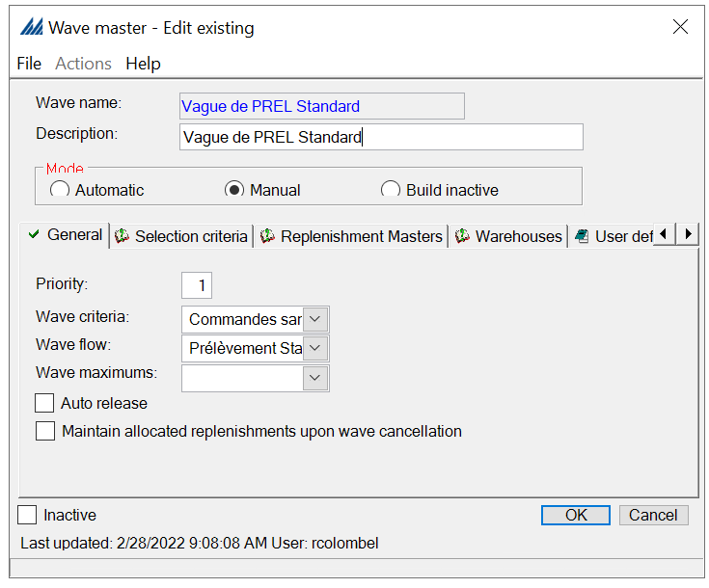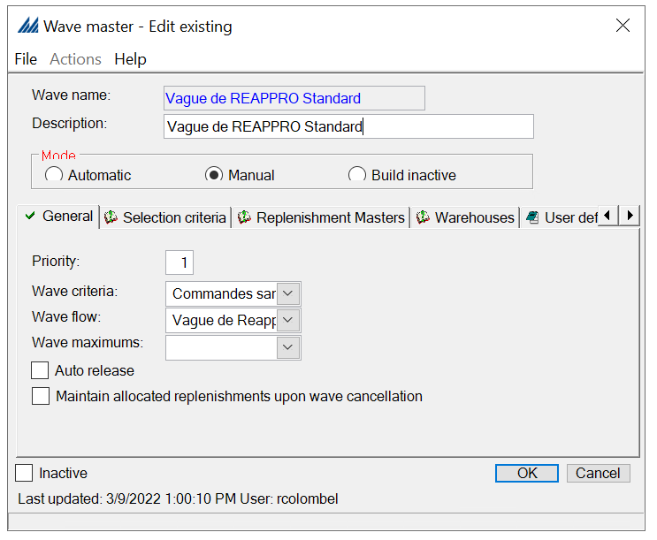
  - Value Added Services

1.10.1 VAS activity criteria
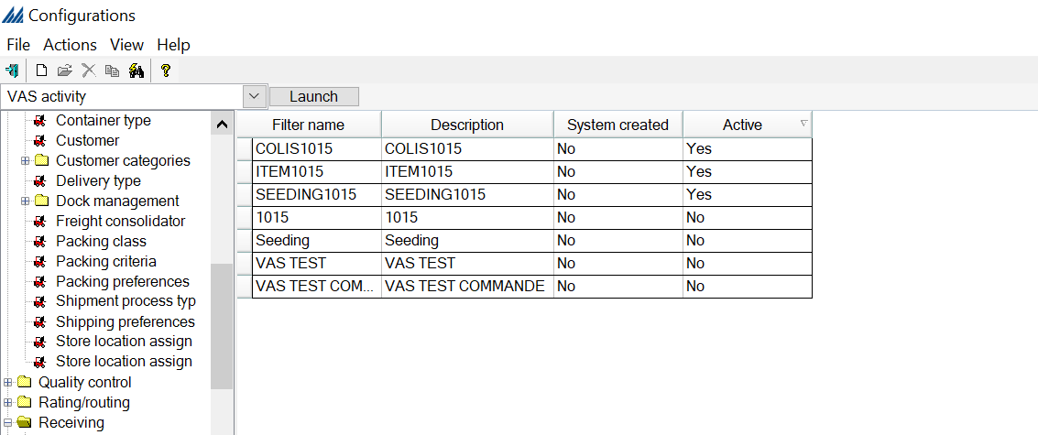

VAS Activity
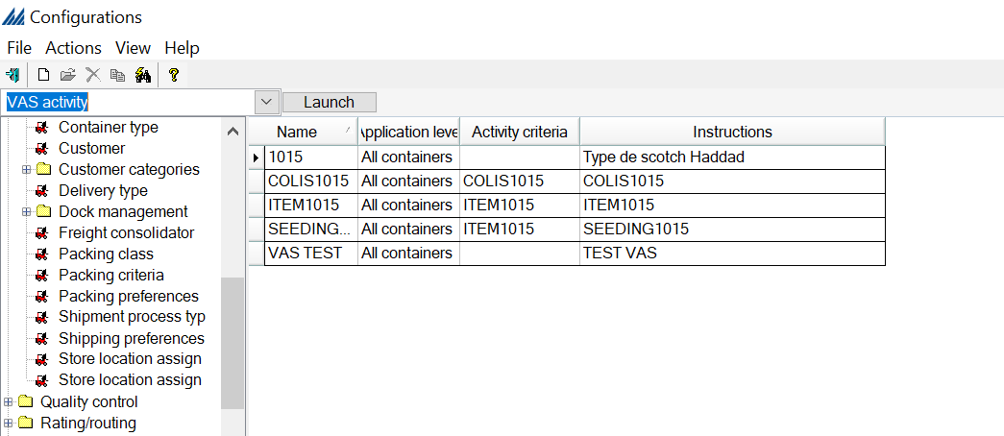

  - Cycle counting
Cycle counting is a crucial concept, as it enables a comparison between what should be in a location and what is physically there. Doing so will allow SCALE to give accurate numbers regarding the inventory. However, cycle counting can either be planned or not. In both cases, SCALE needs to support adjustments and inventory transfer, regardless of if it was planned.

Cycle count system values
All these system-created values are used by the system to process cycle counts. Refer to the Help menu to know if you need to modify any of those values (depending on if the cycle counting is planned or not).
Keep in mind that to be able to confirm count an adjustment type need to be assigned as the System value for the positive and negative adjustments of both Activity and Planned count.
This adjustment type is used, in case of quantity discrepancy during cycle count, to update the quantity in a location.
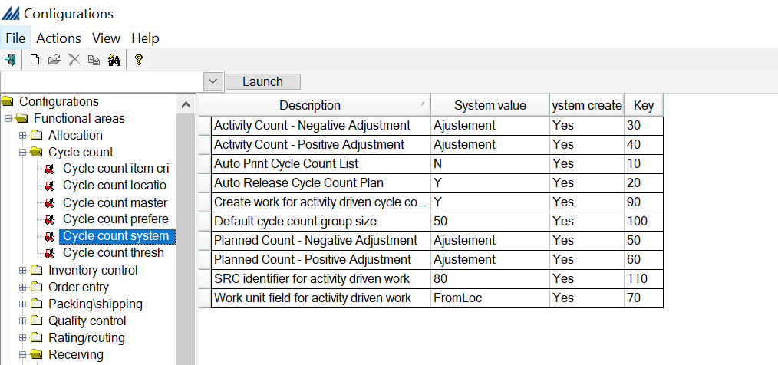

Cycle count Preferences
This step defines when cycle counts should be executed: should they be executed immediately or created as “pending” requests. You will probably not need to change anything here but check in the “*Default” preferences to see if they correspond to what you are expecting.
In our case, we create “Cambrai - Inventaires” preference where “Perform threshold counts immediately” and “Verify bad on FR” icons are checked.
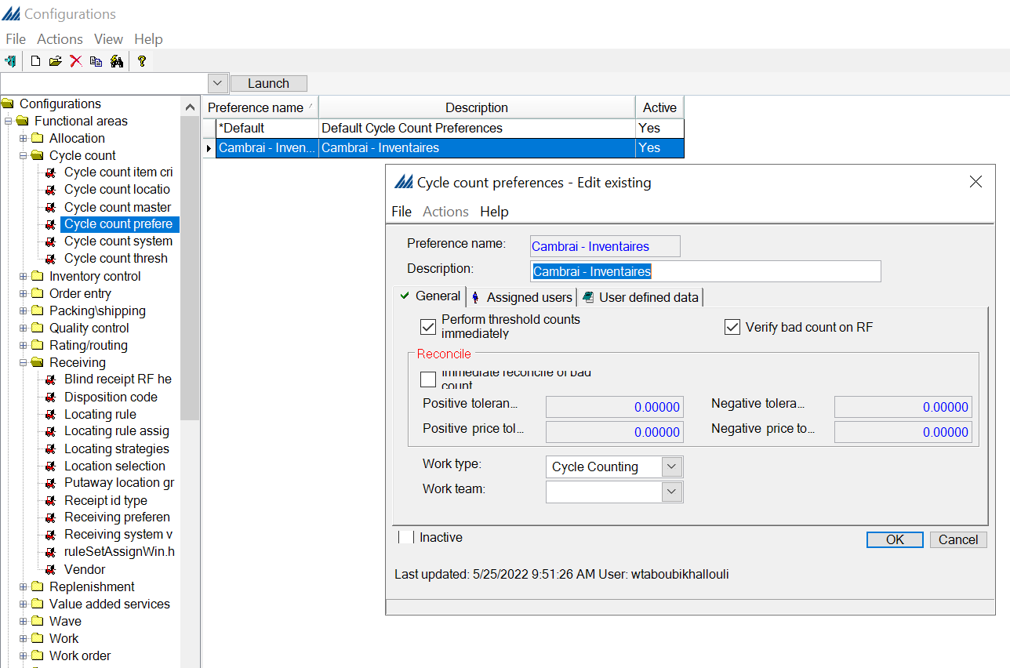

Cycle count item criteria
This step defines which items are eligible for cycle counting by using a filter. This criterion will then be tied to its associated cycle count via the Cycle count master.
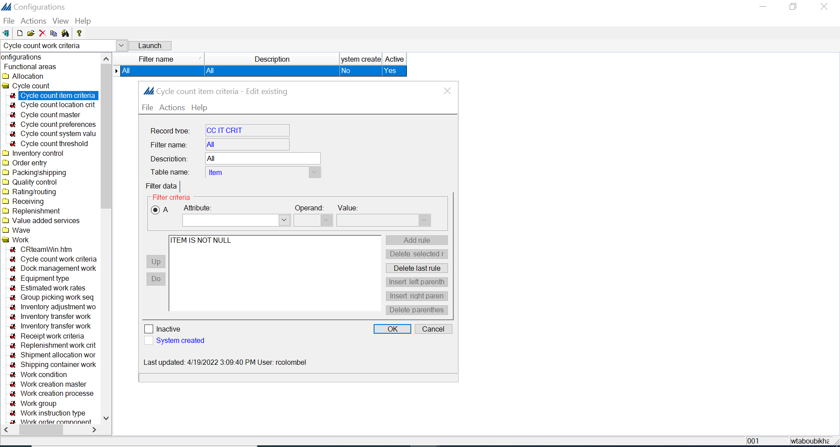

Cycle count location criteria
These records are used by the system to filter the number of locations eligible for a cycle count, according to settings defined on the cycle count master record. The system will only create cycle count requests for locations that match this criterion.
For our case, we create two Filters: All and CC LOCATION Annuel.
- All: To select all the active locations to perform the Cycle count on the whole warehouse.
- CC LOCATION Annuel: To select locations that have not been counted in the last 360 days. This criterion is used for the annual cycle count plan.

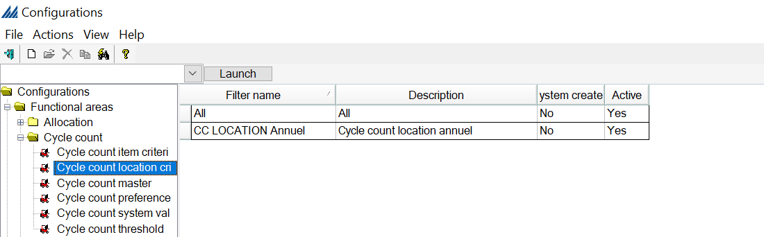
- Cycle count location criteria: All
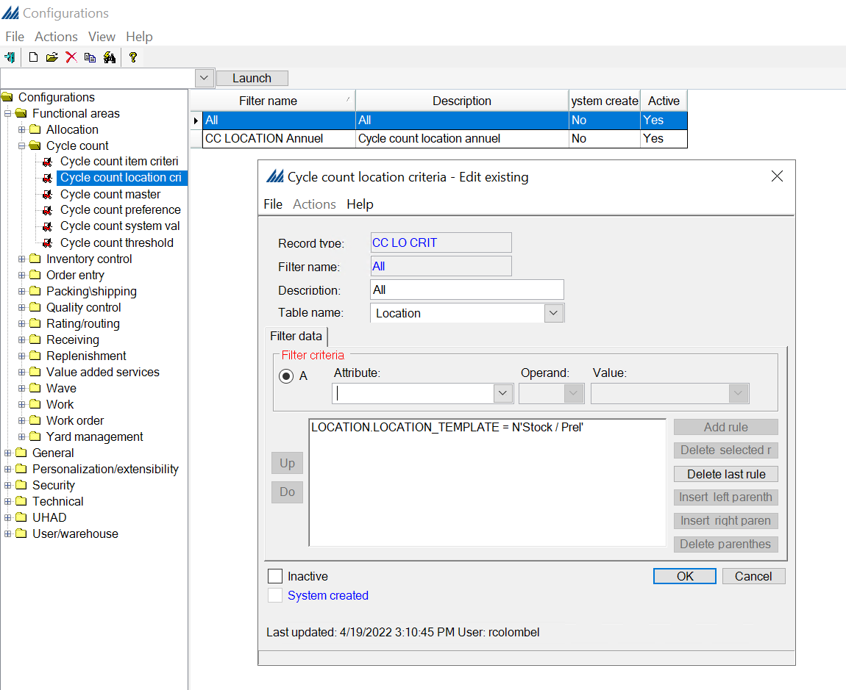
- Cycle count location criteria: CC LOCATION Annuel

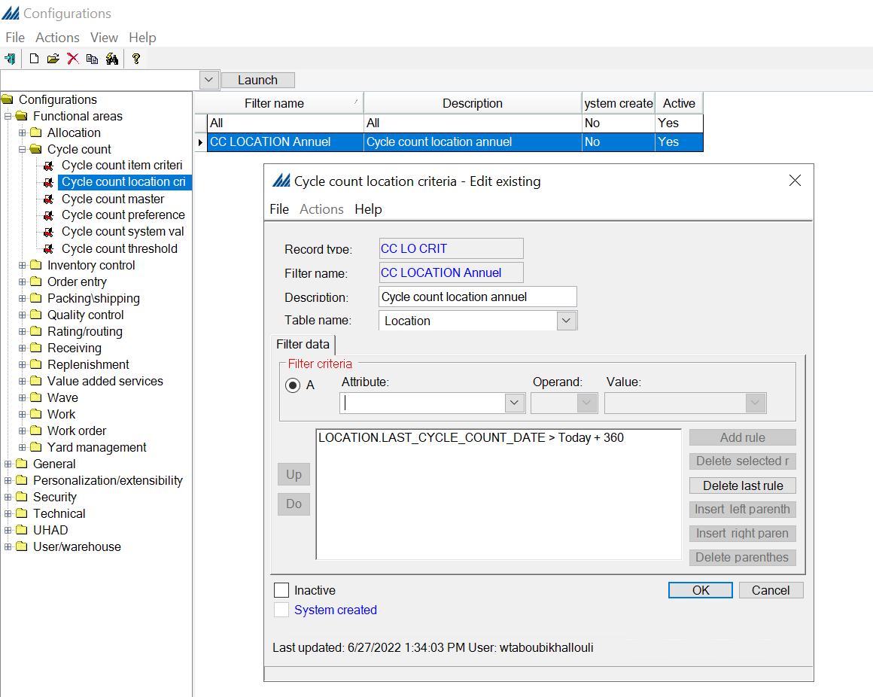

Cycle count master
In this step, we tie the previous steps together under an associated Cycle count.
In our case, we are going to use this cycle count master.

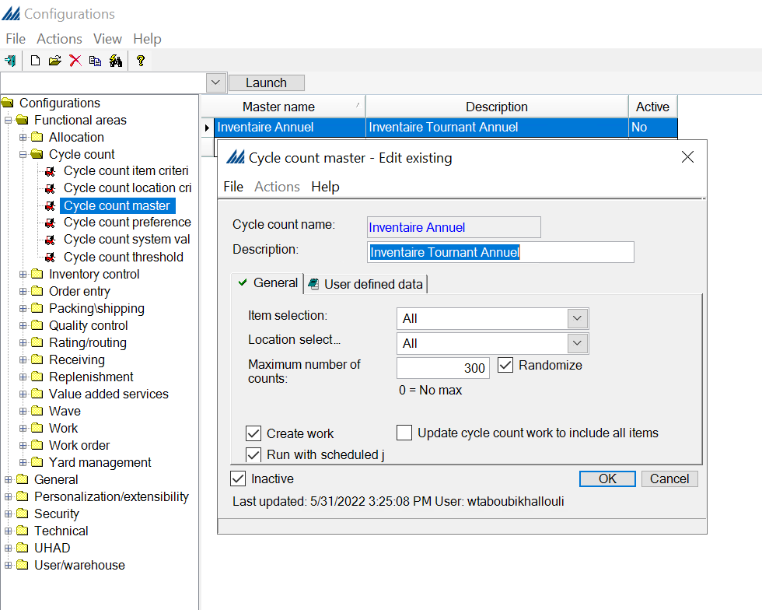
We create this " Inventaire Annuel " cycle count master for annual cycle count plan to create schedule-based cycle count work.

Cycle count threshold
This step determines when the system should trigger the creation of a non-plan based (“activity-driven”) cycle count request for a location. When the system checks to see if a location meets a threshold, it will first look to see if a location matches three variables: Location Type, Work Zone, and Movement Class.
If it the location does not meet all these variables, the system searches for only Location Type and Movement Class. If no location meets those criteria, the system searches for Location Type only. If no locations meet this, the system looks for an all-blank threshold.
In this configuration is also specified the minimum time interval between 2 consecutive counts on the same location in number of days.
In our case, we create threshold to verify empty locations for picking work zones.
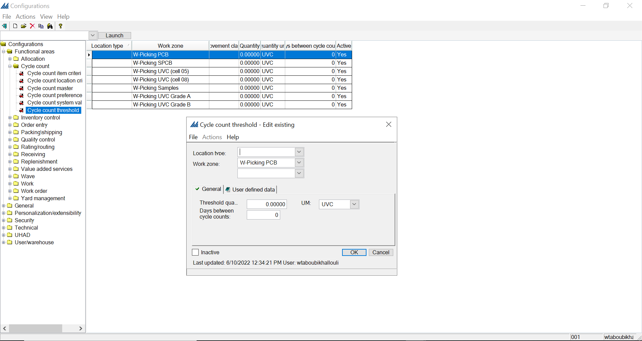

Cycle count work criteria
All work criteria records are created on a work criteria window. There is one work criteria window for each type of work creation process. A work criteria record manages the following activities: it determines which work requests are selected for work processing; it creates a work unit; and it determines the order that work instructions are generated and released to the warehouse floor.
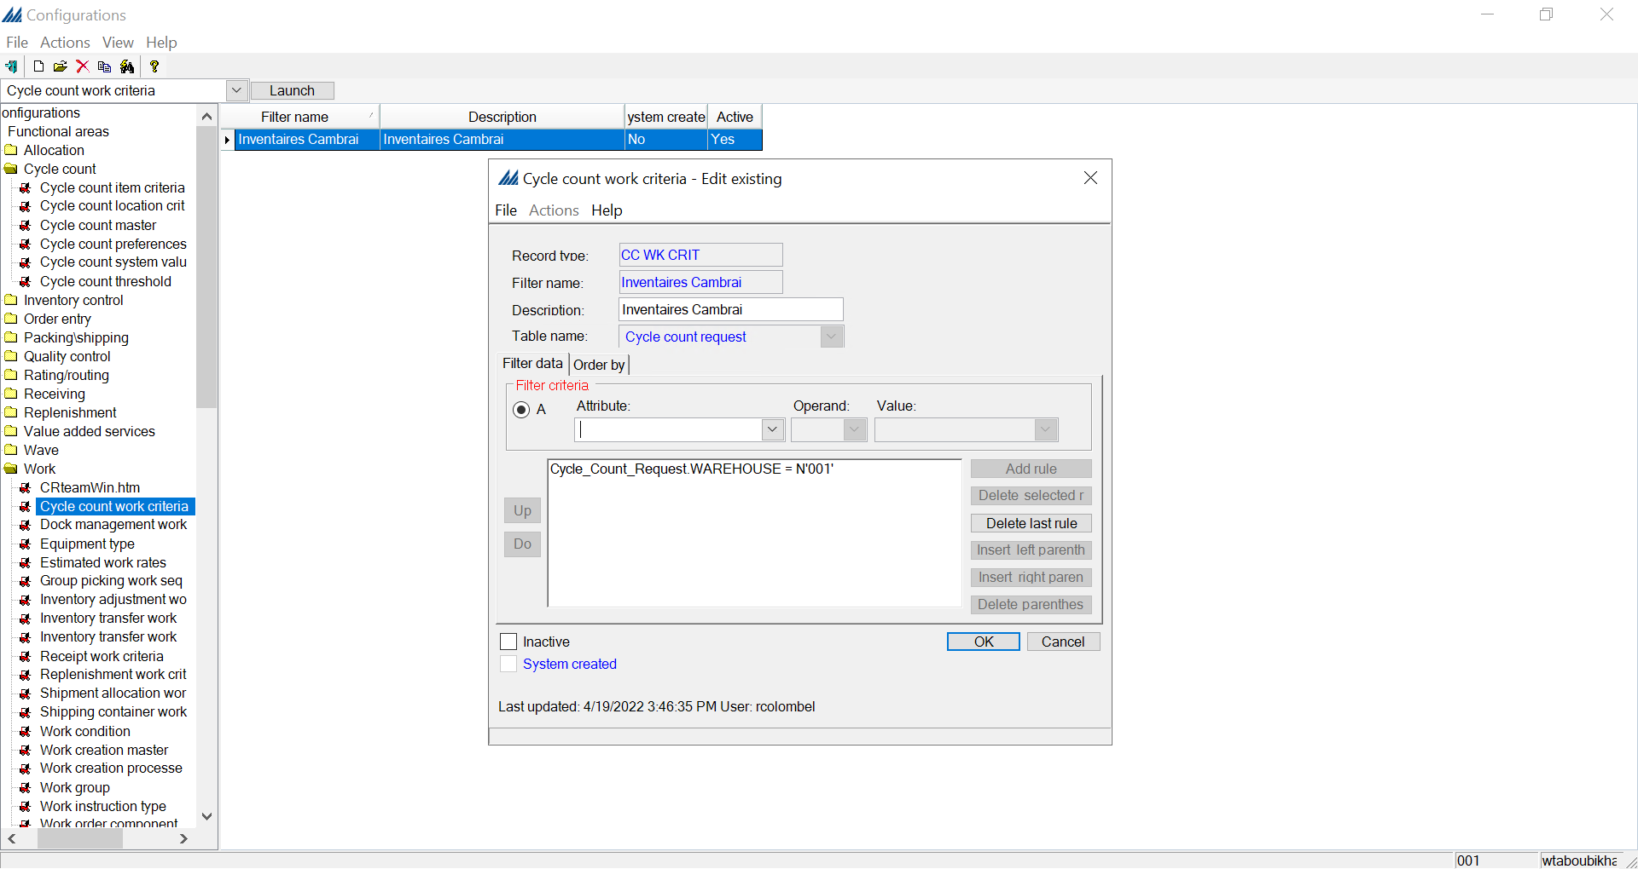

  - Work orders
Work Order processing manages the creation of finished items from component parts. All work order related information, such as components and instructions, can be stored on a bill of material record or manually entered when the work order is created. Component part allocation can be performed automatically when the work order is created or released. Employees can also manually allocate components. You can use work creation to support the movement of component parts to the build location and finished items to their storage locations. You can also choose not to use work creation and instead use paperwork to move items. Also, the system supports bill of material revision numbers. When you copy an existing bill of material record, the system assigns the new record a revision number. This allows you to support multiple versions of one finished item.
In the environment used as guideline for examples of this document there was no configuration of work order at all, so the information provided were based on AIM online help.

Bill of materials
A bill of material record defines a finished item and its requirements. These requirements include what component parts are required to create the finished item and instructions on how to assemble the finished item from its components. When a work order is generated for a finished item, the system defaults relevant bill of material records on both the work order request and any paperwork generated for the finished item.
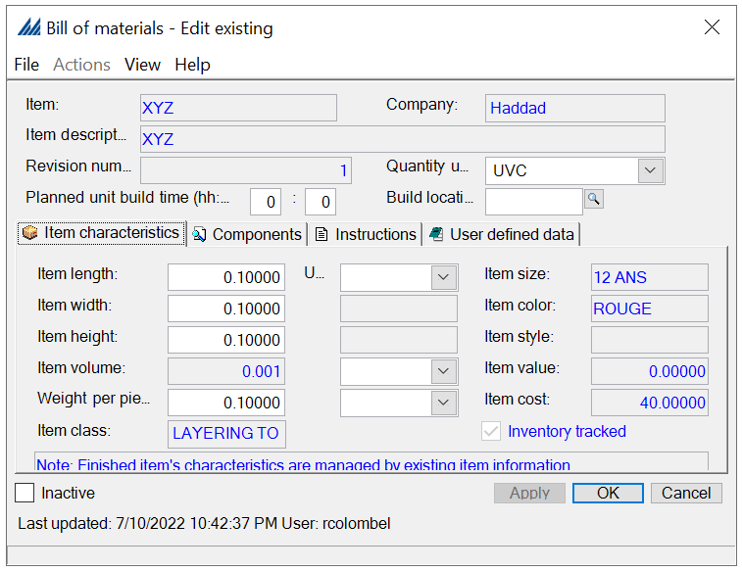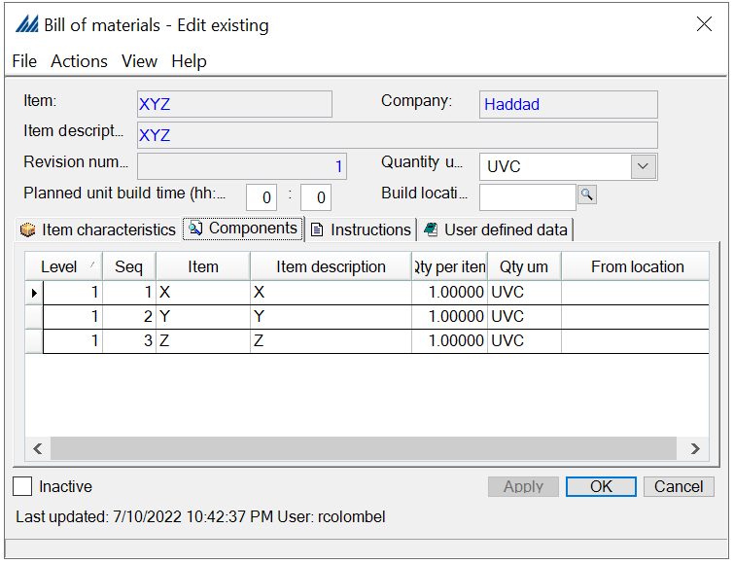

Work order preferences
A work order preference record allows you to manage how a user or group of users will process work orders. The default record should accommodate most employees. However, you can create specific preference records for employees with unique processing needs.
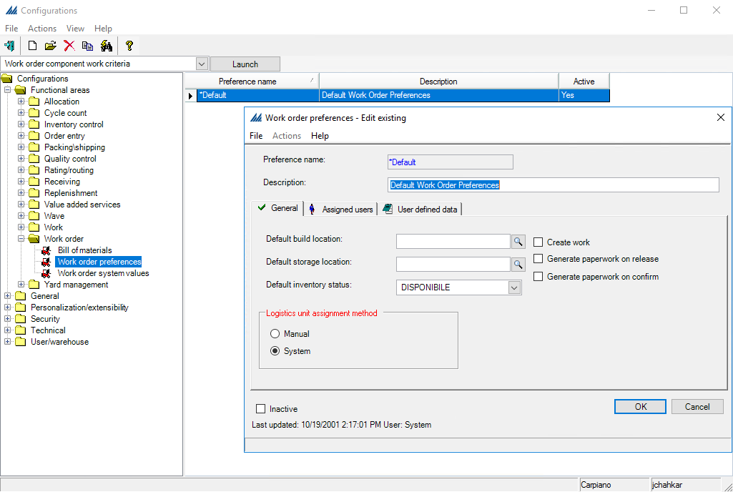

Work order system values
These values manage how work orders are processed in your warehouse. They are system created and you should not need to modify them.

Work order finished item work criteria

Work order component work criteria

  - Replenishment
The replenishment process determines when product should be moved from bulk storage locations and transported to forward picking locations. This allows employees to efficiently complete picks for individual orders without compromising the integrity of larger UM increments. Replenishments are triggered by the system when the location's quantity falls below a minimum threshold percent. You can set this percent value at the location /location type level, or for an item/item class. A replenishment generates an allocation request from the bulk location. The product is marked as In Transit to the forward location.
The allocation of product for the replenishment is managed by the allocation rule defined on the replenishment master.
Below is included a basic scheme of the configuration required to set up correctly all replenishment processes:
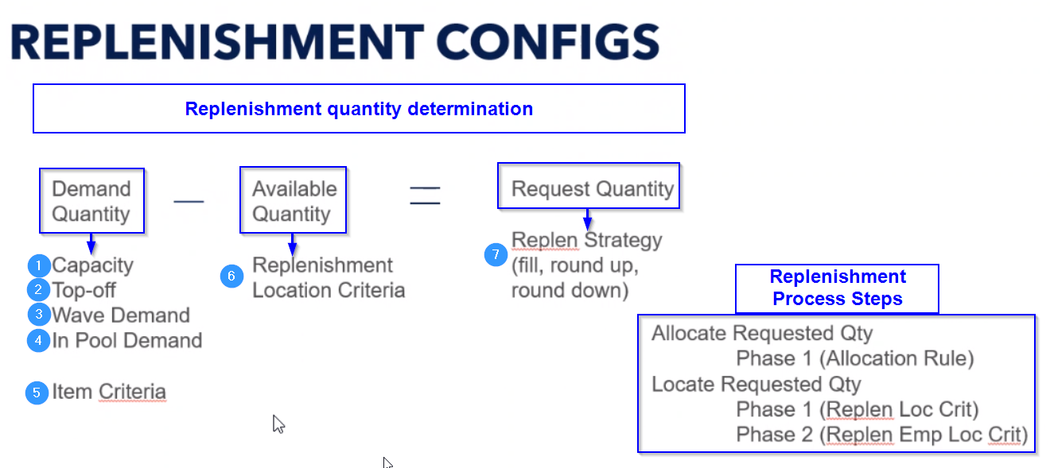

Replenishment location criteria
This step determines when a location may be considered for replenishment.
- If this record is associated with a replenishment master that generates replenishment based on item location capacity, it determines which locations are evaluated for replenishment needs.
- If this record is associated with a replenishment master which generates replenishment based on pool or wave demand, this record determines which locations the system will attempt to replenish. Any location, inventory, or inventory attributes value(s) can be used to define a replenishment location criteria record.
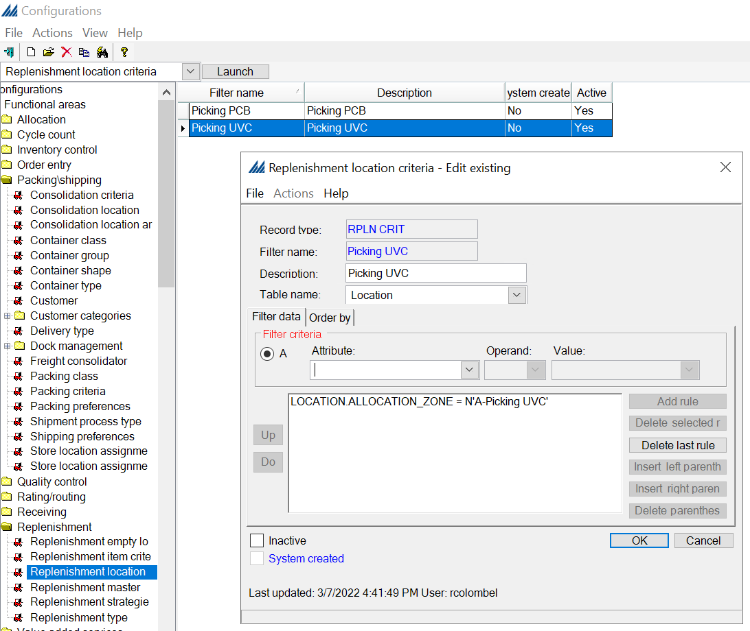

Replenishment item criteria
A replenishment item criteria record identifies which item(s) you want the system to evaluate for replenishment eligibility when you are running demand-based replenishment for a wave or a pool. When replenishment is attempted for either shipments in the order pool or in a wave, the system uses this record to define what types of items should be considered for replenishment. This criterion narrows the amount of processing time required to run the replenishment wave step, while ensuring that important items are ready for allocation.
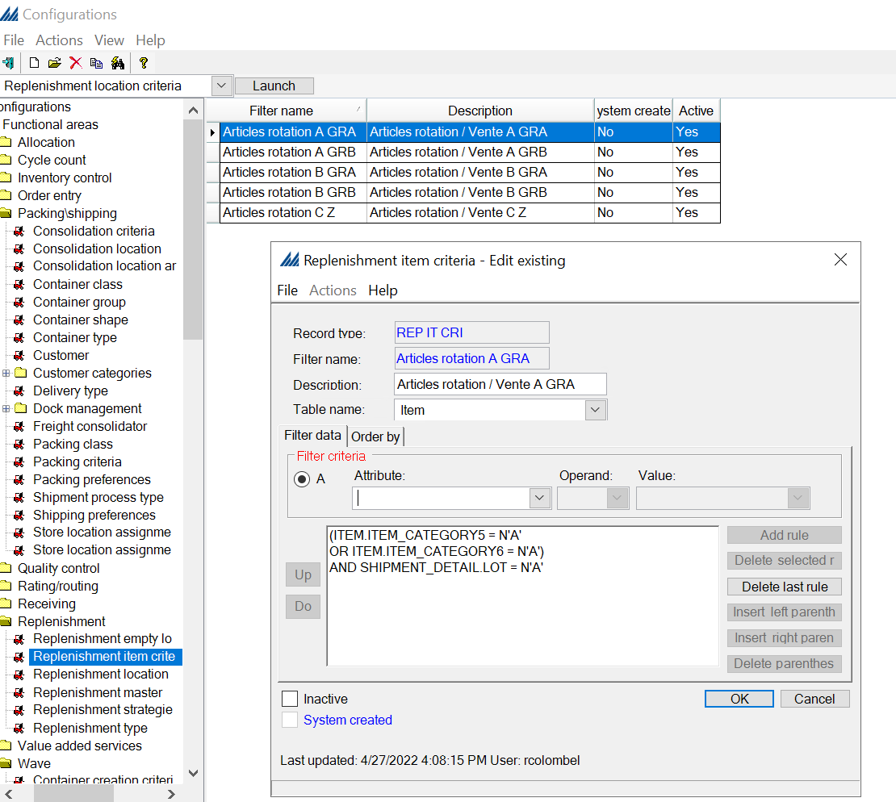

Replenishment empty location criteria
You will use this window to identify which location(s) the system should replenish product to if either of the following situations occurs:
- The amount of product that you must replenish exceeds the locations available for replenishment. After the system replenishes to all the locations that currently contain the product, this field identifies the next location(s) that it can replenish to.
OR
- No locations currently contain the item that you need to replenish. In this case, you will use this field to determine where to start replenishment.
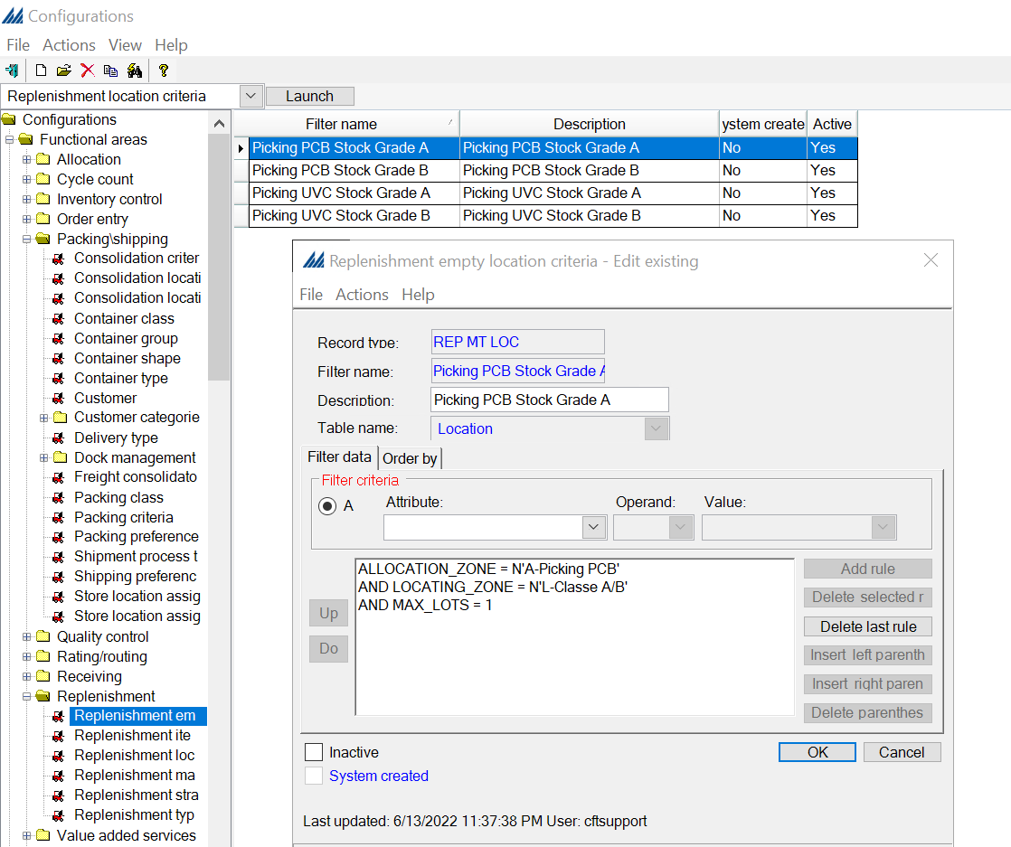

Replenishment master
In the replenishment master all the previous replenishment configuration and the assigned allocation rule for a specific replenishment process are linked together.
In the General tab is specified the replenishment type that define the criteria to calculate the requested quantity, the work creation method, allocation rule and increment.
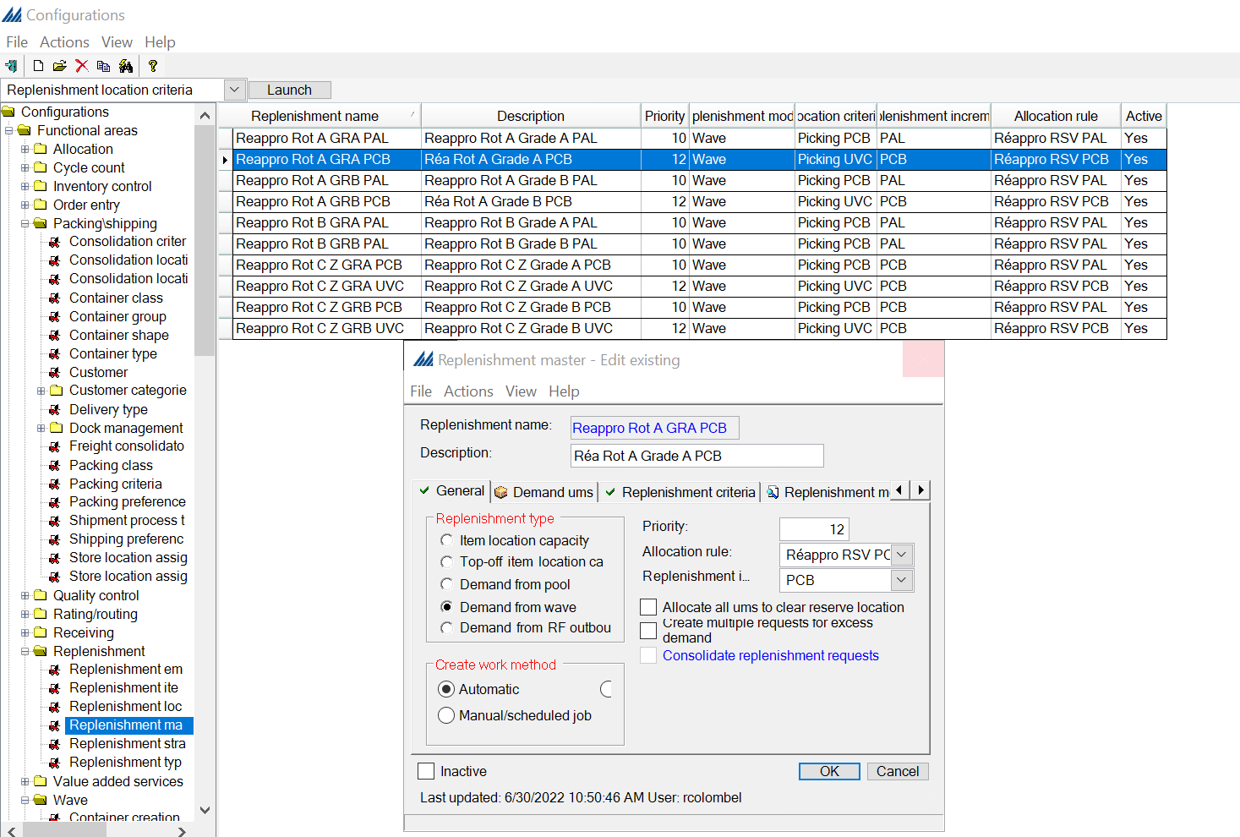
In Replenishment Criteria tab are linked the location and item criteria
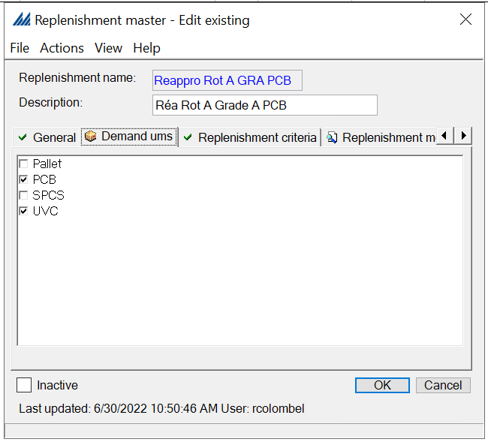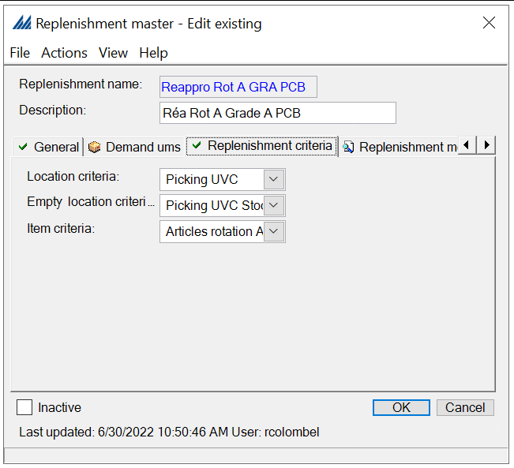
In the Replenishment Strategy tab is specified the rounding criteria for the Increment specified in the General tab, more than one strategy can be applied in the sequence.
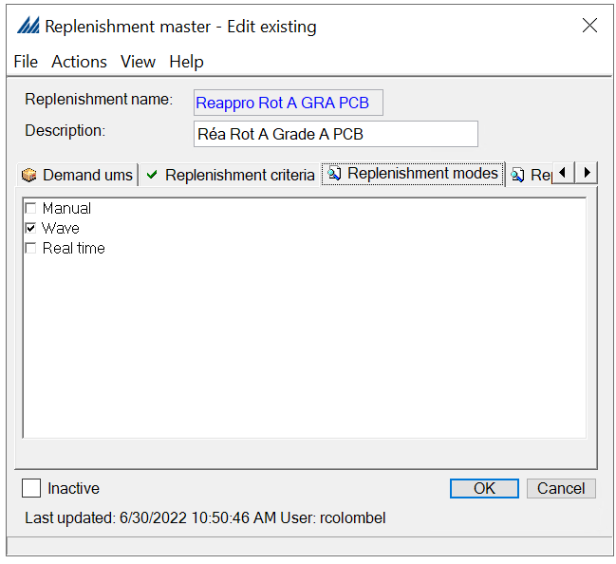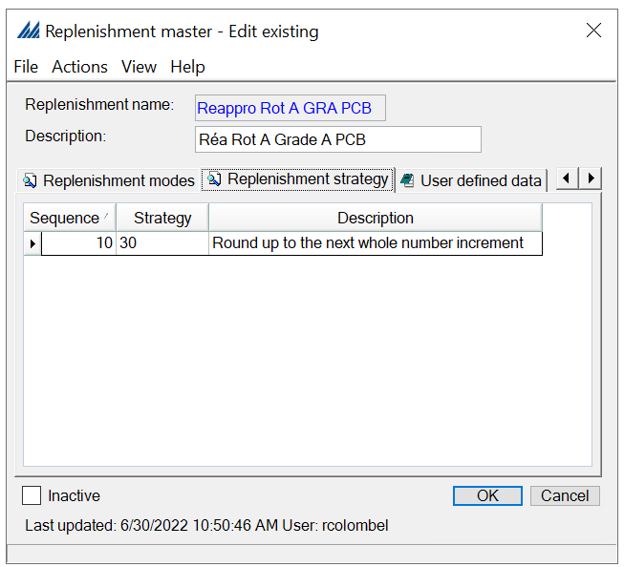

Replenishment work criteria
All work criteria records are created on a work criteria window. There is one work criteria window for each type of work creation process. A work criteria record manages the following activities: it determines which work requests are selected for work processing; it creates a work unit; and it determines the order that work instructions are generated and released to the warehouse floor.
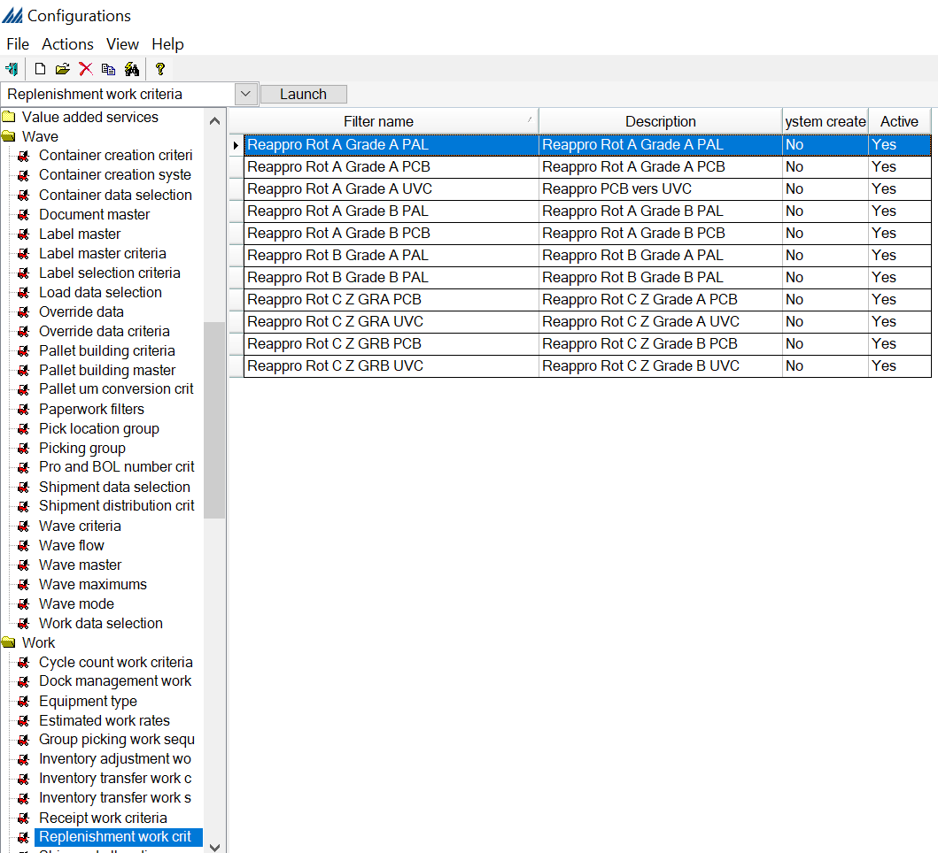
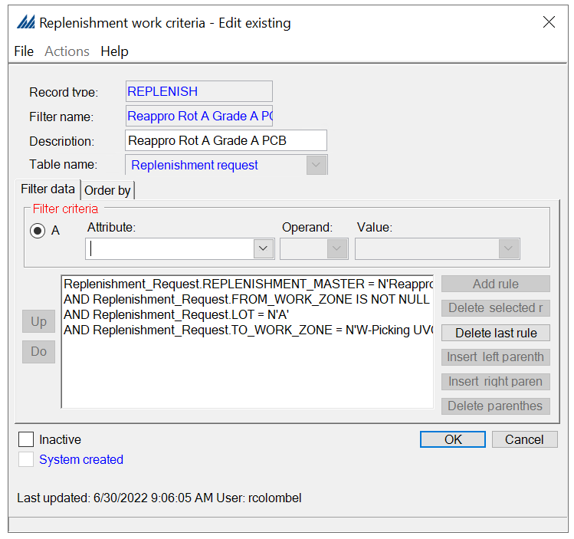
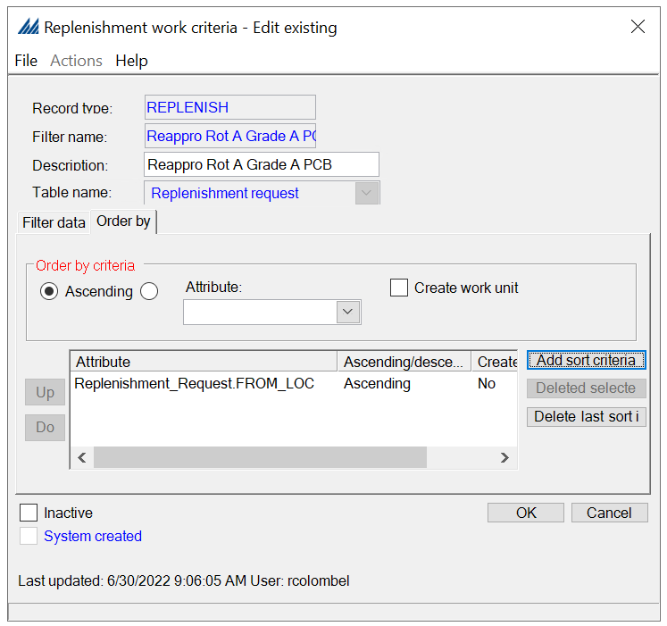

  - Container creation
The container creation process involves the system creating containers for shipment line-item quantities via the execution of a wave step. This wave step determines how many container(s) it will create to pack these allocated item quantities. There are four strategies that can be used by this wave step to determine how to distribute quantities into newly created containers: Consolidate and Do Not Split, Split And Do Not Consolidate, Consolidate And Split Only Once, and 3D Cubing.

Container creation system values
This step allows you to manage certain settings that will affect the execution of the container creation wave step.
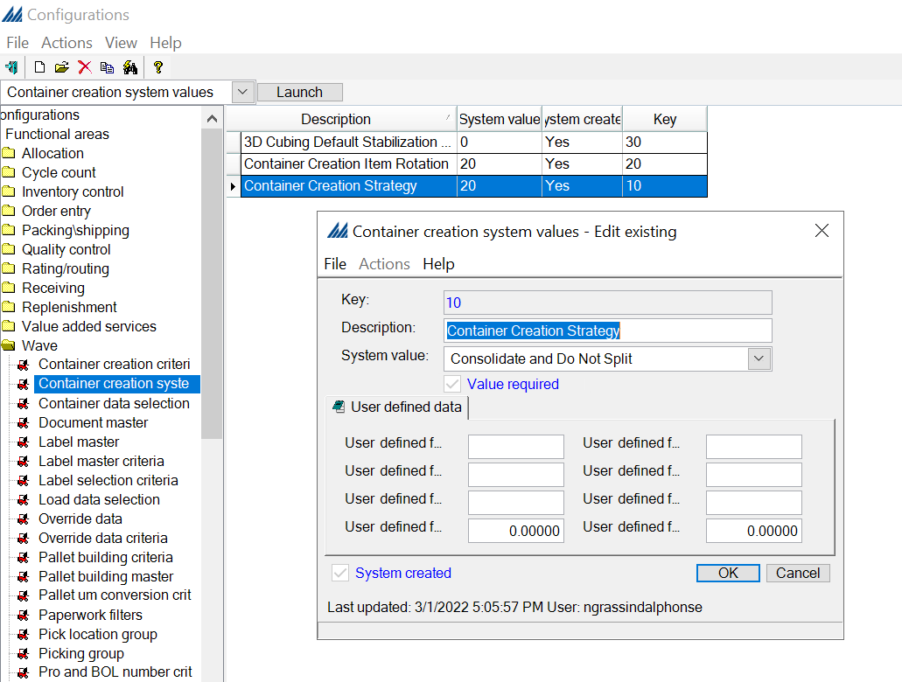
The System value field allows you to select different types of values according to the Key. For example, for the Key 10 (Container Creation Strategy) shown in the figure above, you must choose one of the four strategies mentioned earlier (Consolidate and Do Not Split, Split and Do Not Consolidate, Consolidate and Split Only Once, and 3D Cubing).

Container creation criteria
This step allows you to create a filter to define for which items or shipments you want the system to create containers during the wave, and in which order you want the system to do this. Container creation criteria records help the container creation process selectively create containers only for the items/shipments that you choose.
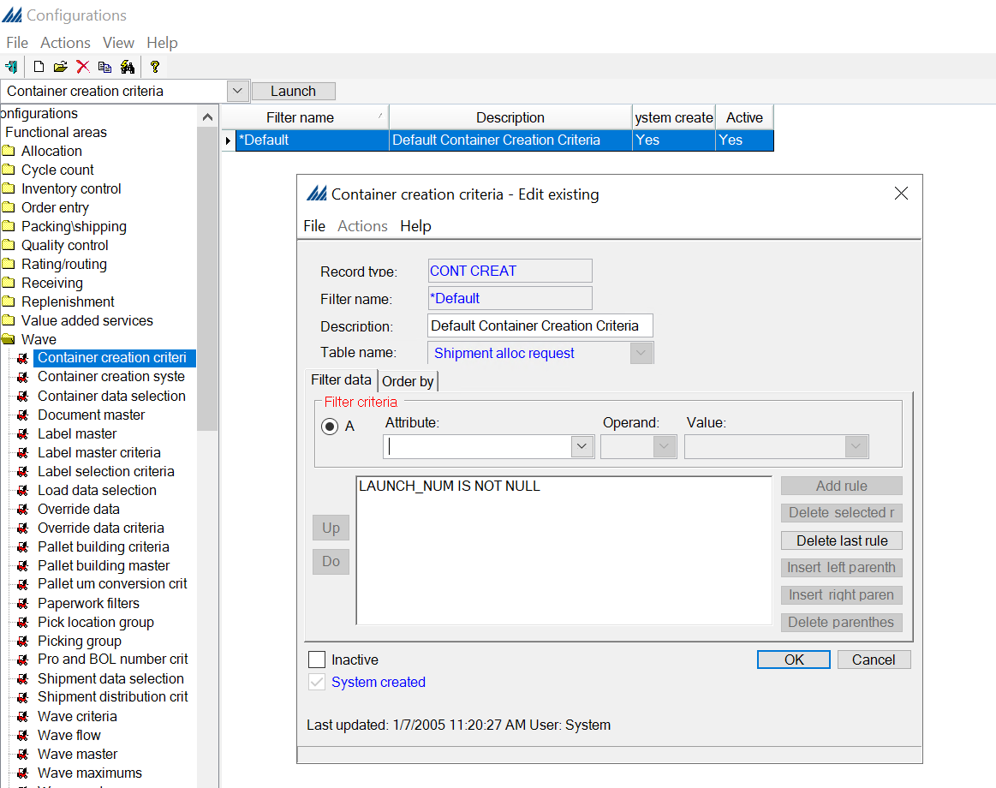
In our case, we only create the “Default Container Creation Criteria” filter, which will select all the items/shipments included in a wave (therefore having a Launch number different from “NULL”).

Container Class
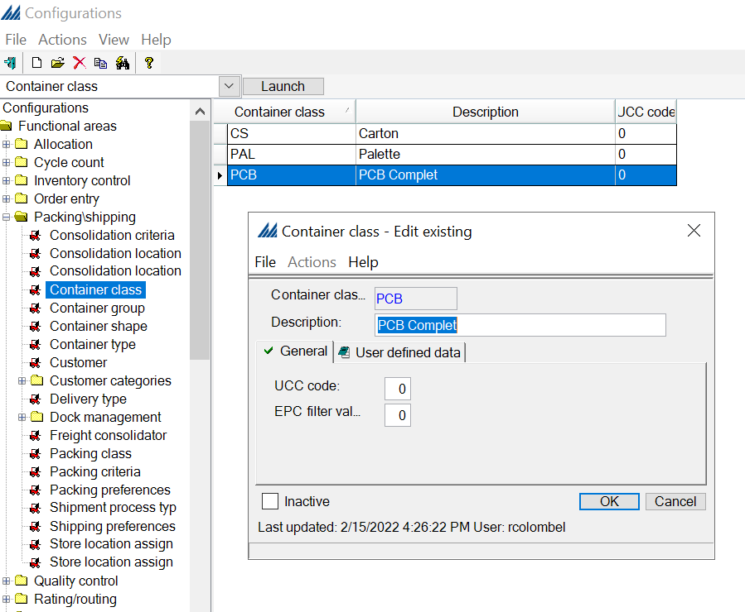
For Haddad warehouse we have different type of container class: Carton (CS), Palette (PAL), PCB Complet (PCB).

Container type
Dealt with in the “Wave” section.
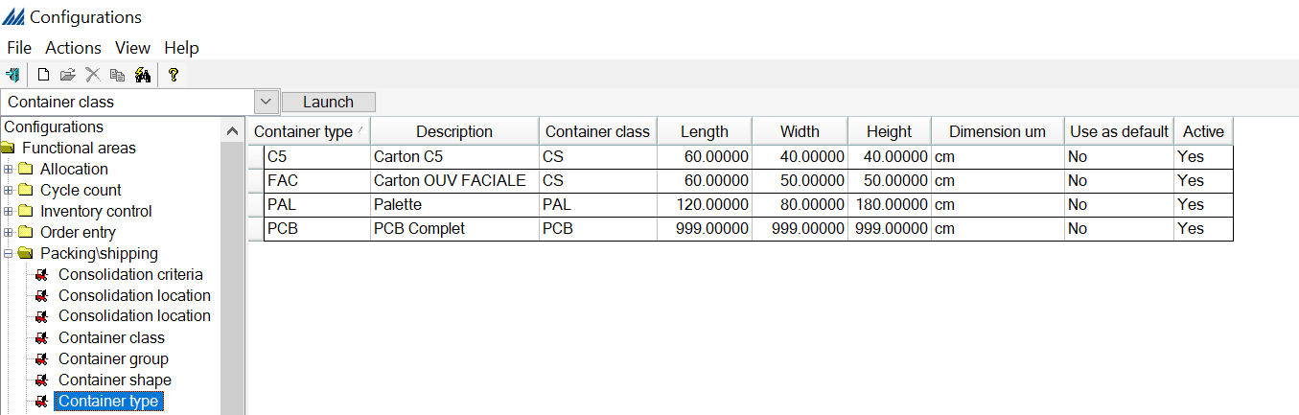

Container Group
A container group identifies all the containers that can be used to pack an item, or group of items. During the container creation wave step, the system processes through a container group's details in sequence order. After you define a container group, you will link it to the correct packing class on the Packing Class Window.
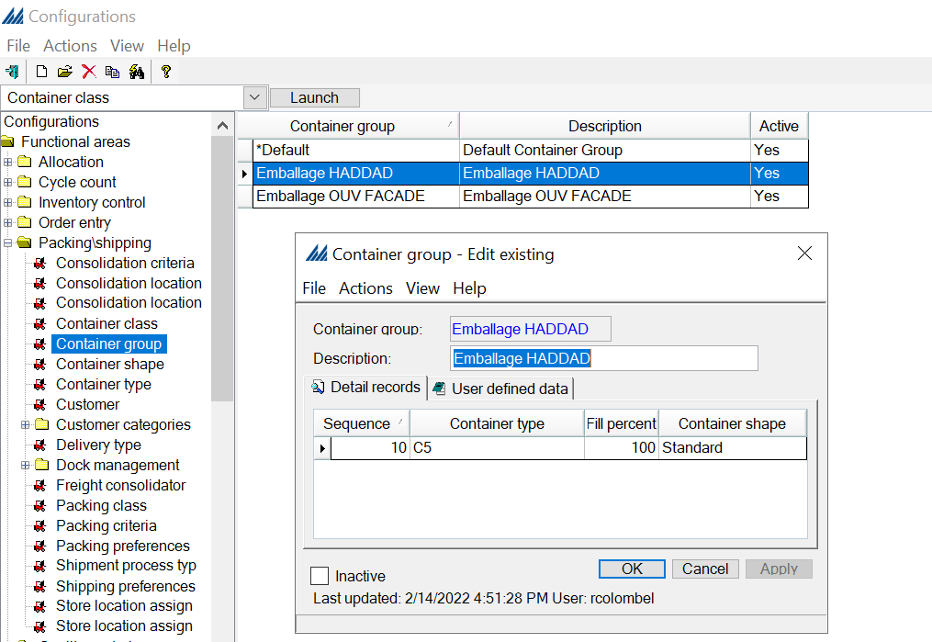

Packing class
A packing class determines which container type(s) the system can evaluate when determining how to pack items during container creation in the wave. You can also indicate on a packing class which items can pack together in the same container. Packing classes can be associated with an item on the Item Window, and on a shipment line record.
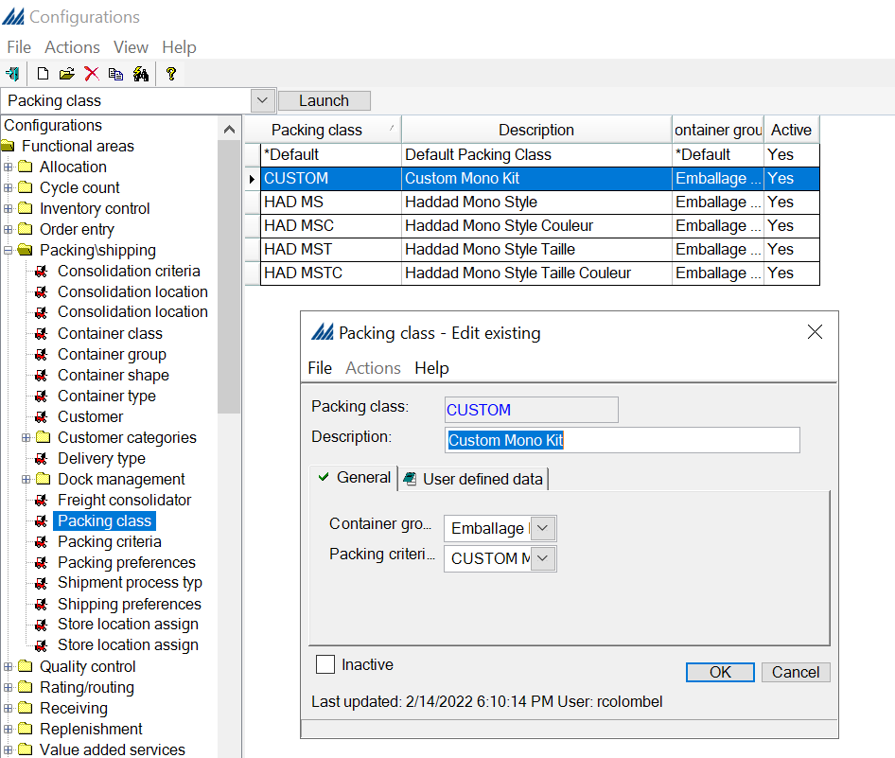

  - Quality control (QC)
SCALE features modules for both inbound and outbound quality control. The inbound quality control process involves the system taking a certain portion of a receipt's item quantity and routing it to a special location so it can be inspected. The outbound quality control process involves taking a subset of the shipping containers that are being shipped out of the warehouse and inspecting the contents to verify that they match what the system believes to be in the container.
Here, we will focus on the case of performing QC manually on a shipping container. We will first define the assignment criteria, before selecting an evaluation method and finally tie this information together using the QC assignment feature.

QC assignment criteria
Here, we create a filter to select specific containers.
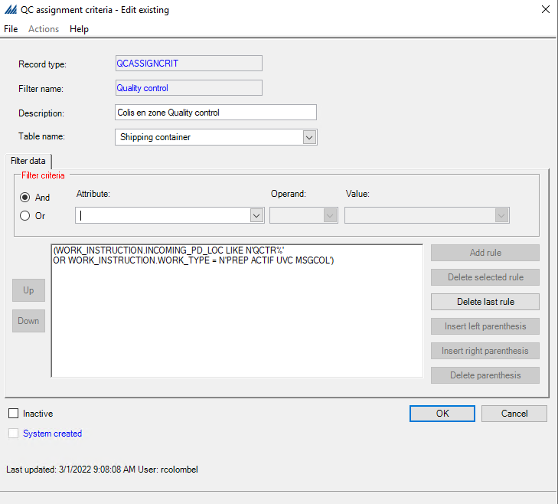
In this case, we want to select shipping containers, so we set the filter to make eligible only shipping containers from the warehouse we are working in (we only have one warehouse, which explains why the rule is set to “IS NOT NULL”).

QC evaluation method
Then, moving to the evaluation method, we notice all the evaluation methods are system created and correspond to a specific identifier. We will choose the one named “Manual”.
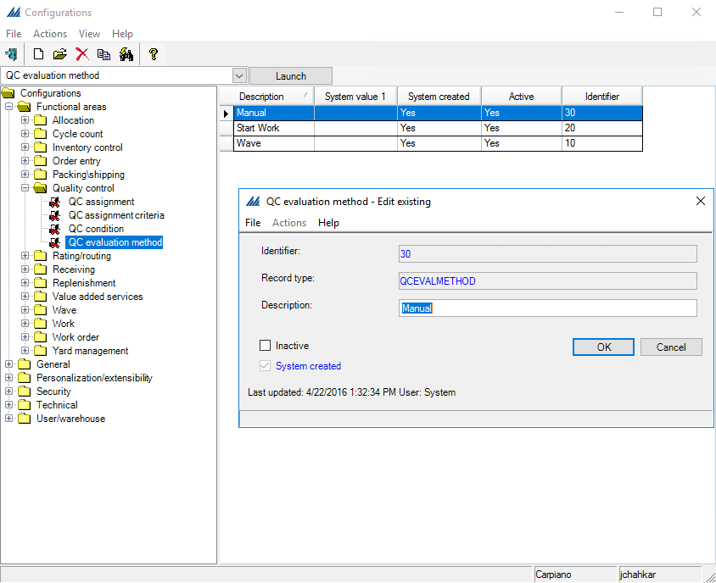

QC assignment
Finally, we assign the criteria and evaluation method to a QC. In the General tab, we indicate the assignment criteria defined in the first step of QC. In the tab QC evaluation method, we check the evaluation method selected in the previous step (“Manual”).
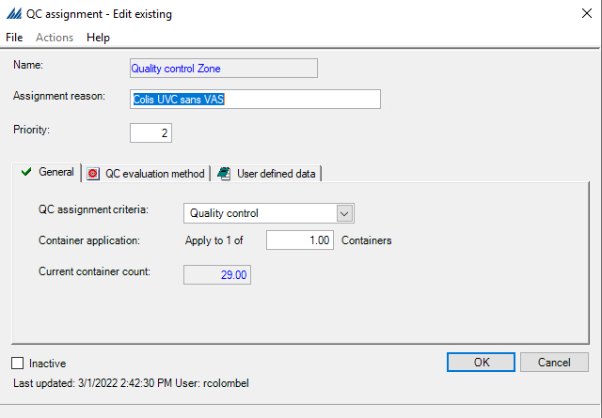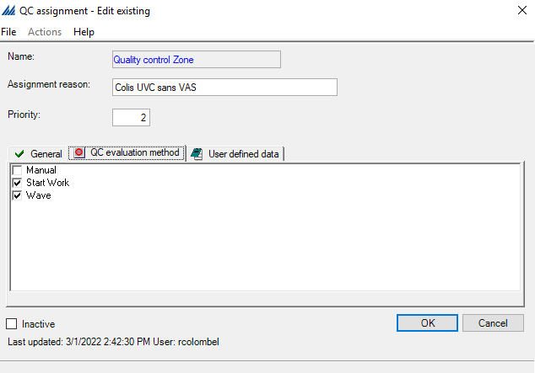

    - Interfaces
In this section, you can set up how SCALE communicates with the ERP host system You can invoke an interface upload/download by either starting it manually from SCALE, or have the system kick it off automatically via a scheduled job. The interface will process though all the appropriate files/records in order of last modified time (earliest to latest).
This task is usually performed at the very beginning of the project by experiences consultants.
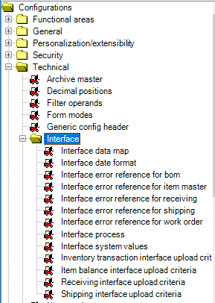

Interface system values
To share records between the ERP and the system, you will need to identify several system settings, some of which are defined for a specific functional area (such as shipping or receiving).
We updated the following parameters
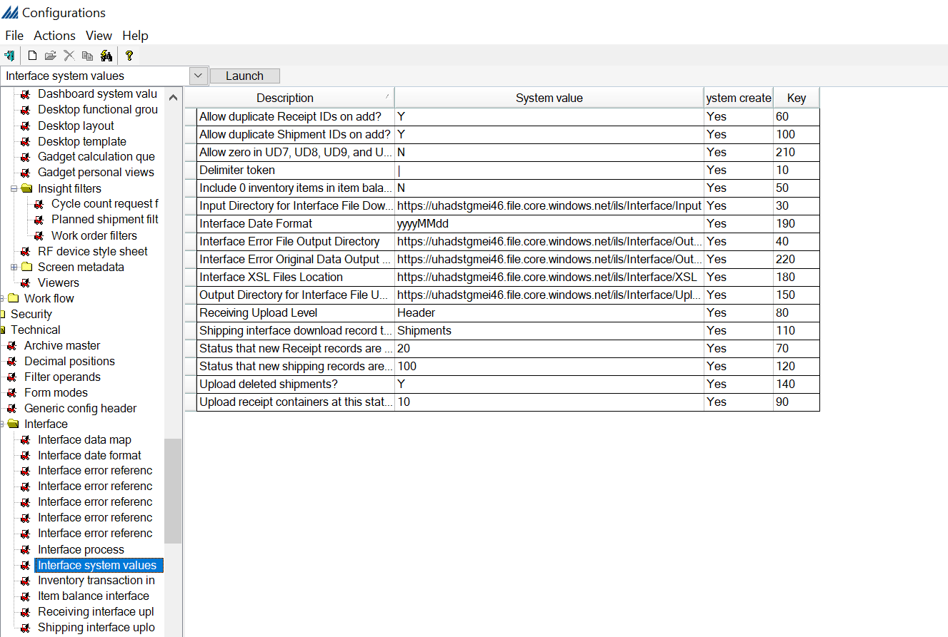

Interface data maps (not required if XML)
An interface data map record is required to map the interface file in case of delimited or fixed length mode. It identifies what fields should be included in an interfaced file, and the position of each field, SCALE uses these records to read files it obtains from the ERP.
On the left side you have all the available fields for a specific record type and on the left side you can specify the actual fields to be mapped, fields are moved to the selected fields windows using the dedicated Add and Remove buttons. As mode you can select delimited data or as fixed length data. Note that if you choose fixed length mode, the system will require that each field defined for this data map be given a specific length.
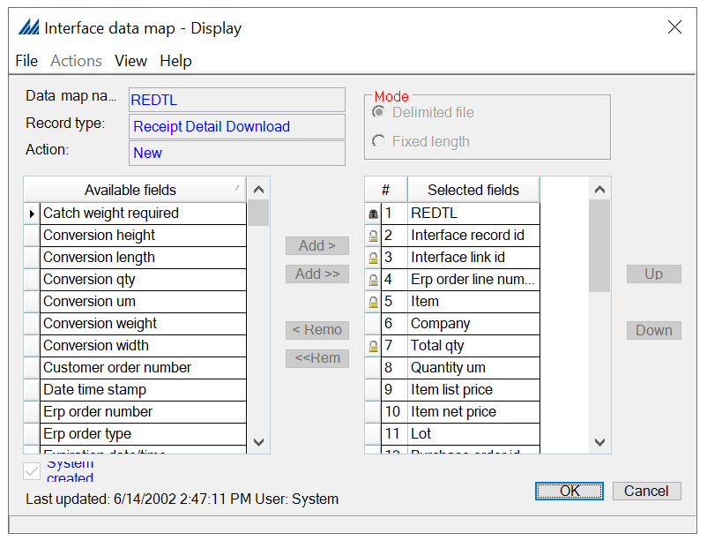

Interface process
Each interface functional area has already a set of process parameters as Default in SCALE, which determines how its data can be downloaded and/or uploaded between SCALE and the ERP. For each Interface Process Window, a series of detail records are present in a sequence that determine in what order the system will execute them.
Detail records indicate the different processes that have been defined for this particular functional area and should be adapted to business needs from upload and download interface by expert technical consultants.
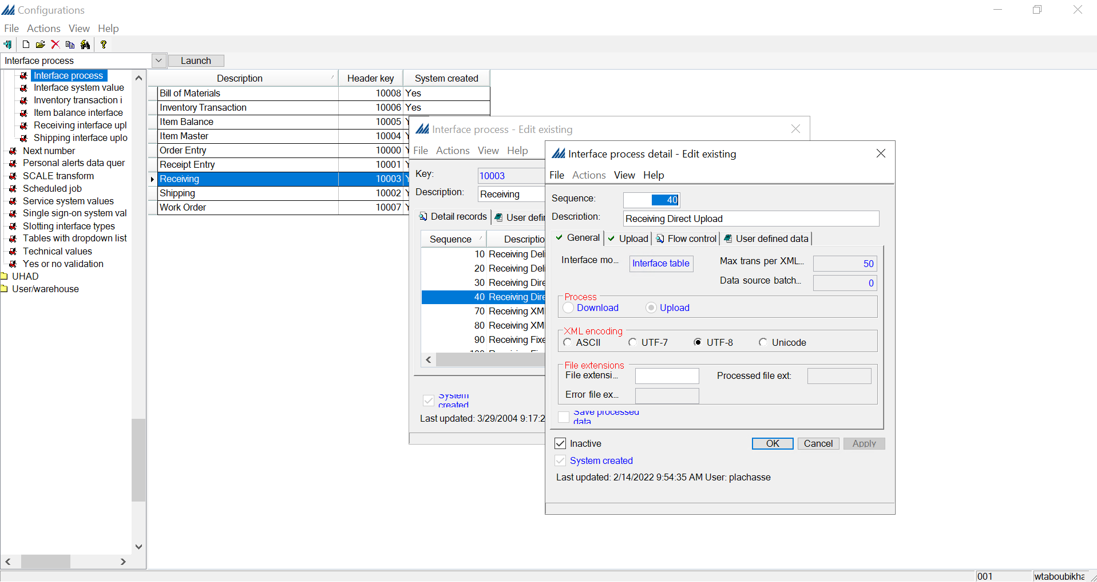
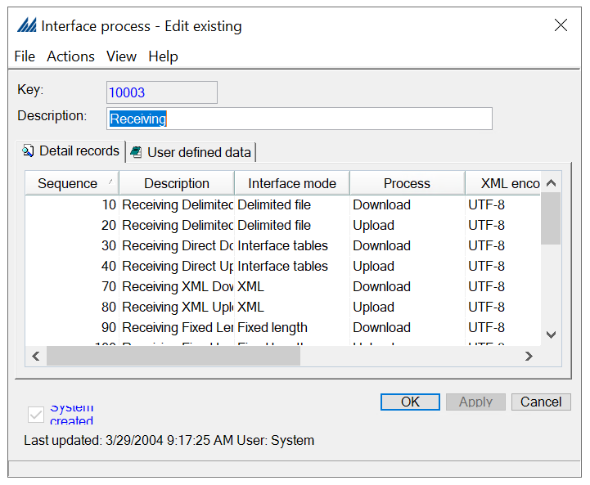

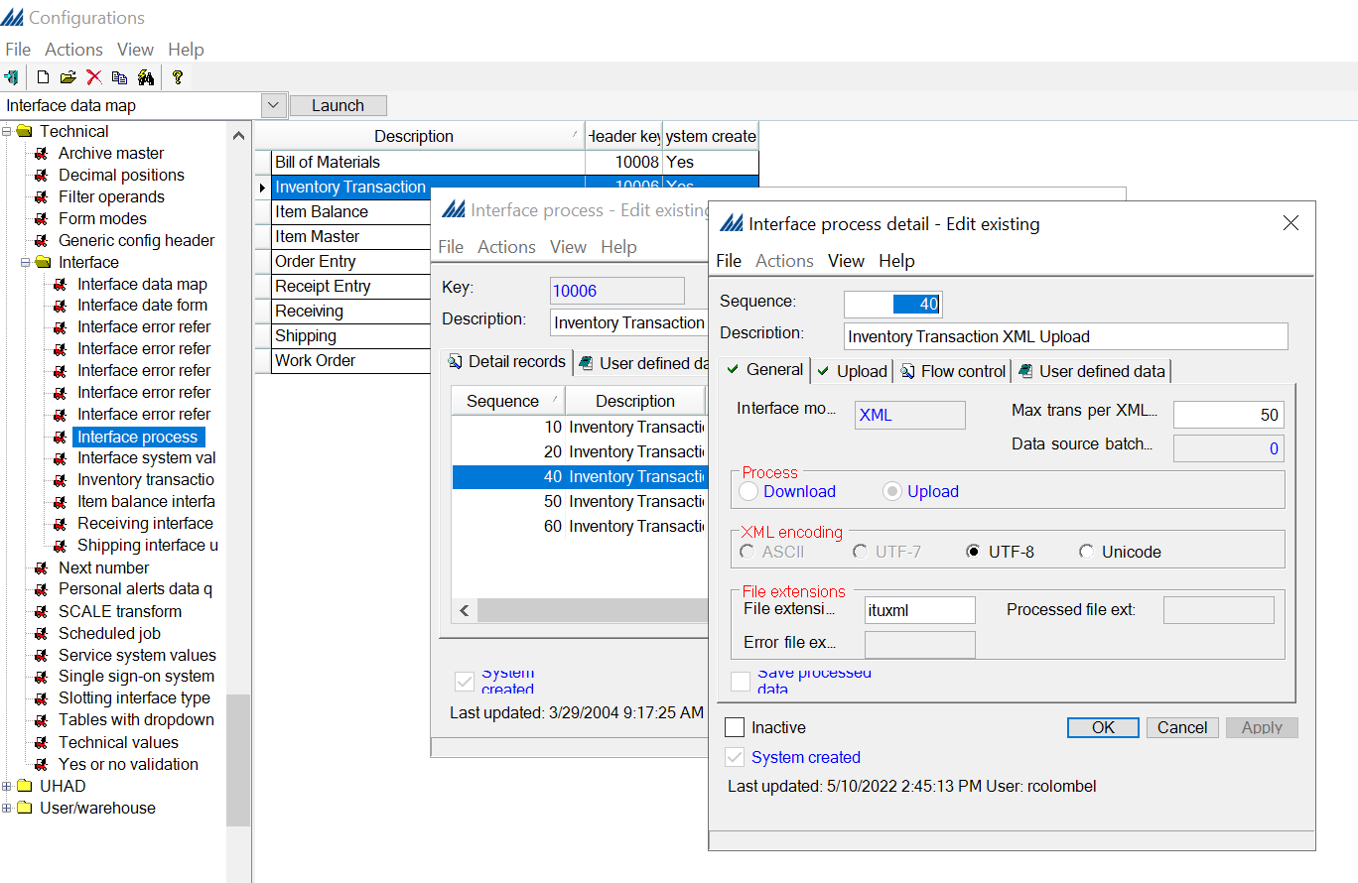
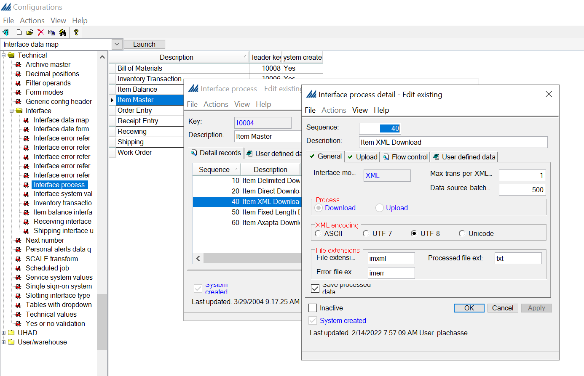

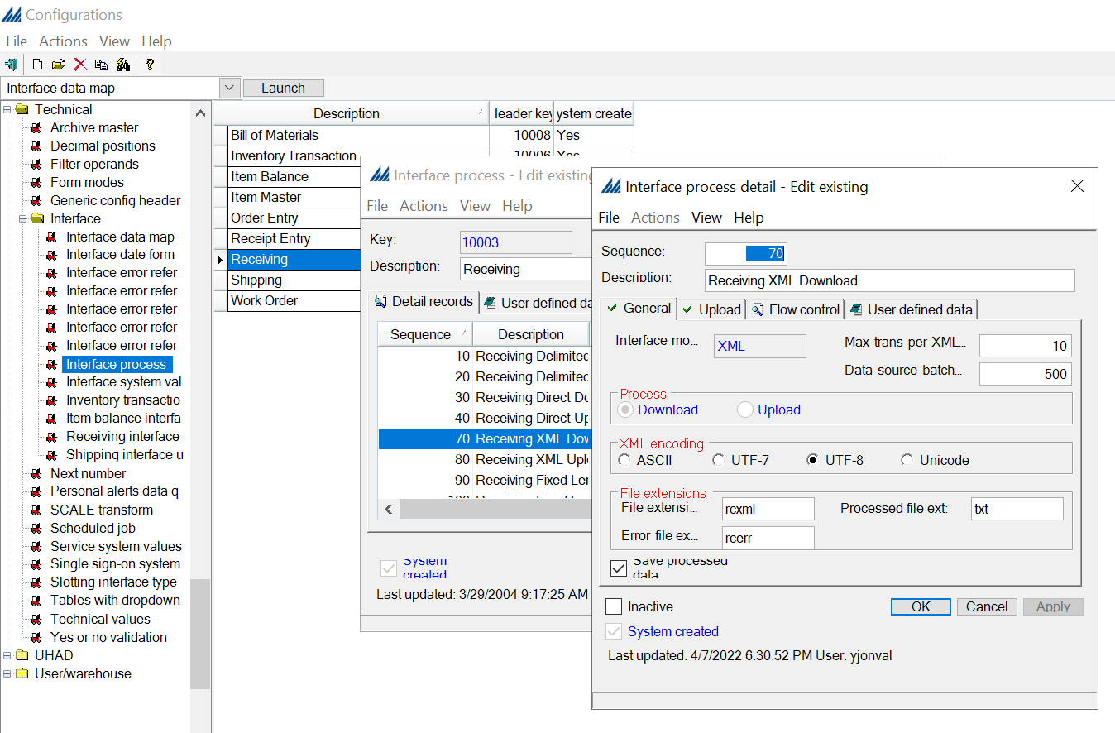

Interface upload criteria
For each communication from SCALE to the host system it is required to configure the upload criteria:
- Receiving interface
- Shipping interface
- Item balance interface
- Inventory Transaction interface
Criteria are used as filter for the records to be uploaded for the specified upload process detail, so SCALE will place the records in the upload directory defined on the interface process detail.

Carrier Interface

Generic Config Header
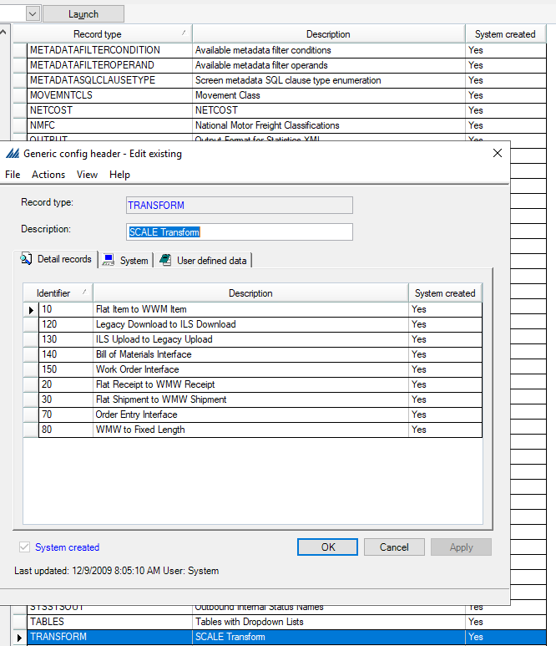

XSL Transformation
No xsl

Shipping interface upload criteria
No shipping interface upload criteria

Interface process

  - Document Printing
Scale allows the printing of documents and labels for all the warehouse processes, most common documents templates and related configurations are already present in SCALE, in the following paragraphs are reported the configuration required to print documents.
Usually documents and labels are printed during the wave process or during work creation process.

Shipment data selection
You will use the data selection windows to identify which document types should be generated for a specific group of records in a wave, based on the characteristics of the record.
For example, if the document type is a bill of lading, you can generate it for all shipment records assigned to an LTL or truckload carrier. You will also use this window to determine the order that the documents will be printed. You can create paperwork for the following wave records: container IDs, work instructions and shipments.
Later, you will associate the document type with a document master record. The document master record determines which document type will be printed for the records defined on the data selection window.
You will use one of the data selection windows to determine which document types are printed for specific records in a wave. There is one data selection record for each type of wave record that might require paperwork. In our case, no Shipment data selection was needed.

Document master
The document master controls all aspects of paperwork document (non-label) generation during a wave; including determining which documents can be generated, the order in which those documents are produced, and how they'll be printed. Note that this record must be defined on the wave master record being run to be used
In our case, since there was no Shipment data selection, there was also no Document master.

Document Type
A document type determines the format of the document (paper or label), and, for which functional areas it is used.
It is a general document category (both paperwork and label), such as a pick list or a shipping label, representing the physical structure (label or document) of all paperwork associated with the type.
The majority of document types are already present in the system, but you can also create new types to use special document layouts requested by your customer.
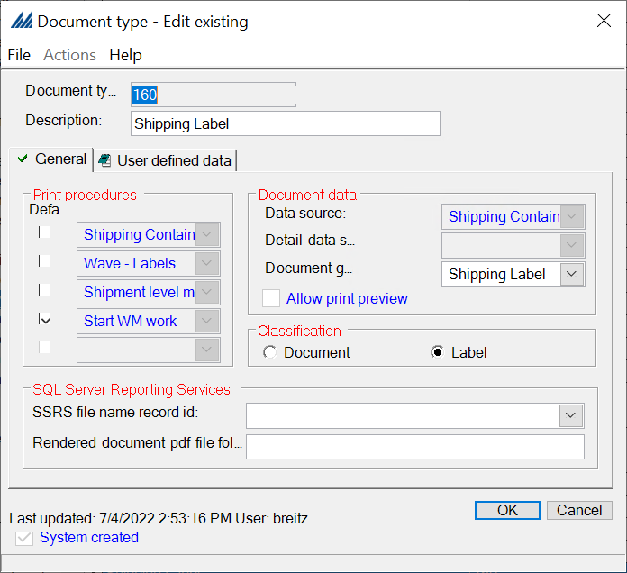

Document
In this configuration are included already all the available document templates in SCALE that can be used to print any document or label.
In case new document are needed to satisfy customer requirement a new document need to be created
Then associate it with a template, which provides its structure and identifying what application will generate the document (SSRS, Progistics, etc), and associate it with a document type and document criteria.
If you are creating a custom report in SSRS, save it on the server under https://DataBaseServerAddress/Reports/browse/ILS/Reporting , where DataBaseServerAdress should be replaced by your own database server address. Here, our database has the address is psql23.btb.fr, so your custom Report file should be saved in https://psql23.btb.fr/Reports/browse/ILS/Reporting. Then, in your Configuration, in the Document window, in the Printed As option, select Reporting Services Document and then in Document Template you should be able to select your custom report.
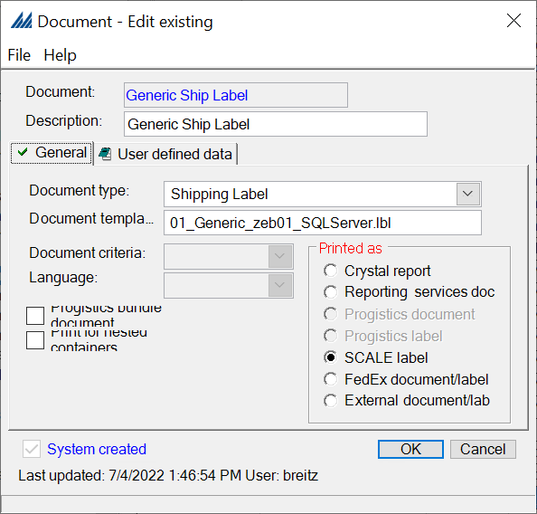

Label master
In order to use the Label master for a specific label, you first need to create the according Document type (second figure - first red rectangle), Label selection criteria (second figure - second red rectangle) and the Label master criteria (first figure - first red rectangle).
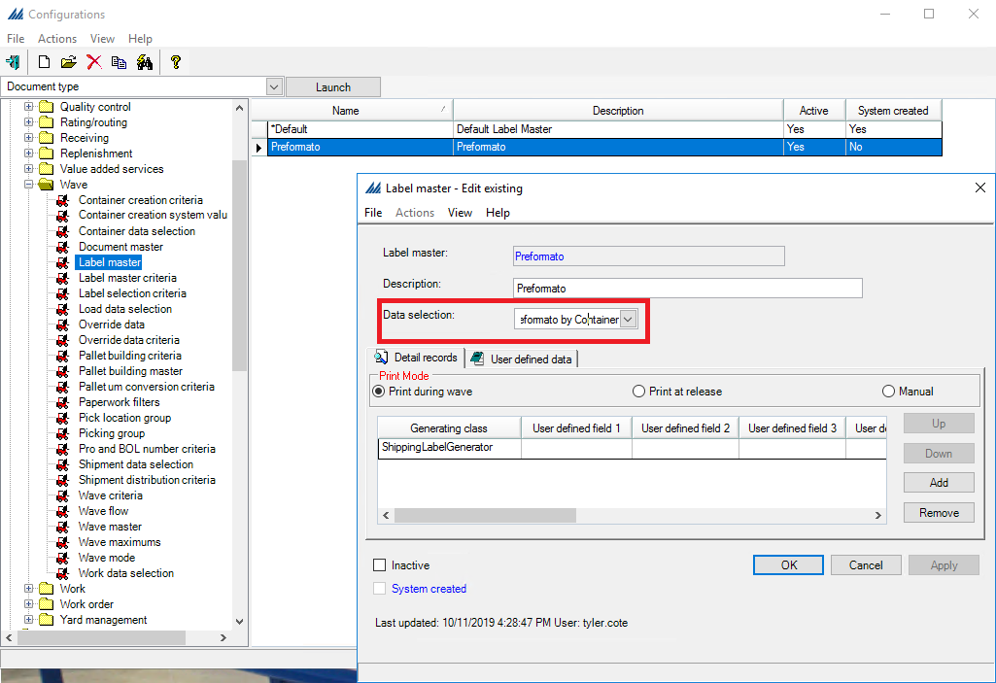
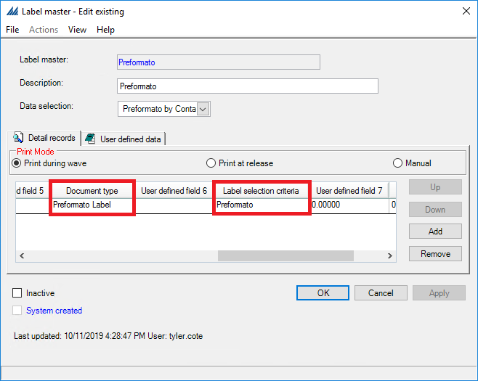
In the Document type window, be careful to check the Label box as shown below.
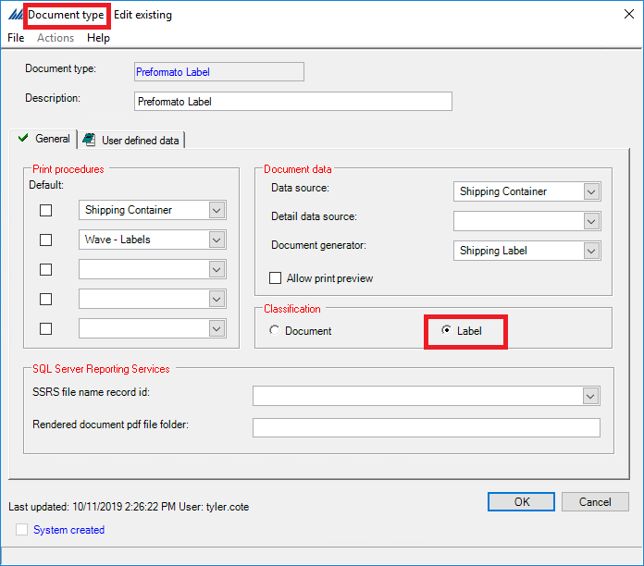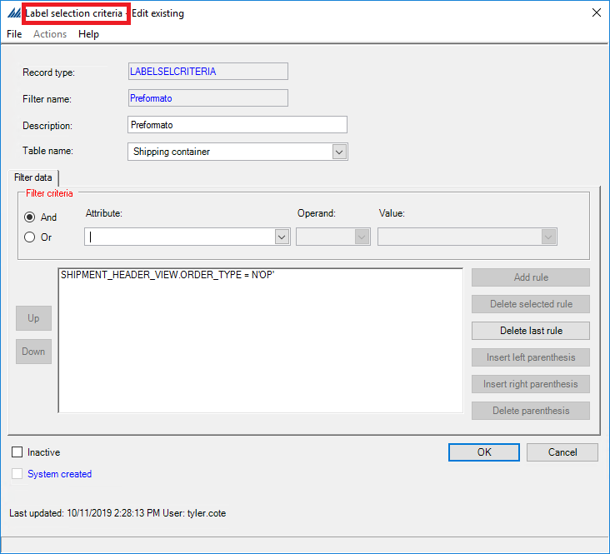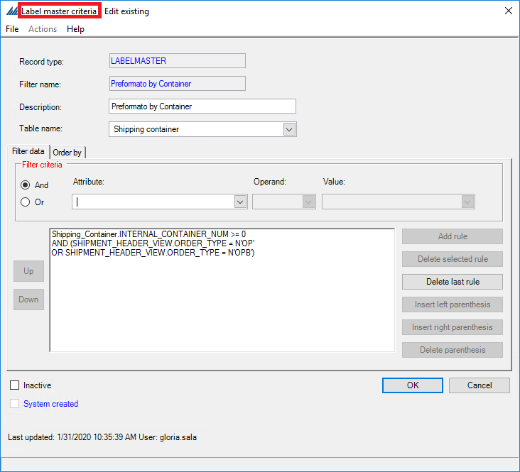

Document routing
Since we defined documents and labels to be printed, for each of them we need to provide the printing parameters in the document routing.
In the Routing Criteria tab is determined if a document should be printed, based on printing criteria commonly included in the printed document itself like Warehouse, Company Ship To, Carrier and Container Class and what machine the document will be printed from; for example, a particular packing station's client machine.
In the Routing Selection tab is set up a number of copies on which the printed document will be routed to, and which document will be used. The printer needs to be inserted in the Print Device Configuration to be selected for the routing.
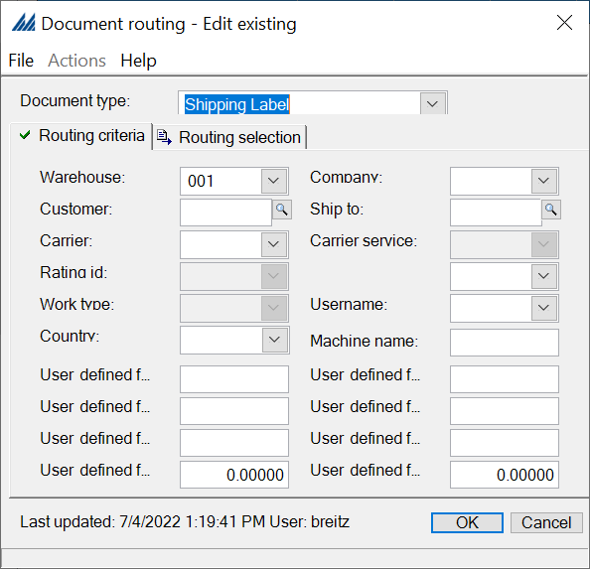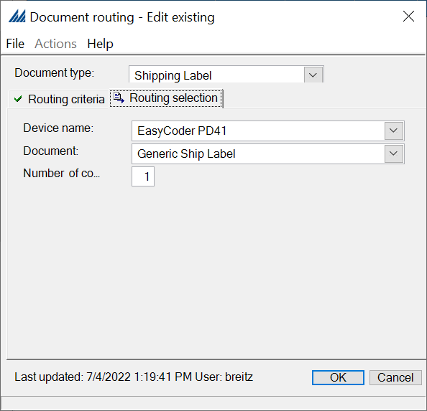

Conclusion
This document was not made to give a comprehensive list of steps to do, but to give a general idea of the steps which need to be done to complete a very simplistic configuration. For more detailed information regarding each feature, you can always go to the dedicated Help menu regarding that feature.
Other sources of help such as Yammer or the Manhattan SCALE - ManhWiki can be useful.

Links and Documentation
Manhattan SCALE - ManhWiki :
http://wiki.manh.com/index.php/Manhattan_SCALE
Yammer (SCALE Support) :
https://www.yammer.com/manh.com/#/threads/inGroup?type=in_group&feedId=815112
AIM (Advanced Information Manager):
http://mamatters/manhproducts/aim/default.aspx
SCALE Training Documentation:
https://manh1.sharepoint.com/sites/pso/PSOAmericas/scale/Reference%20Material/Forms/AllItems.aspx?viewid=c872f4c0%2Dd7d8%2D42db%2Dab45%2D318a606f33cb&id=%2Fsites%2Fpso%2FPSOAmericas%2Fscale%2FReference%20Material%2FManhattan%20SCALE%20Training%20Documentation

